# Sites that were included

NSABHC0001 Test Set: (Timestamp('2003-08-08 00:00:00'), Timestamp('2006-02-21 00:00:00')), Period: 82  
  
NSABHC0003 Test Set: (Timestamp('2008-10-24 00:00:00'), Timestamp('2011-10-17 00:00:00')), Period: 83  
  
NSABHC0004 Test Set: (Timestamp('2005-08-05 00:00:00'), Timestamp('2008-04-16 00:00:00')), Period: 158  
  
NSABHC0007 Test Set: (Timestamp('2019-12-26 00:00:00'), Timestamp('2022-12-26 00:00:00')), Period: 87  
  
NSABHC0008 Test Set: (Timestamp('2020-01-27 00:00:00'), Timestamp('2022-12-26 00:00:00')), Period: 82  
  
NSABHC0010 Test Set: (Timestamp('1993-04-05 00:00:00'), Timestamp('1998-05-22 00:00:00')), Period: 87  
  
NSACHC0001 Test Set: (Timestamp('2003-05-12 00:00:00'), Timestamp('2005-11-17 00:00:00')), Period: 89  
  
NSACHC0004 Test Set: (Timestamp('1993-05-07 00:00:00'), Timestamp('1998-06-07 00:00:00')), Period: 89  
  
NSAMDD0003 Test Set: (Timestamp('1987-09-21 00:00:00'), Timestamp('1993-03-13 00:00:00')), Period: 78  
  
NSAMDD0007 Test Set: (Timestamp('1993-07-10 00:00:00'), Timestamp('1998-10-29 00:00:00')), Period: 76  
  
NSAMDD0008 Test Set: (Timestamp('2015-06-30 00:00:00'), Timestamp('2017-12-12 00:00:00')), Period: 77  
  
NSAMDD0022 Test Set: (Timestamp('2014-12-23 00:00:00'), Timestamp('2017-08-17 00:00:00')), Period: 80  
  
NSAMDD0024 Test Set: (Timestamp('2020-04-09 00:00:00'), Timestamp('2022-12-28 00:00:00')), Period: 85  
  
NSAMDD0028 Test Set: (Timestamp('2017-12-22 00:00:00'), Timestamp('2020-05-11 00:00:00')), Period: 88  
  
NSAMDD0029 Test Set: (Timestamp('2006-06-15 00:00:00'), Timestamp('2009-03-19 00:00:00')), Period: 89  
  
NSAMDD0031 Test Set: (Timestamp('1993-06-03 00:00:00'), Timestamp('1998-08-04 00:00:00')), Period: 80  
  
NSAMUL0001 Test Set: (Timestamp('2003-12-08 00:00:00'), Timestamp('2006-07-09 00:00:00')), Period: 91  
  
NTABRT0001 Test Set: (Timestamp('1999-05-10 00:00:00'), Timestamp('2004-01-08 00:00:00')), Period: 81  
  
NTABRT0002 Test Set: (Timestamp('2020-06-12 00:00:00'), Timestamp('2022-12-19 00:00:00')), Period: 80  
  
NTABRT0003 Test Set: (Timestamp('2012-10-28 00:00:00'), Timestamp('2015-10-13 00:00:00')), Period: 79  
  
NTABRT0004 Test Set: (Timestamp('2008-12-28 00:00:00'), Timestamp('2011-12-06 00:00:00')), Period: 148  
  
NTABRT0006 Test Set: (Timestamp('1998-02-25 00:00:00'), Timestamp('2003-02-06 00:00:00')), Period: 146  
  
NTABRT0008 Test Set: (Timestamp('2003-10-12 00:00:00'), Timestamp('2006-06-30 00:00:00')), Period: 77  
  
NTAFIN0004 Test Set: (Timestamp('2004-11-24 00:00:00'), Timestamp('2007-11-25 00:00:00')), Period: 126  
  
NTAFIN0009 Test Set: (Timestamp('2013-11-25 00:00:00'), Timestamp('2016-07-27 00:00:00')), Period: 126  
  
NTAFIN0011 Test Set: (Timestamp('1992-09-04 00:00:00'), Timestamp('1998-12-01 00:00:00')), Period: 144  
  
NTAFIN0018 Test Set: (Timestamp('2006-05-05 00:00:00'), Timestamp('2008-10-17 00:00:00')), Period: 84  
  
NTAFIN0022 Test Set: (Timestamp('1987-09-07 00:00:00'), Timestamp('1992-08-19 00:00:00')), Period: 82  
  
NTAFIN0030 Test Set: (Timestamp('2020-05-20 00:00:00'), Timestamp('2022-12-28 00:00:00')), Period: 86  
  
NTAFIN0031 Test Set: (Timestamp('1999-08-31 00:00:00'), Timestamp('2004-04-22 00:00:00')), Period: 85  
  
NTAFIN0032 Test Set: (Timestamp('1987-09-23 00:00:00'), Timestamp('1993-01-10 00:00:00')), Period: 79  
  
NTAGFU0021 Test Set: (Timestamp('1993-03-31 00:00:00'), Timestamp('1999-08-23 00:00:00')), Period: 89  
  
NTAGFU0023 Test Set: (Timestamp('2015-07-26 00:00:00'), Timestamp('2017-10-19 00:00:00')), Period: 87  
  
NTAGFU0025 Test Set: (Timestamp('1999-08-07 00:00:00'), Timestamp('2004-01-17 00:00:00')), Period: 87  
  
NTAGFU0031 Test Set: (Timestamp('1992-11-30 00:00:00'), Timestamp('1998-09-12 00:00:00')), Period: 78  
  
NTAGFU0040 Test Set: (Timestamp('2008-08-05 00:00:00'), Timestamp('2011-08-30 00:00:00')), Period: 156  
  
NTAMGD0005 Test Set: (Timestamp('2013-02-01 00:00:00'), Timestamp('2015-09-27 00:00:00')), Period: 86  
  
NTASSD0004 Test Set: (Timestamp('2013-08-23 00:00:00'), Timestamp('2016-02-21 00:00:00')), Period: 104  
  
NTASSD0017 Test Set: (Timestamp('1993-10-18 00:00:00'), Timestamp('1999-07-15 00:00:00')), Period: 94  
  
NTASSD0019 Test Set: (Timestamp('2006-10-06 00:00:00'), Timestamp('2009-06-16 00:00:00')), Period: 92  
  
NTATAN0001 Test Set: (Timestamp('2018-10-06 00:00:00'), Timestamp('2020-08-24 00:00:00')), Period: 119  
  
NTATAN0002 Test Set: (Timestamp('1987-09-07 00:00:00'), Timestamp('1994-09-10 00:00:00')), Period: 121  
  
QDABBN0001 Test Set: (Timestamp('2017-09-10 00:00:00'), Timestamp('2020-02-14 00:00:00')), Period: 81  
  
QDABBS0010 Test Set: (Timestamp('1987-09-18 00:00:00'), Timestamp('1993-07-16 00:00:00')), Period: 78  
  
QDACYP0001 Test Set: (Timestamp('2011-07-13 00:00:00'), Timestamp('2014-11-10 00:00:00')), Period: 59  
  
QDACYP0002 Test Set: (Timestamp('2014-07-05 00:00:00'), Timestamp('2017-04-24 00:00:00')), Period: 51  
  
QDACYP0003 Test Set: (Timestamp('1992-10-11 00:00:00'), Timestamp('1997-07-21 00:00:00')), Period: 64  
  
QDACYP0017 Test Set: (Timestamp('1987-10-13 00:00:00'), Timestamp('1993-05-05 00:00:00')), Period: 48  
  
QDACYP0018 Test Set: (Timestamp('2014-07-10 00:00:00'), Timestamp('2017-05-08 00:00:00')), Period: 81  
  
QDAGUP0001 Test Set: (Timestamp('2006-02-05 00:00:00'), Timestamp('2009-03-01 00:00:00')), Period: 91  
  
QDAGUP0010 Test Set: (Timestamp('2017-08-05 00:00:00'), Timestamp('2020-02-18 00:00:00')), Period: 162  
  
QDAMGD0010 Test Set: (Timestamp('2017-12-28 00:00:00'), Timestamp('2020-04-23 00:00:00')), Period: 91  
  
QDAMGD0012 Test Set: (Timestamp('1987-09-21 00:00:00'), Timestamp('1993-07-03 00:00:00')), Period: 93  
  
SAABHC0001 Test Set: (Timestamp('1998-02-06 00:00:00'), Timestamp('2002-09-05 00:00:00')), Period: 154  
  
SAABHC0003 Test Set: (Timestamp('2017-11-18 00:00:00'), Timestamp('2020-04-15 00:00:00')), Period: 153  
  
SAAFLB0005 Test Set: (Timestamp('2009-01-02 00:00:00'), Timestamp('2012-10-09 00:00:00')), Period: 69  
  
SAAFLB0006 Test Set: (Timestamp('2019-11-22 00:00:00'), Timestamp('2022-12-24 00:00:00')), Period: 52  
  
SAAGAW0003 Test Set: (Timestamp('2008-07-26 00:00:00'), Timestamp('2012-05-18 00:00:00')), Period: 133  
  
SAAGAW0005 Test Set: (Timestamp('2013-03-16 00:00:00'), Timestamp('2015-11-25 00:00:00')), Period: 84  
  
SAARIV0007 Test Set: (Timestamp('2006-08-08 00:00:00'), Timestamp('2009-04-02 00:00:00')), Period: 125  
  
SAASTP0009 Test Set: (Timestamp('2008-10-28 00:00:00'), Timestamp('2012-03-13 00:00:00')), Period: 168  
  
SASMDD0009 Test Set: (Timestamp('2003-11-04 00:00:00'), Timestamp('2006-05-20 00:00:00')), Period: 73  
  
SASMDD0014 Test Set: (Timestamp('2006-06-29 00:00:00'), Timestamp('2009-04-10 00:00:00')), Period: 73  
  
SATFLB0005 Test Set: (Timestamp('2000-02-27 00:00:00'), Timestamp('2004-04-18 00:00:00')), Period: 68  
  
SATFLB0006 Test Set: (Timestamp('2009-02-11 00:00:00'), Timestamp('2012-07-21 00:00:00')), Period: 74  
  
SATFLB0009 Test Set: (Timestamp('2017-10-07 00:00:00'), Timestamp('2020-02-10 00:00:00')), Period: 69  
  
SATFLB0017 Test Set: (Timestamp('1998-01-21 00:00:00'), Timestamp('2002-11-15 00:00:00')), Period: 154  
  
SATFLB0023 Test Set: (Timestamp('2003-09-16 00:00:00'), Timestamp('2005-10-15 00:00:00')), Period: 109  
  
SATSTP0004 Test Set: (Timestamp('2009-01-26 00:00:00'), Timestamp('2012-03-31 00:00:00')), Period: 89  
  
SATSTP0005 Test Set: (Timestamp('2004-01-29 00:00:00'), Timestamp('2006-07-05 00:00:00')), Period: 91  
  
SATSTP0006 Test Set: (Timestamp('1987-09-11 00:00:00'), Timestamp('1993-03-03 00:00:00')), Period: 91  
  
WAACAR0003 Test Set: (Timestamp('2012-09-14 00:00:00'), Timestamp('2015-08-14 00:00:00')), Period: 163  
  
WAACOO0009 Test Set: (Timestamp('2012-05-22 00:00:00'), Timestamp('2015-09-04 00:00:00')), Period: 81  
  
WAACOO0011 Test Set: (Timestamp('2011-03-09 00:00:00'), Timestamp('2014-10-27 00:00:00')), Period: 93  
  
WAACOO0016 Test Set: (Timestamp('2009-05-30 00:00:00'), Timestamp('2013-02-18 00:00:00')), Period: 77  
  
WAACOO0017 Test Set: (Timestamp('2016-04-07 00:00:00'), Timestamp('2018-06-08 00:00:00')), Period: 74  
  
WAACOO0018 Test Set: (Timestamp('1993-03-07 00:00:00'), Timestamp('1998-04-06 00:00:00')), Period: 77  
  
WAACOO0020 Test Set: (Timestamp('2010-11-25 00:00:00'), Timestamp('2014-06-14 00:00:00')), Period: 115  
  
WAACOO0021 Test Set: (Timestamp('2008-10-27 00:00:00'), Timestamp('2010-10-17 00:00:00')), Period: 109  
  
WAACOO0024 Test Set: (Timestamp('1987-09-15 00:00:00'), Timestamp('1992-07-19 00:00:00')), Period: 99  
  
WAACOO0025 Test Set: (Timestamp('2015-06-08 00:00:00'), Timestamp('2018-01-23 00:00:00')), Period: 82  
  
WAACOO0026 Test Set: (Timestamp('1992-11-15 00:00:00'), Timestamp('1998-10-15 00:00:00')), Period: 143  
  
WAACOO0027 Test Set: (Timestamp('2006-05-07 00:00:00'), Timestamp('2008-12-13 00:00:00')), Period: 143  
  
WAACOO0028 Test Set: (Timestamp('2003-10-22 00:00:00'), Timestamp('2006-06-23 00:00:00')), Period: 143  
  
WAACOO0029 Test Set: (Timestamp('2003-10-21 00:00:00'), Timestamp('2006-04-04 00:00:00')), Period: 136  
  
WAADAL0002 Test Set: (Timestamp('2018-01-15 00:00:00'), Timestamp('2020-04-18 00:00:00')), Period: 84  
  
WAAGVD0001 Test Set: (Timestamp('2020-03-28 00:00:00'), Timestamp('2022-12-31 00:00:00')), Period: 76  
  
WAAHAM0001 Test Set: (Timestamp('2017-12-19 00:00:00'), Timestamp('2020-08-14 00:00:00')), Period: 109  
  
WAAHAM0002 Test Set: (Timestamp('2015-07-07 00:00:00'), Timestamp('2017-10-24 00:00:00')), Period: 113  
  
WAAHAM0005 Test Set: (Timestamp('2001-03-02 00:00:00'), Timestamp('2005-04-06 00:00:00')), Period: 54  
  
WAALSD0002 Test Set: (Timestamp('2020-08-08 00:00:00'), Timestamp('2022-12-27 00:00:00')), Period: 168  
  
WAAMAL0001 Test Set: (Timestamp('1999-05-15 00:00:00'), Timestamp('2003-10-26 00:00:00')), Period: 71  
  
WAAMUR0006 Test Set: (Timestamp('2006-05-19 00:00:00'), Timestamp('2009-04-01 00:00:00')), Period: 92  
  
WAAPIL0005 Test Set: (Timestamp('1987-09-04 00:00:00'), Timestamp('1992-10-19 00:00:00')), Period: 96  
  
WAAPIL0010 Test Set: (Timestamp('2020-06-18 00:00:00'), Timestamp('2022-12-25 00:00:00')), Period: 92  
  
WAAPIL0011 Test Set: (Timestamp('2015-06-29 00:00:00'), Timestamp('2018-02-05 00:00:00')), Period: 90  
  
WAAPIL0021 Test Set: (Timestamp('1987-09-04 00:00:00'), Timestamp('1992-07-15 00:00:00')), Period: 91  
  
WAAPIL0024 Test Set: (Timestamp('2020-01-27 00:00:00'), Timestamp('2022-12-26 00:00:00')), Period: 92  
  
WAAPIL0028 Test Set: (Timestamp('2016-06-17 00:00:00'), Timestamp('2018-09-11 00:00:00')), Period: 132  
  
WAAPIL0032 Test Set: (Timestamp('2017-12-12 00:00:00'), Timestamp('2020-04-08 00:00:00')), Period: 90  
  
WAAYAL0002 Test Set: (Timestamp('2006-06-10 00:00:00'), Timestamp('2009-06-02 00:00:00')), Period: 80  
  
WAAYAL0005 Test Set: (Timestamp('1999-03-27 00:00:00'), Timestamp('2003-10-24 00:00:00')), Period: 82

# Table: MSE of the Random Forest on each output

|  |  |  |  |  |
| --- | --- | --- | --- | --- |
|  | pv_filter | npv_filter | bs_filter | loss_mean |
| Train | 0.911 | 0.94 | 1.232 | 1.028 |
| Test | 20.992 | 29.149 | 38.723 | 29.621 |

# Permutation Importance

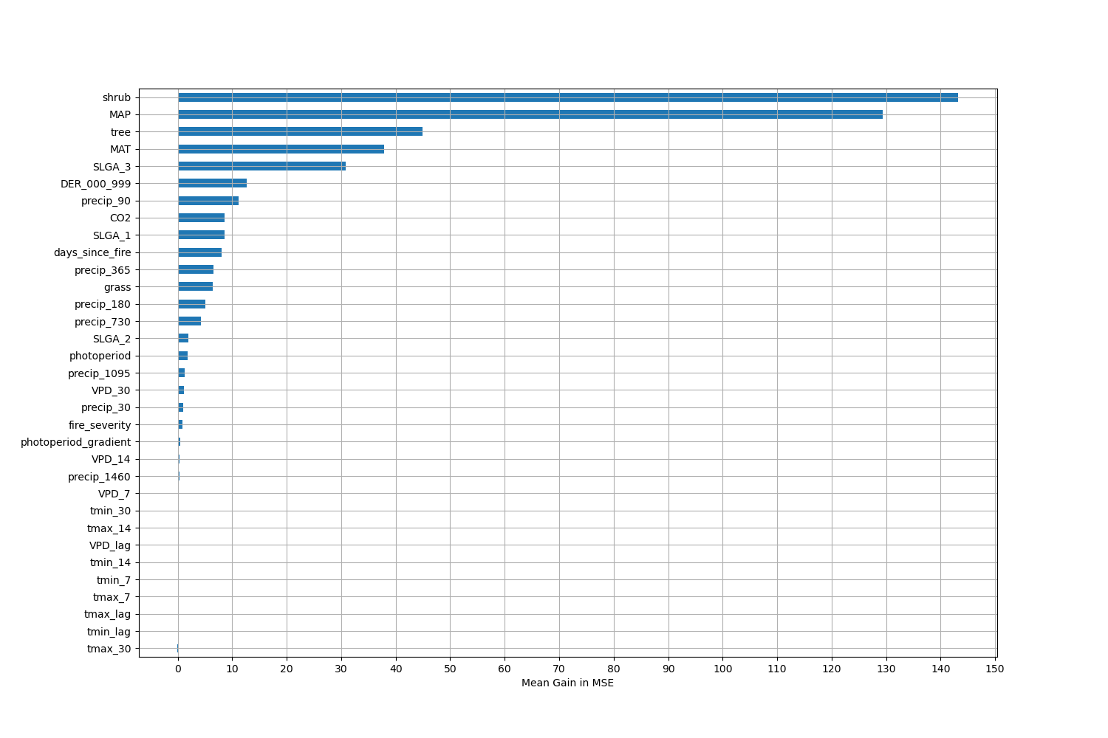

# Permutation Importance by Precip

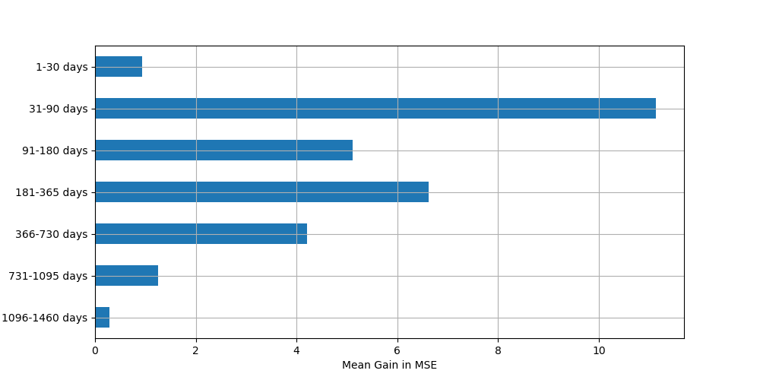

# ALE Importance

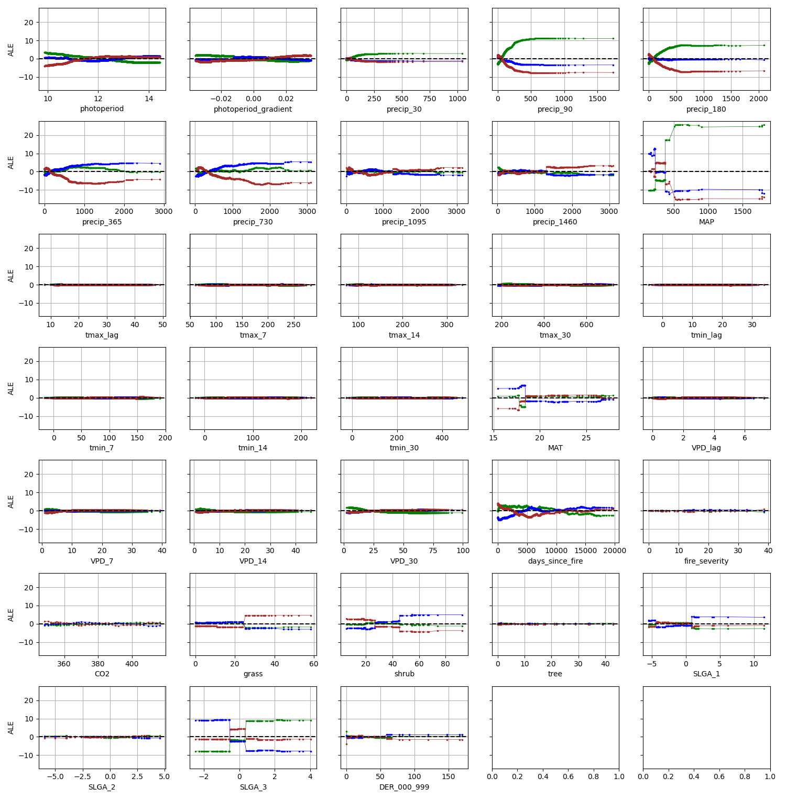

# NSABHC0001

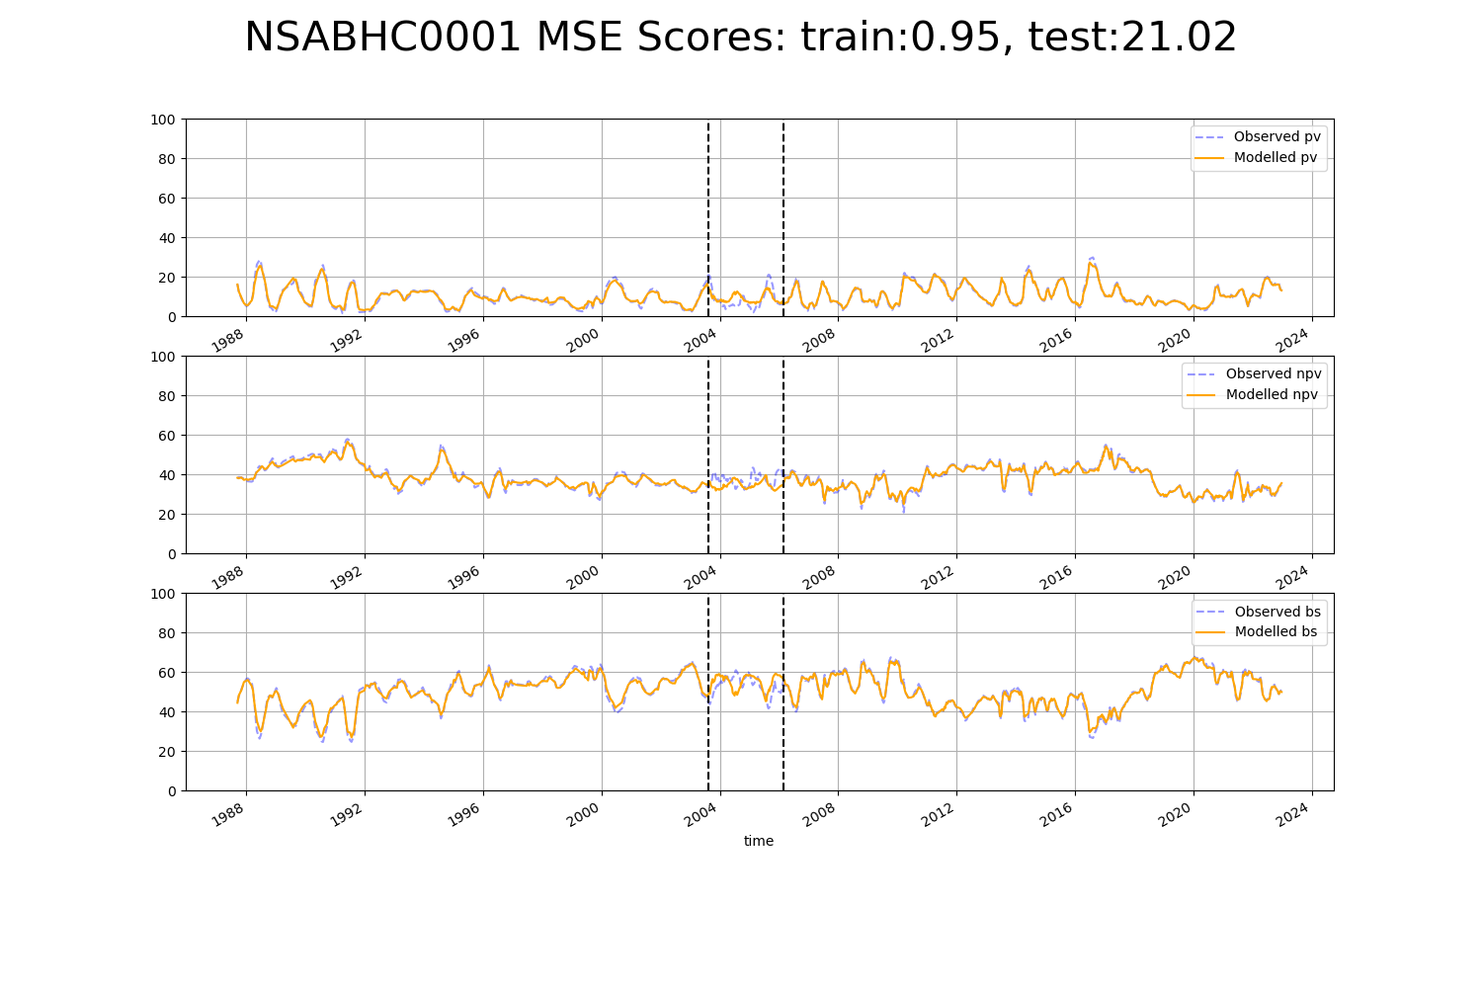

# NSABHC0003

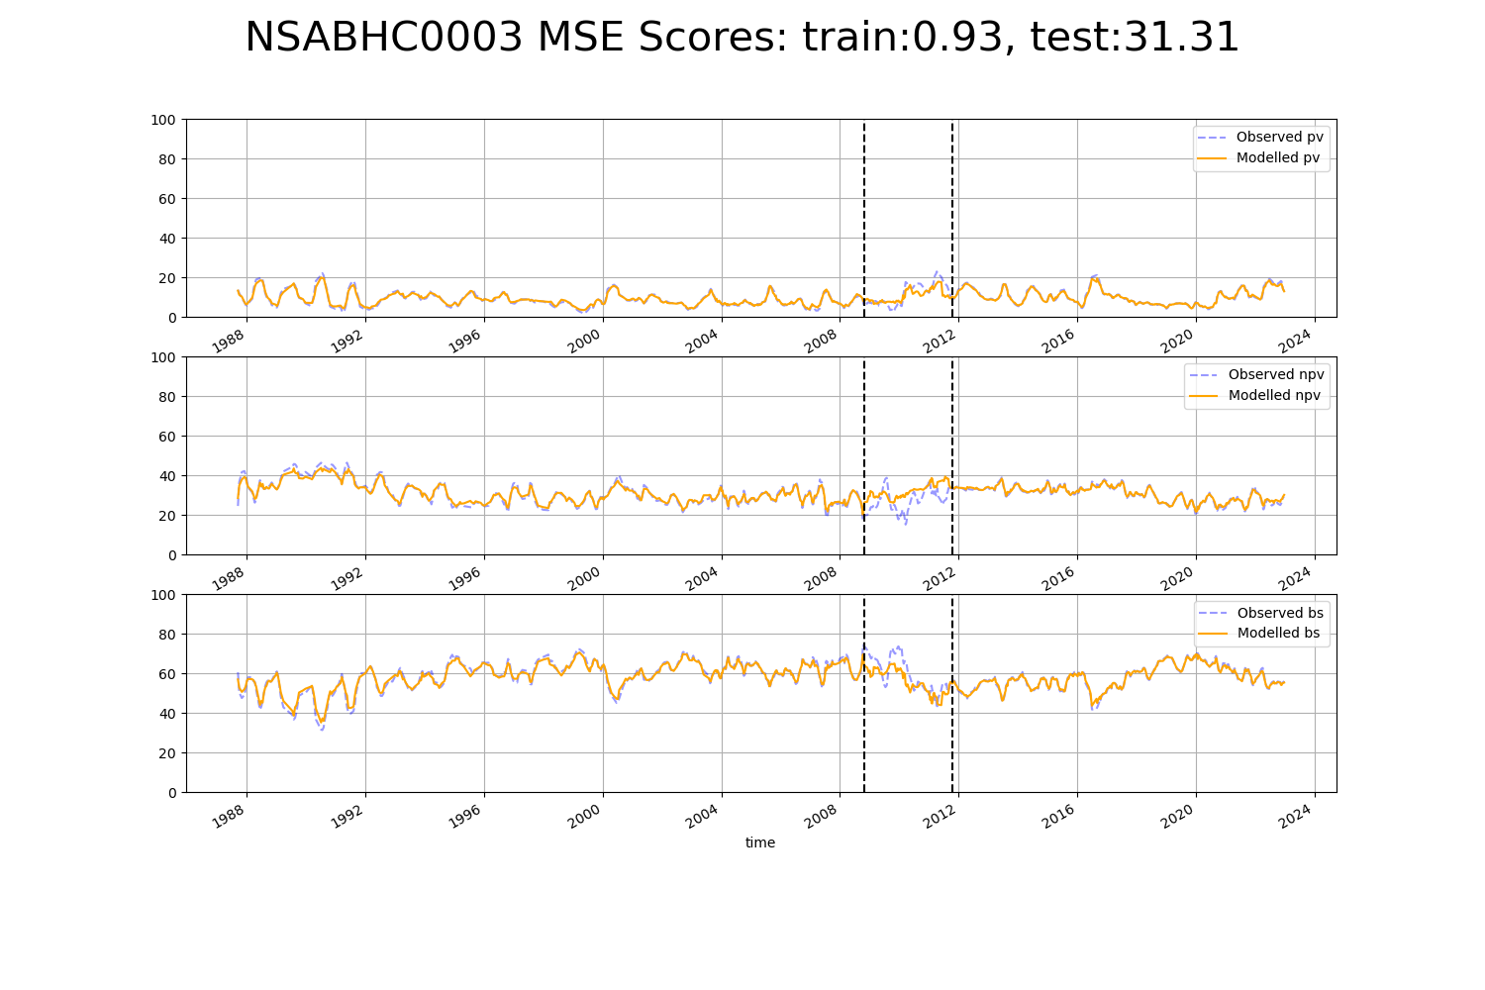

# NSABHC0004

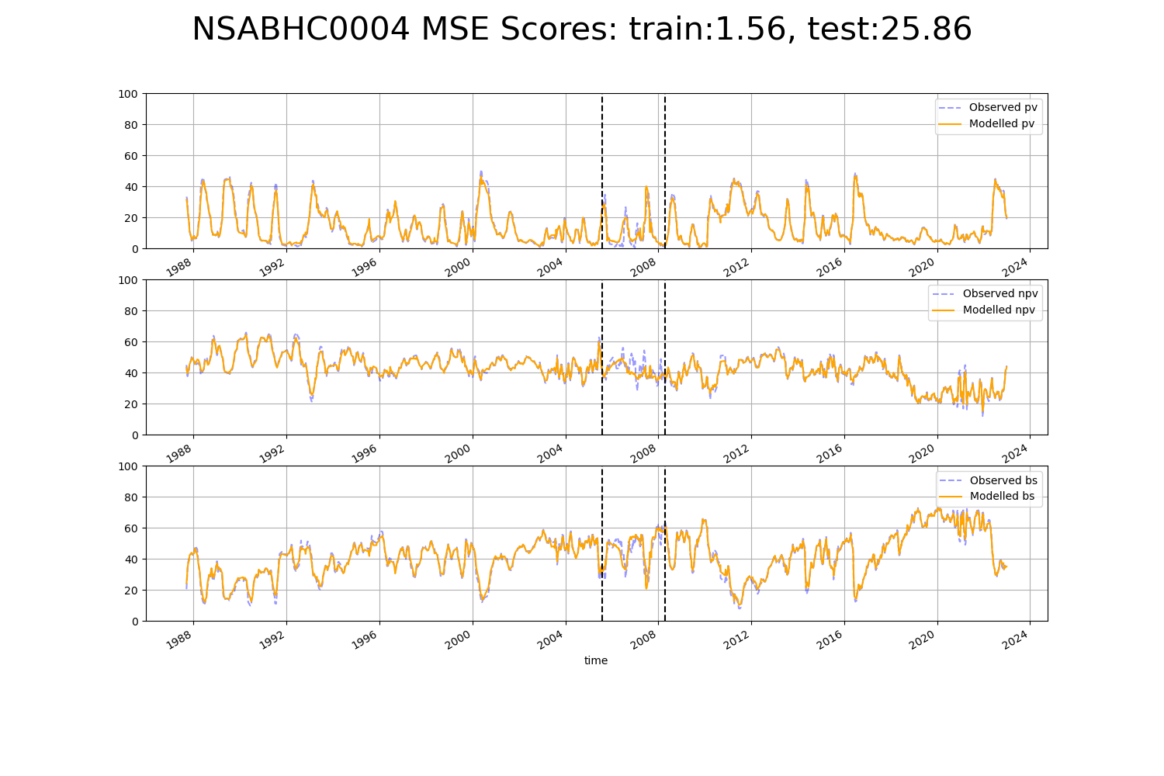

# NSABHC0007

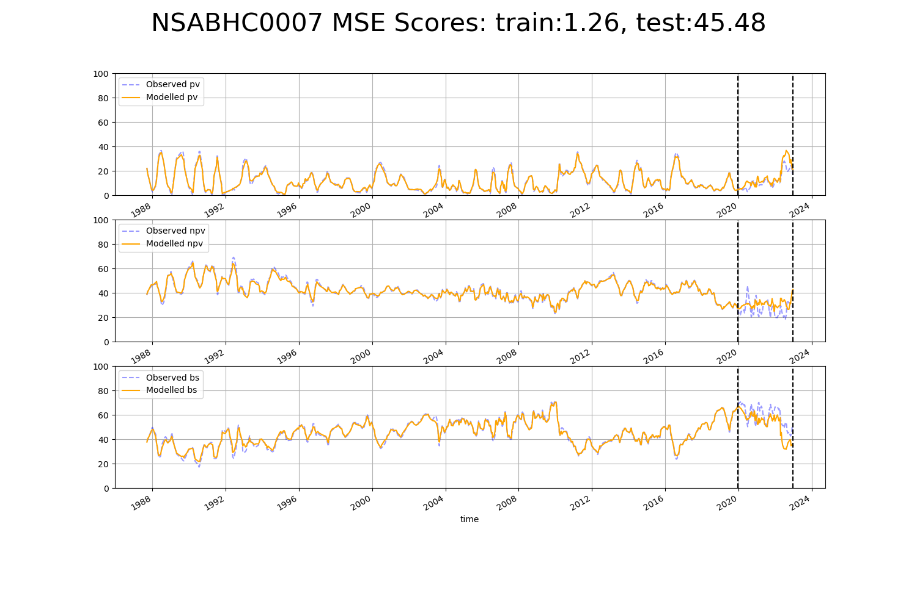

# NSABHC0008

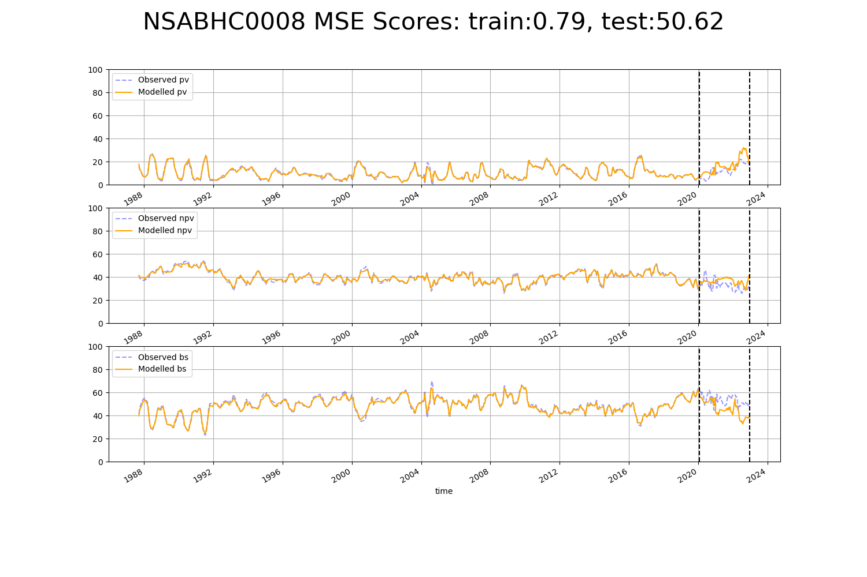

# NSABHC0010

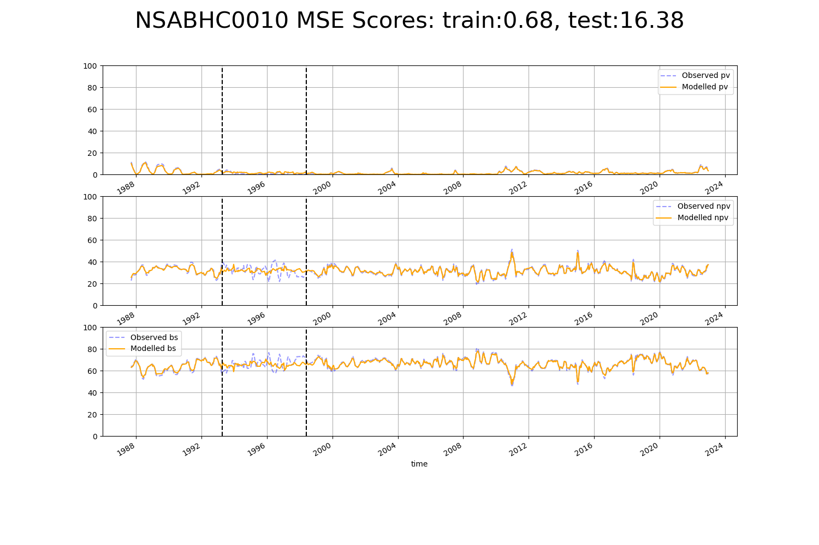

# NSACHC0001

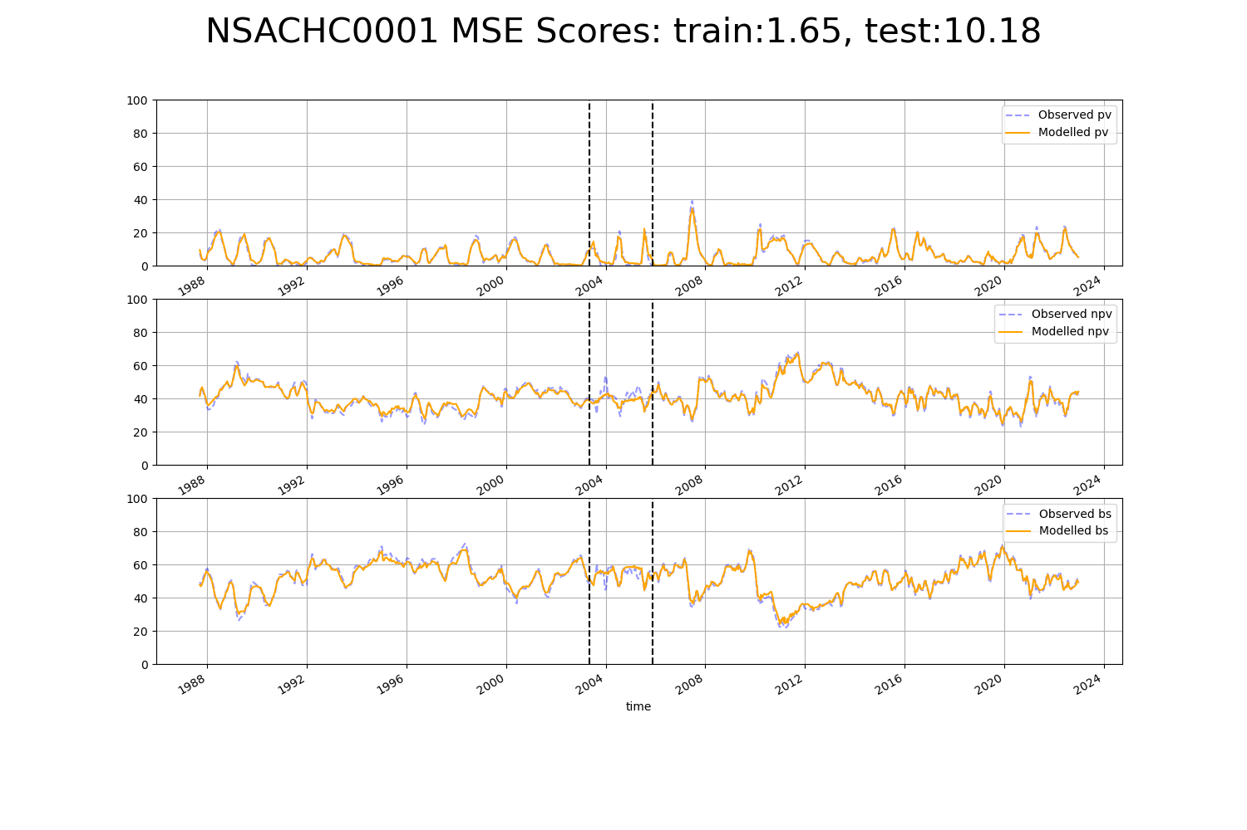

# NSACHC0004

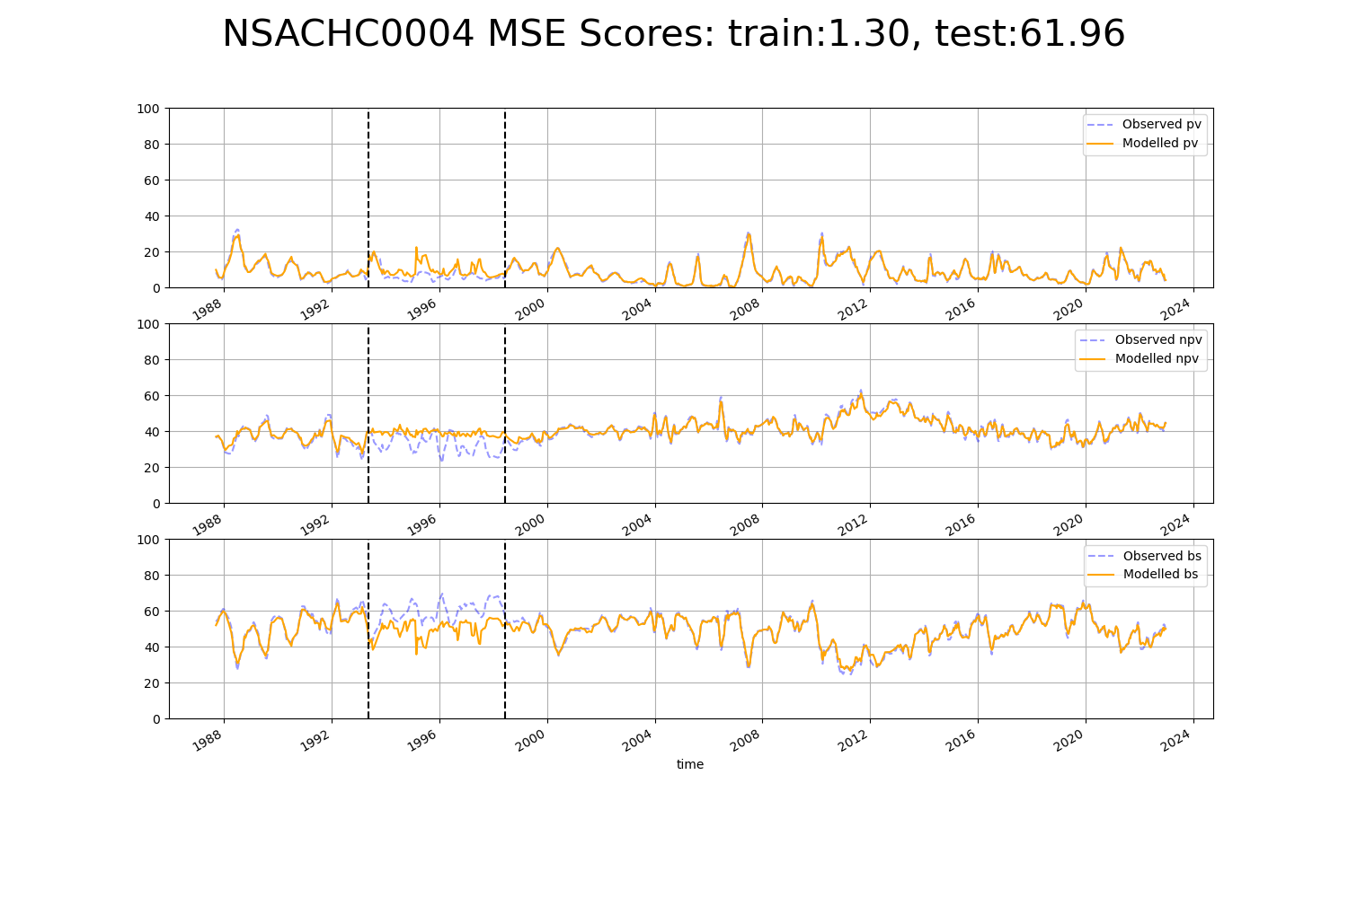

# NSAMDD0003

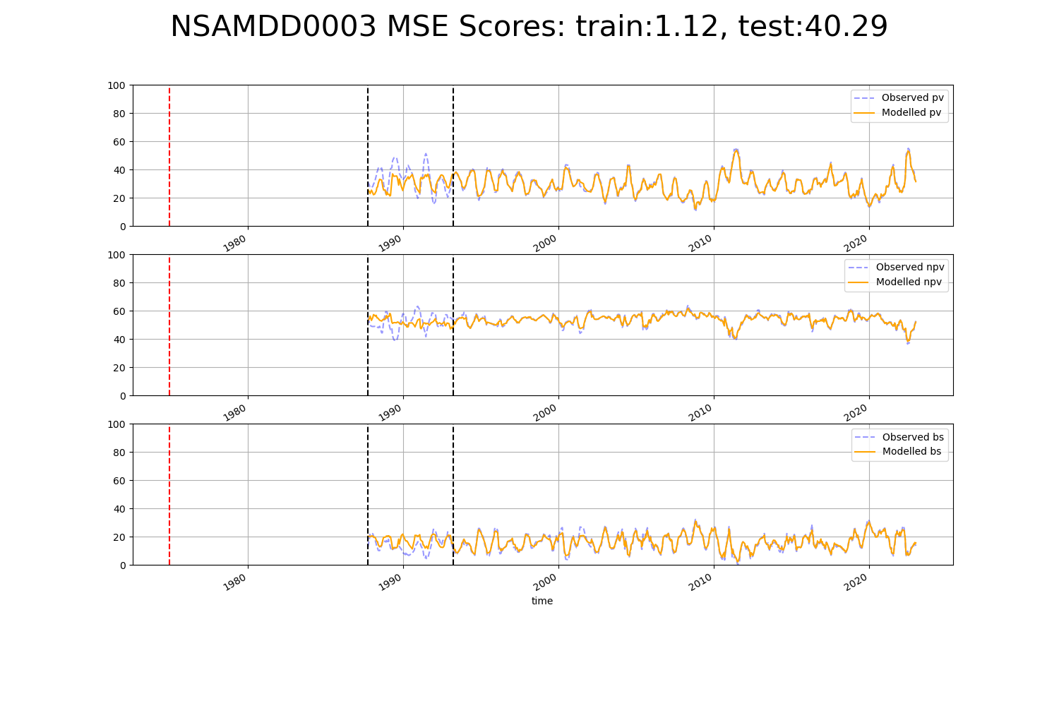

# NSAMDD0007

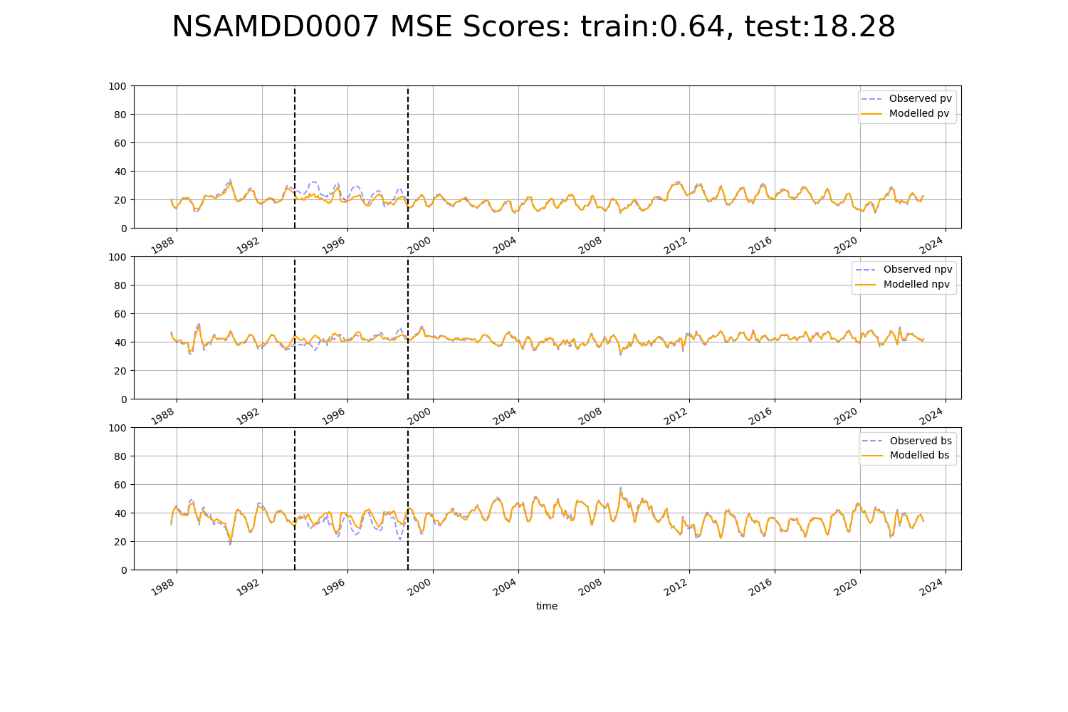

# NSAMDD0008

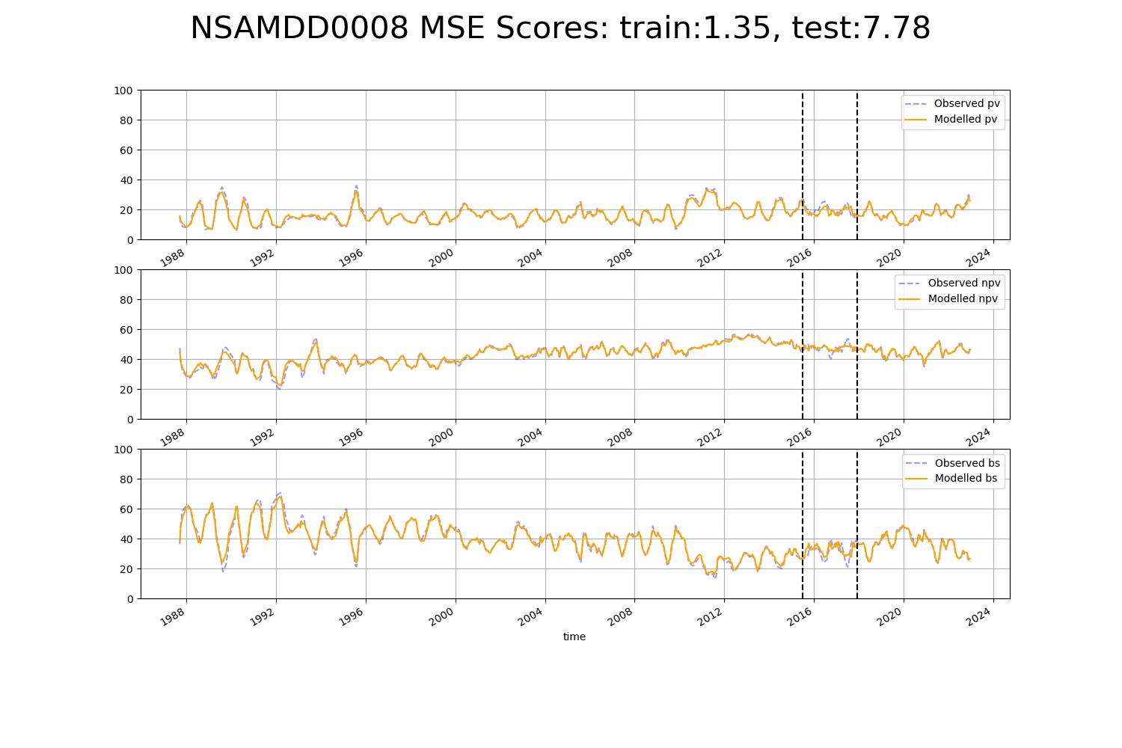

# NSAMDD0022

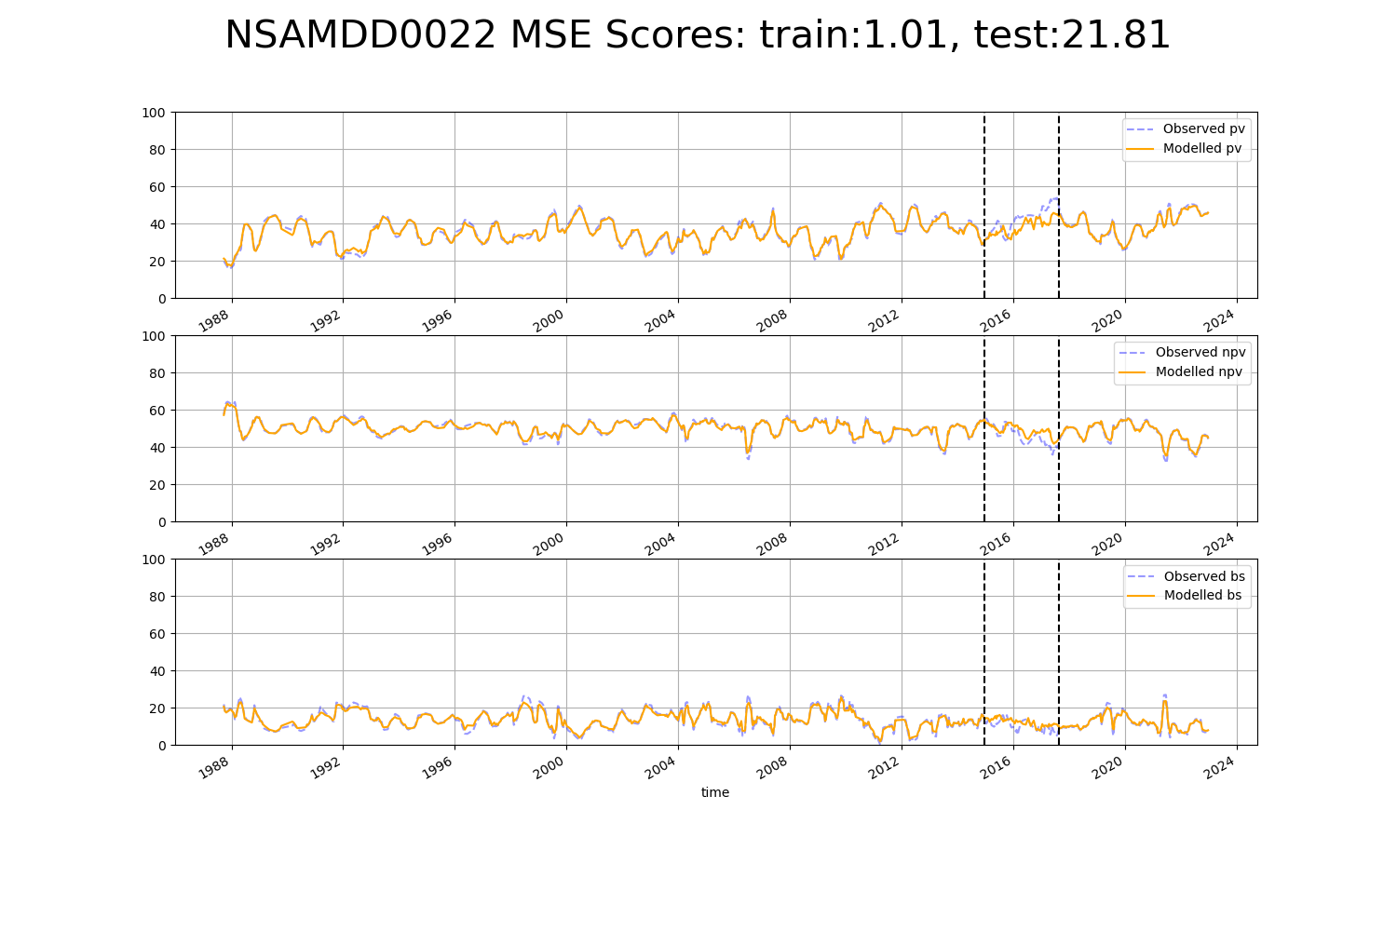

# NSAMDD0024

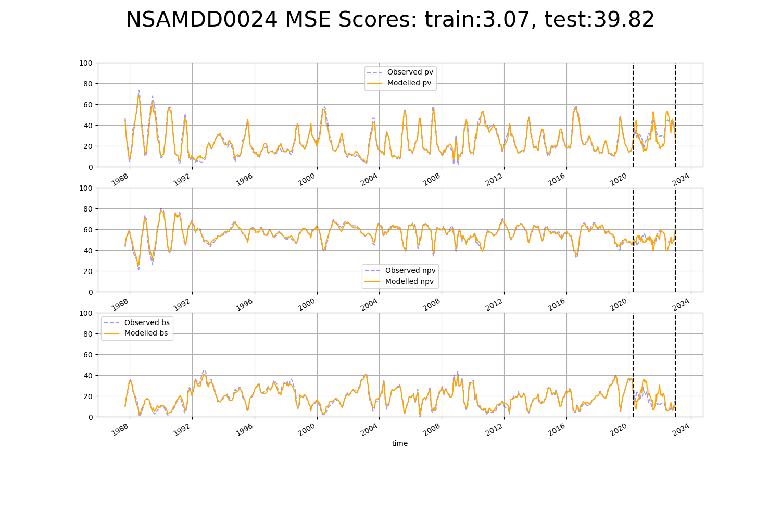

# NSAMDD0028

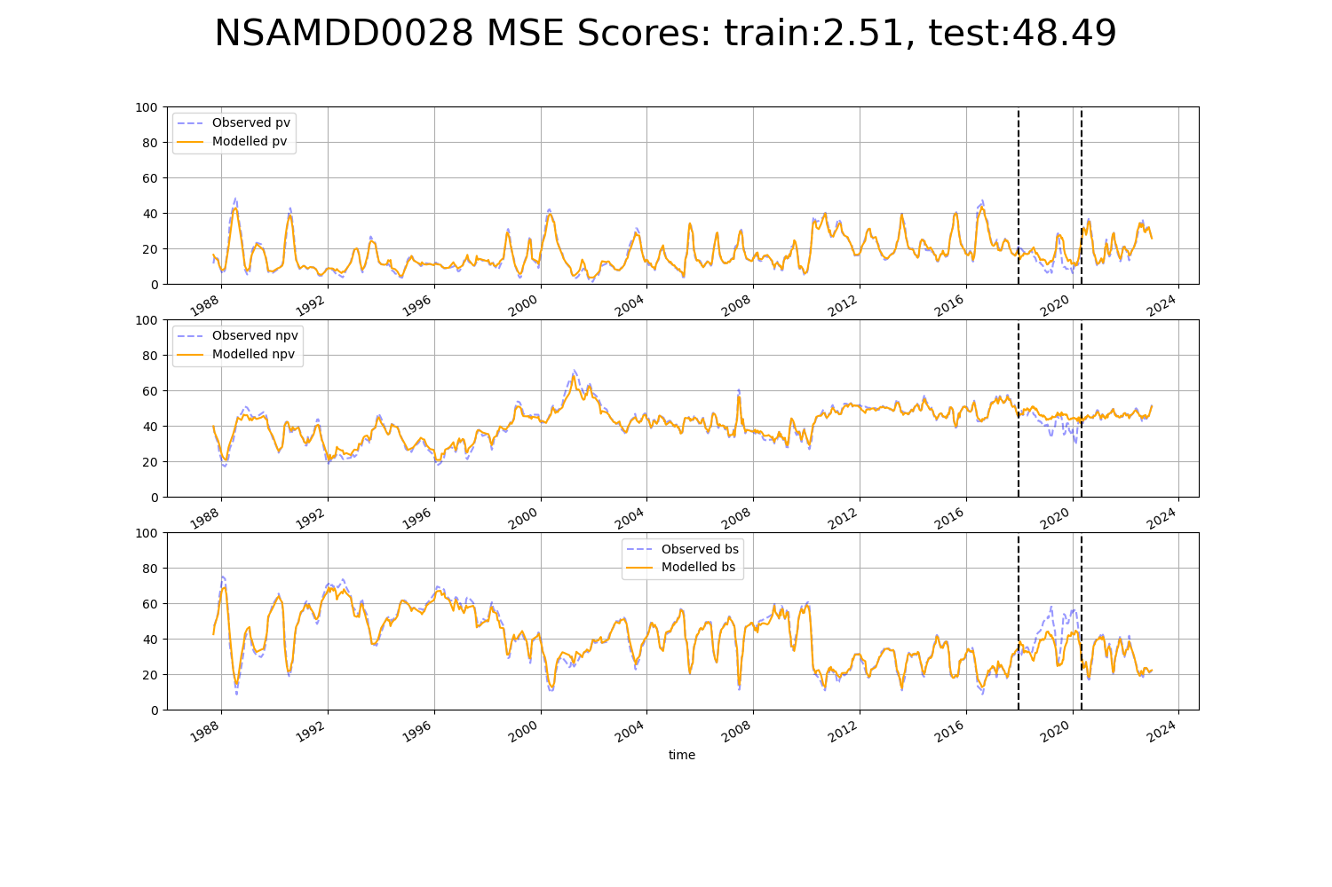

# NSAMDD0029

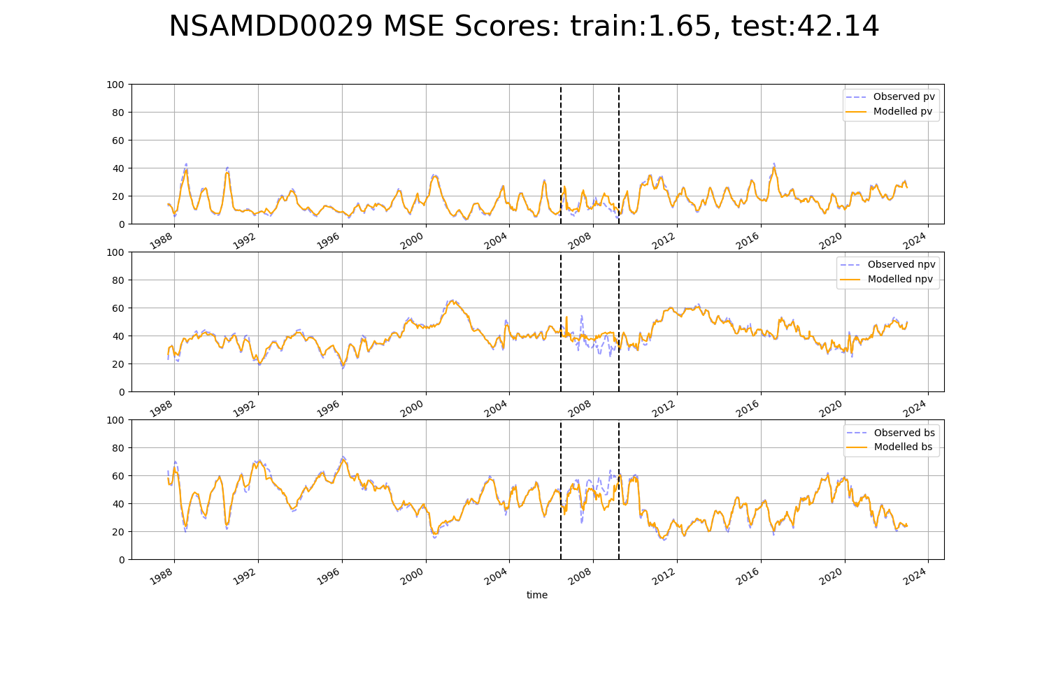

# NSAMDD0031

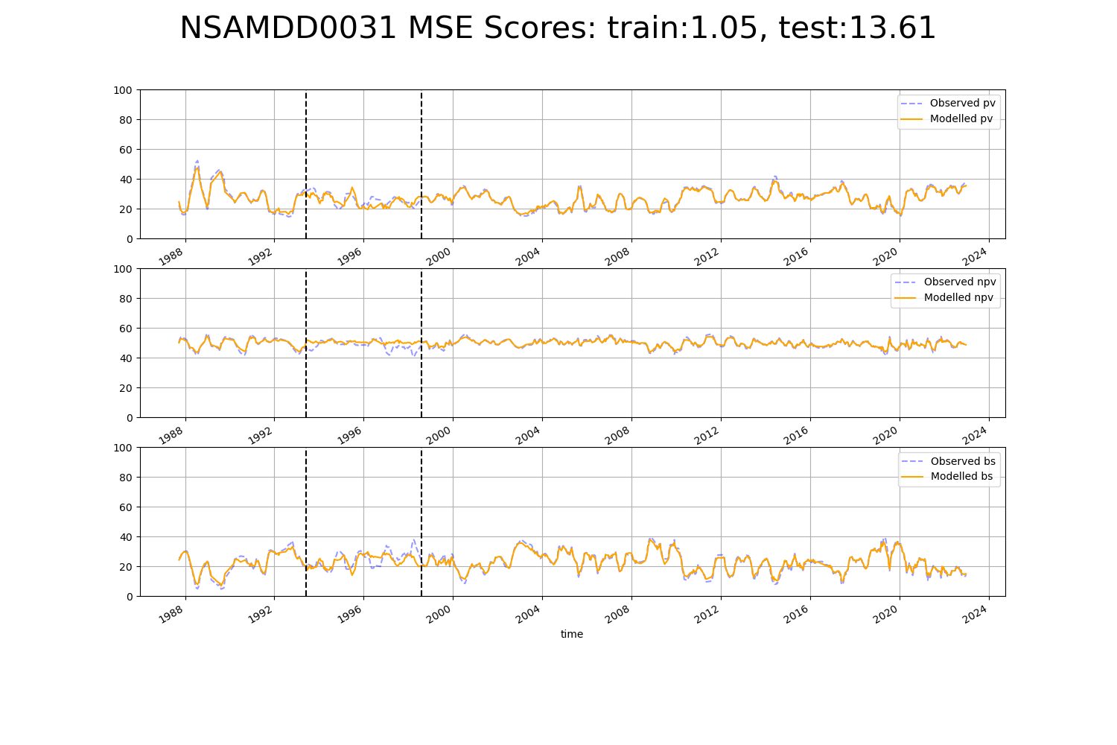

# NSAMUL0001

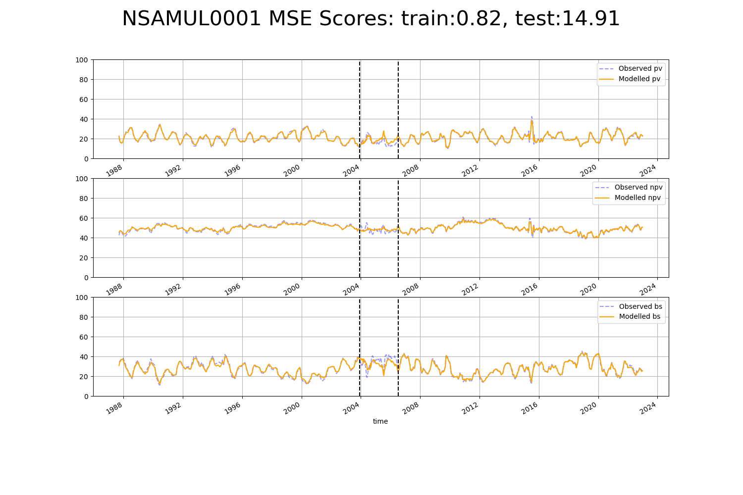

# NTABRT0001

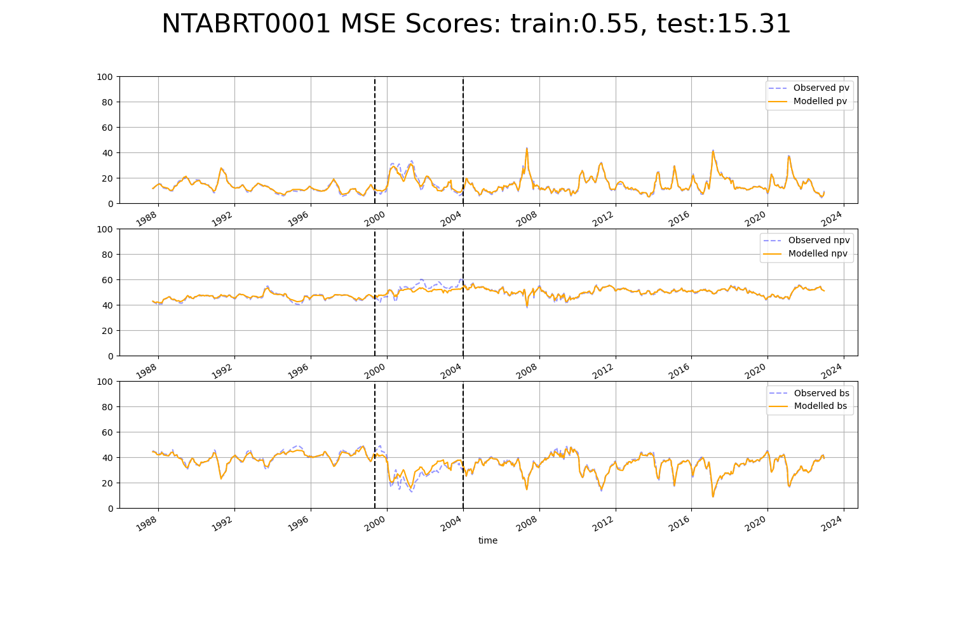

# NTABRT0002

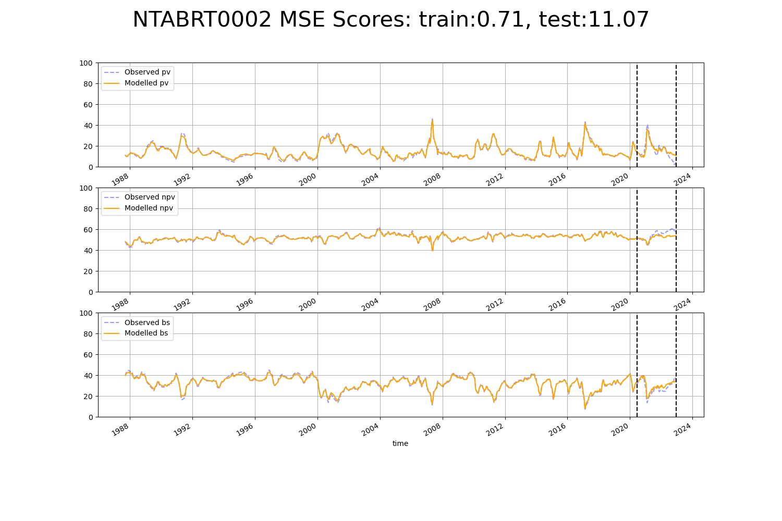

# NTABRT0003

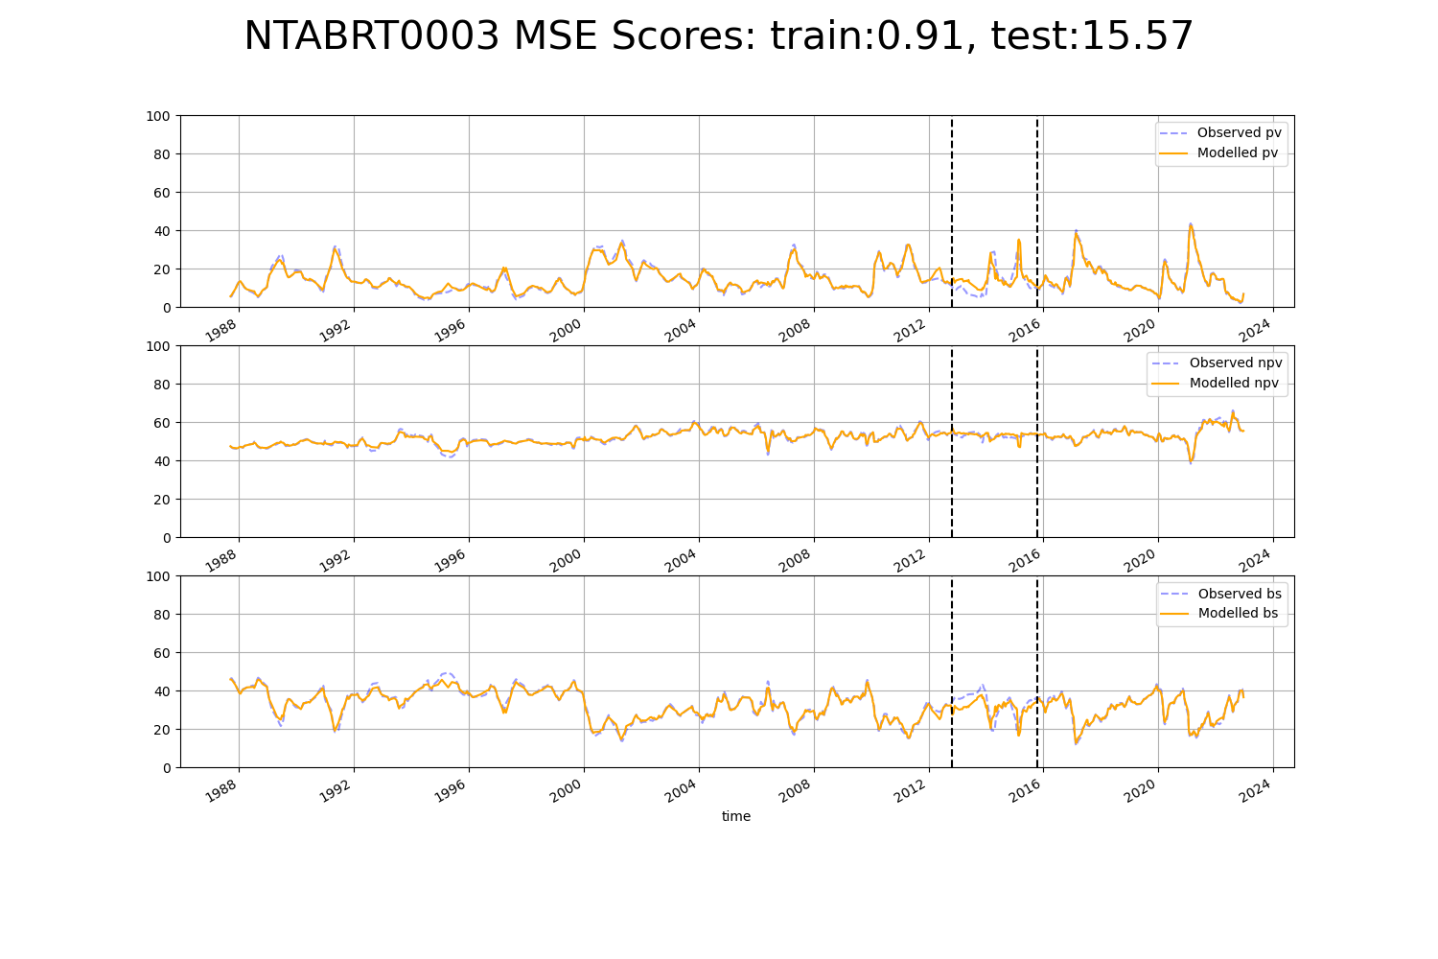

# NTABRT0004

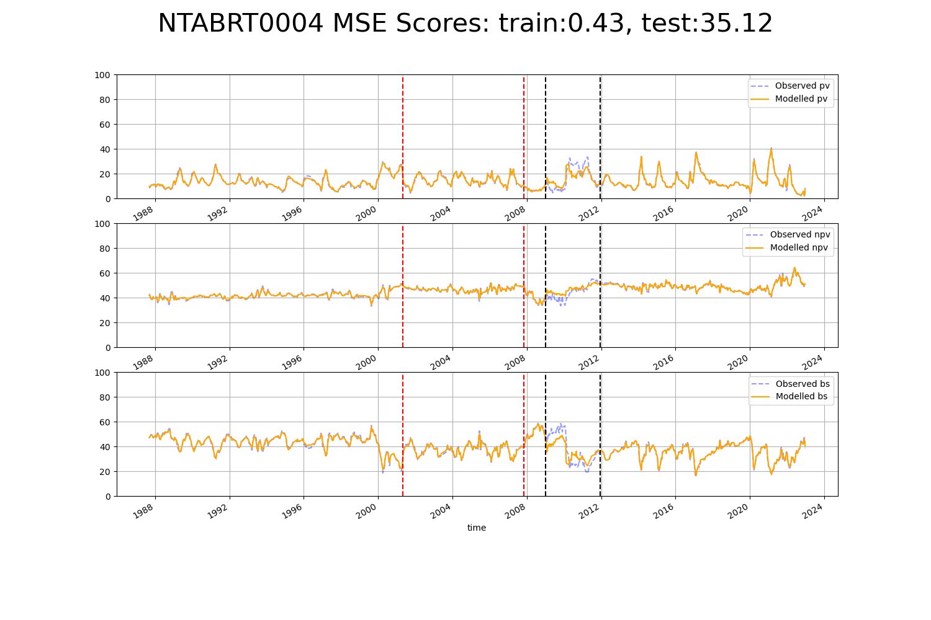

# NTABRT0006

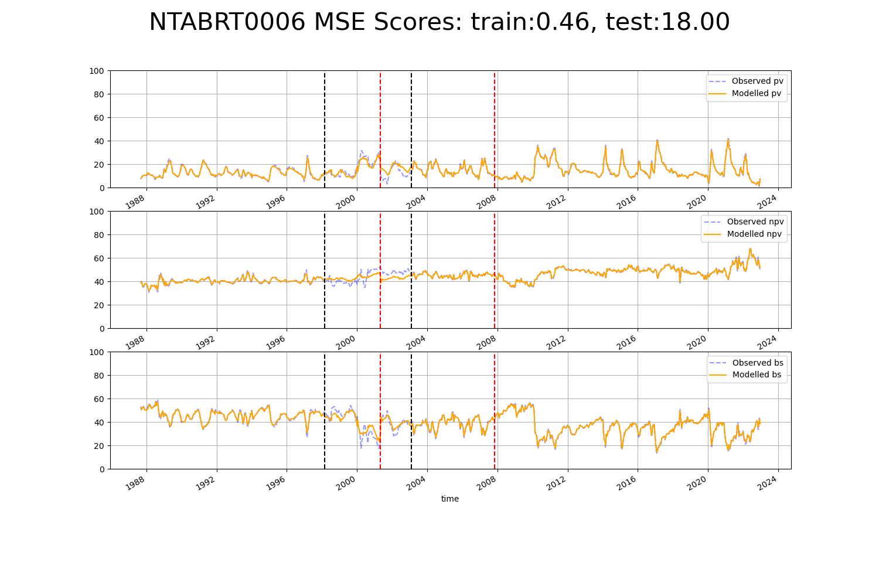

# NTABRT0008

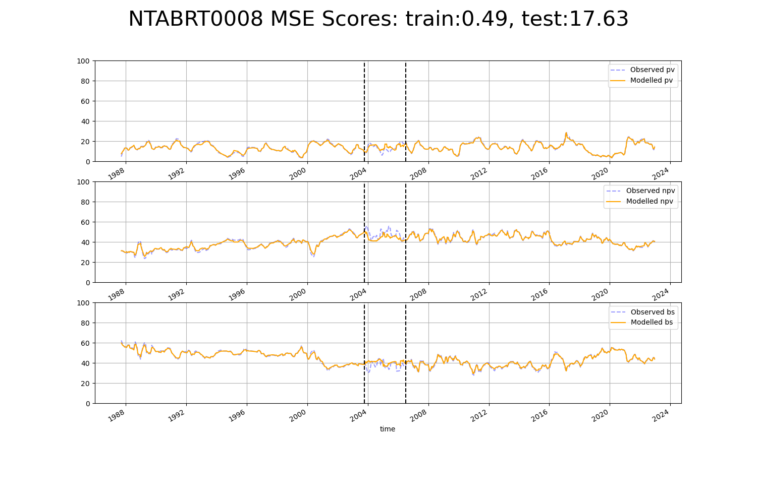

# NTAFIN0004

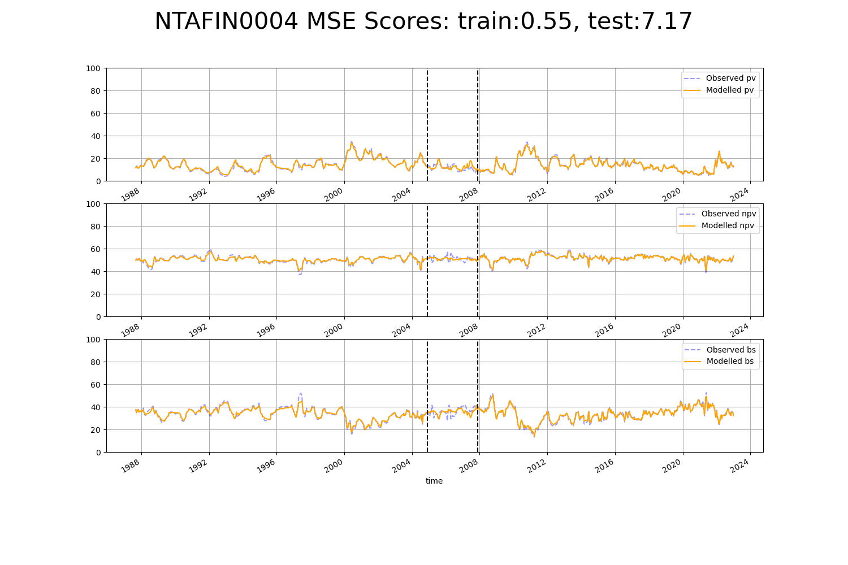

# NTAFIN0009

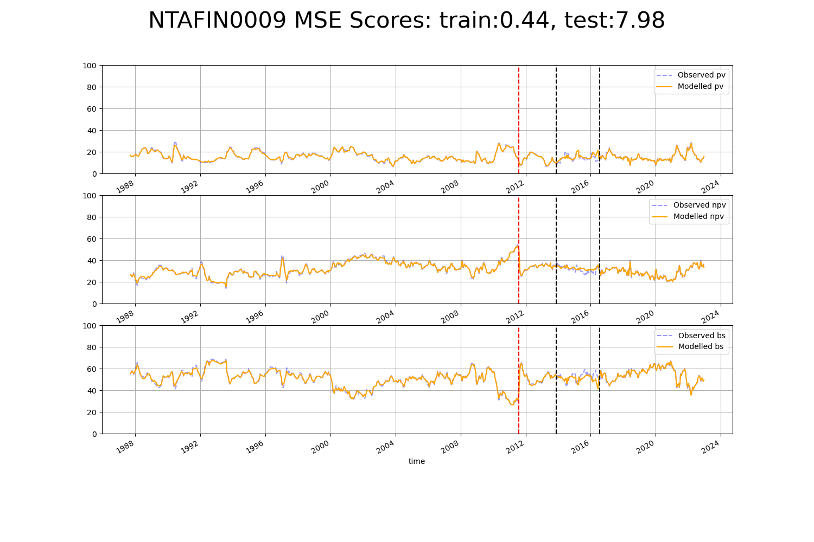

# NTAFIN0011

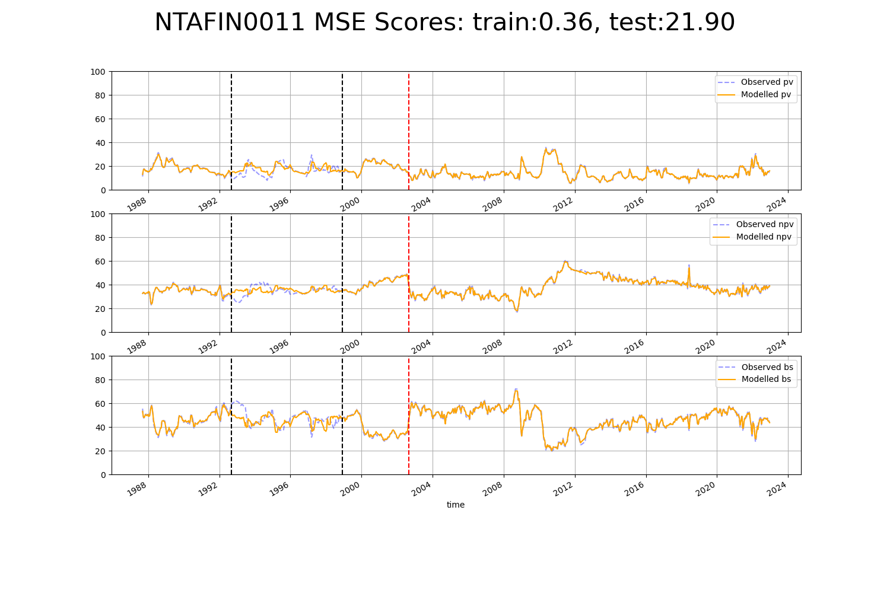

# NTAFIN0018

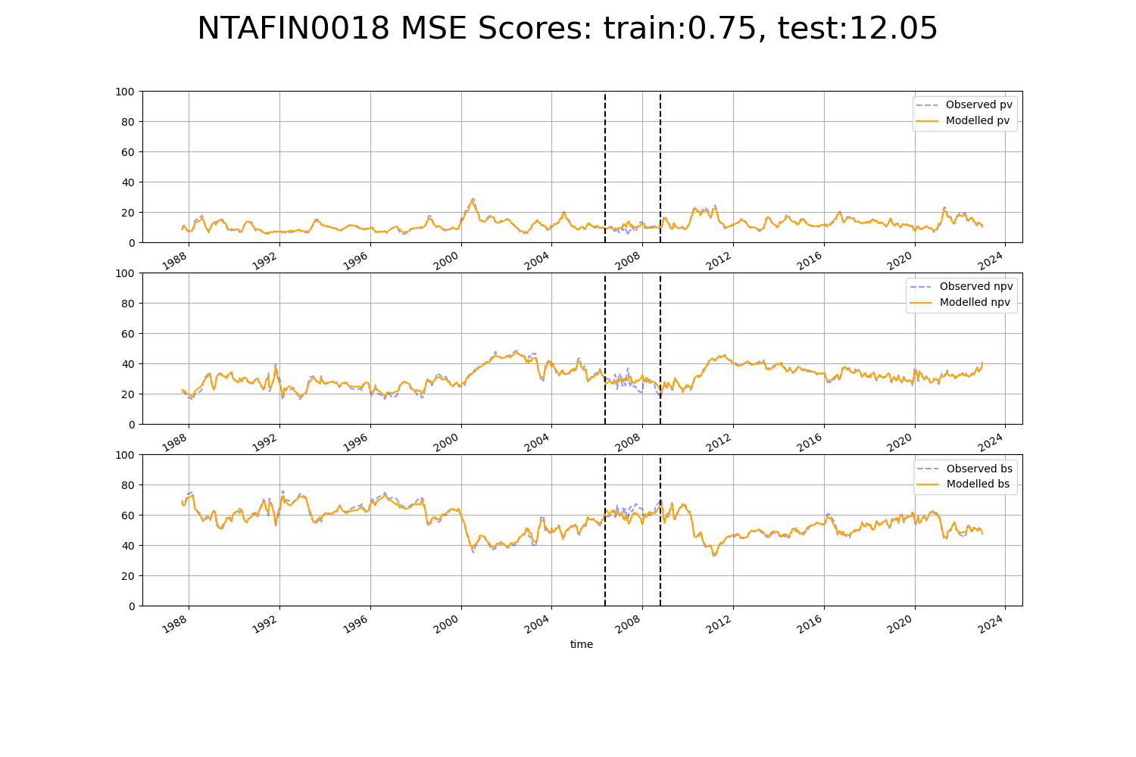

# NTAFIN0022

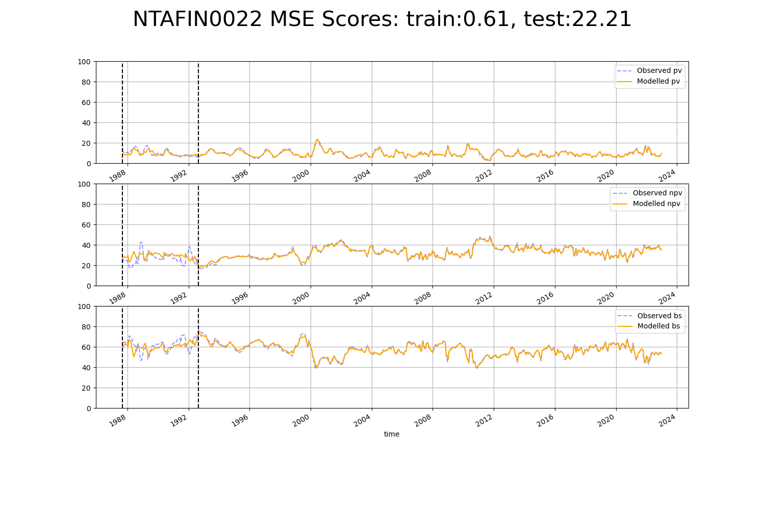

# NTAFIN0030

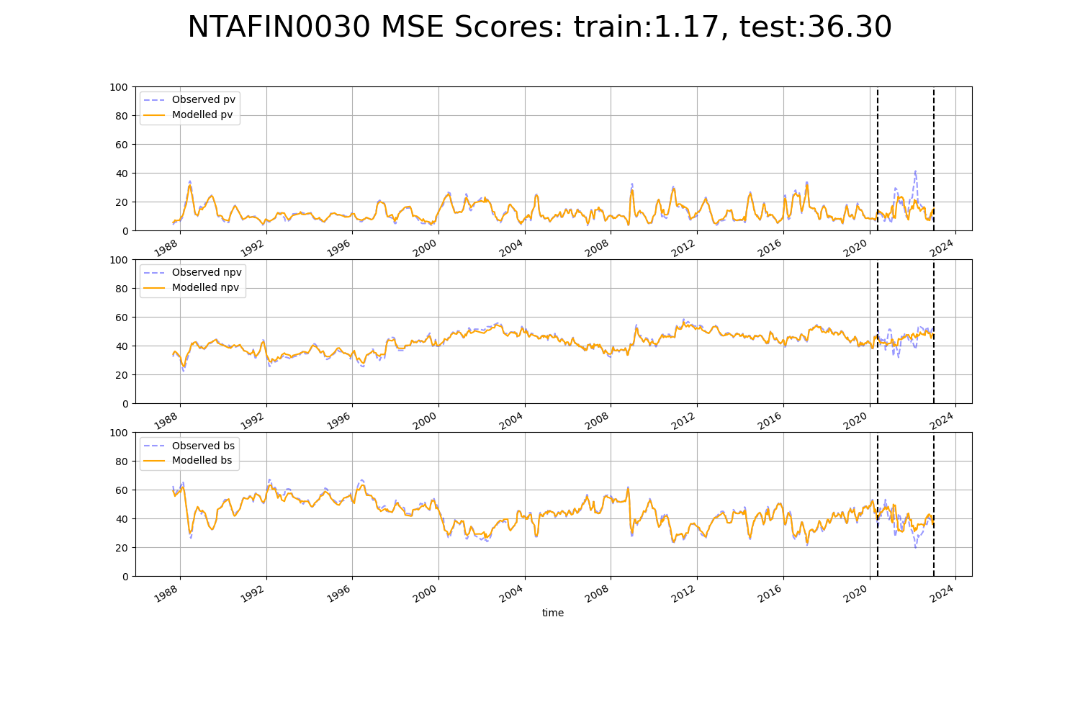

# NTAFIN0031

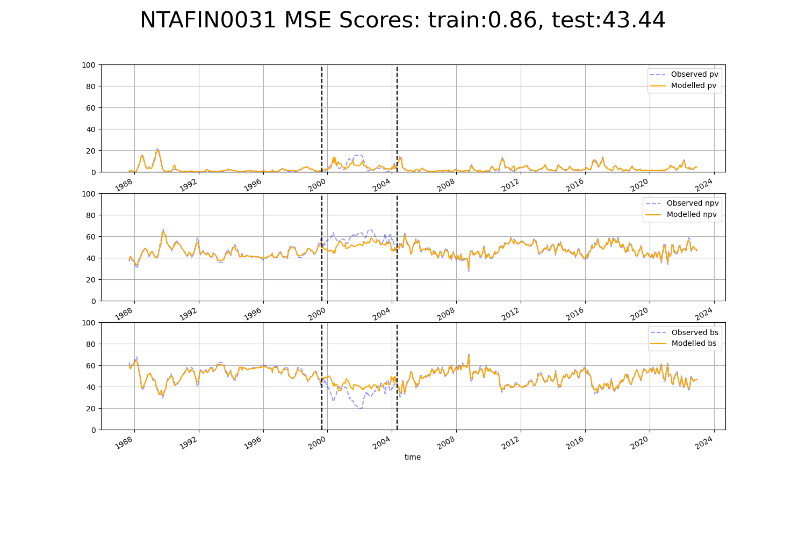

# NTAFIN0032

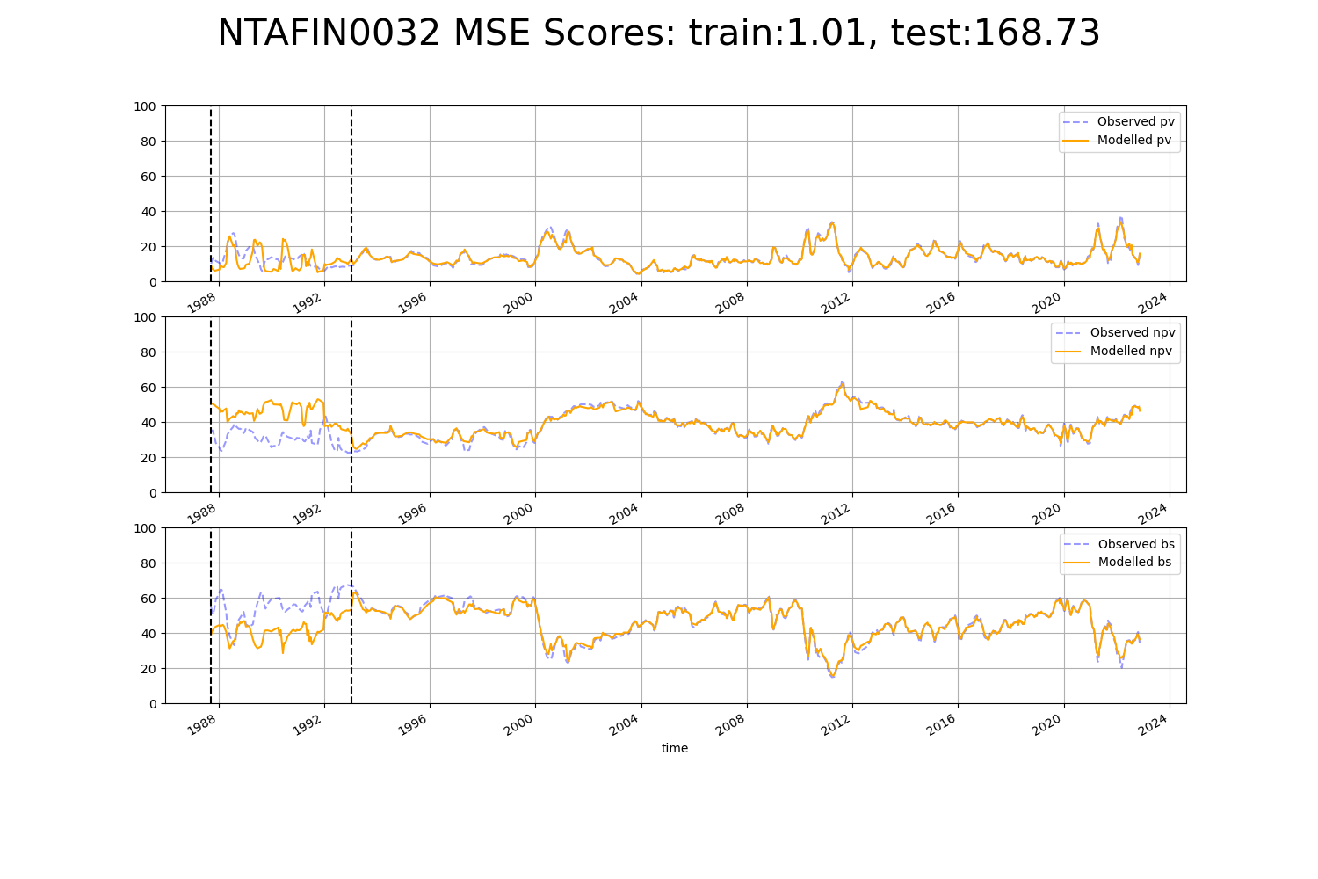

# NTAGFU0021

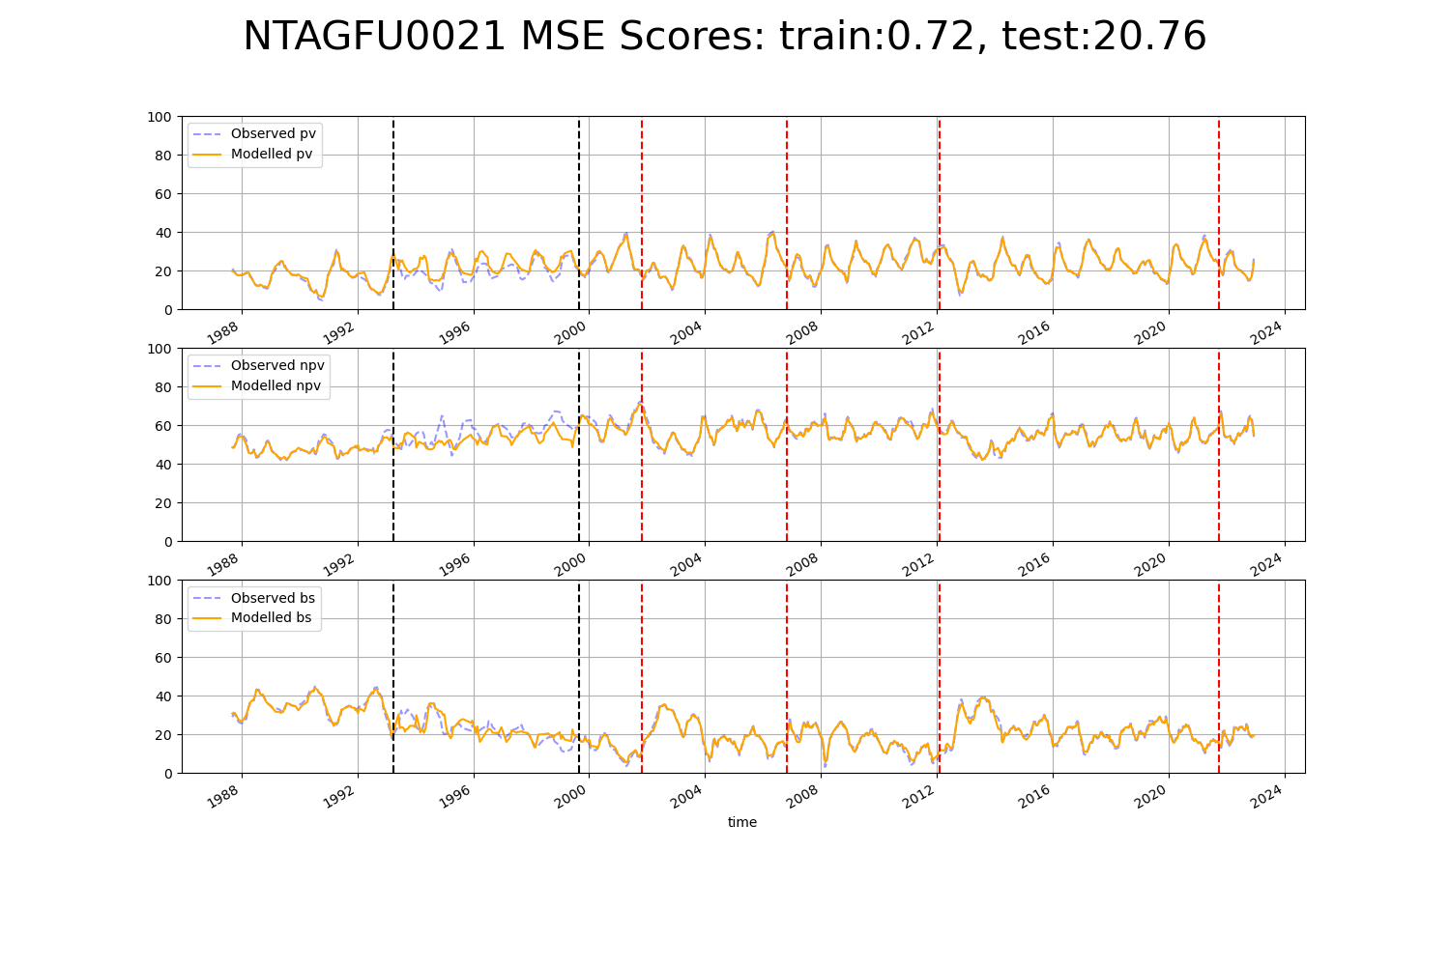

# NTAGFU0023

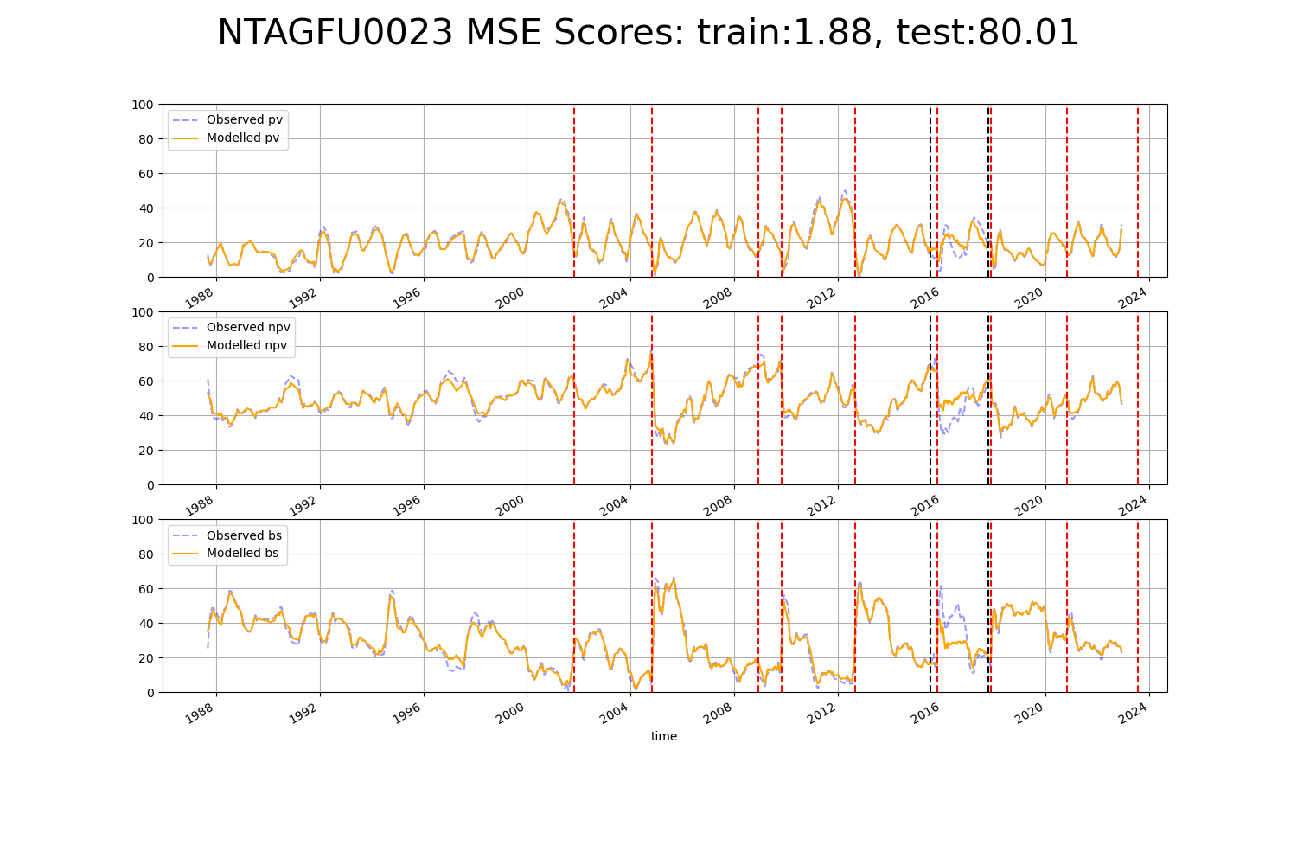

# NTAGFU0025

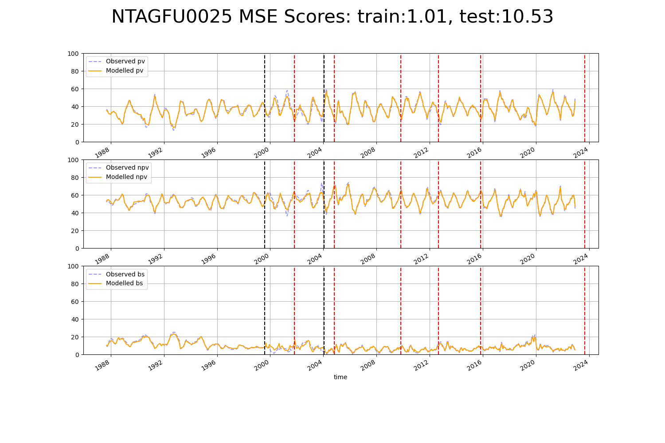

# NTAGFU0031

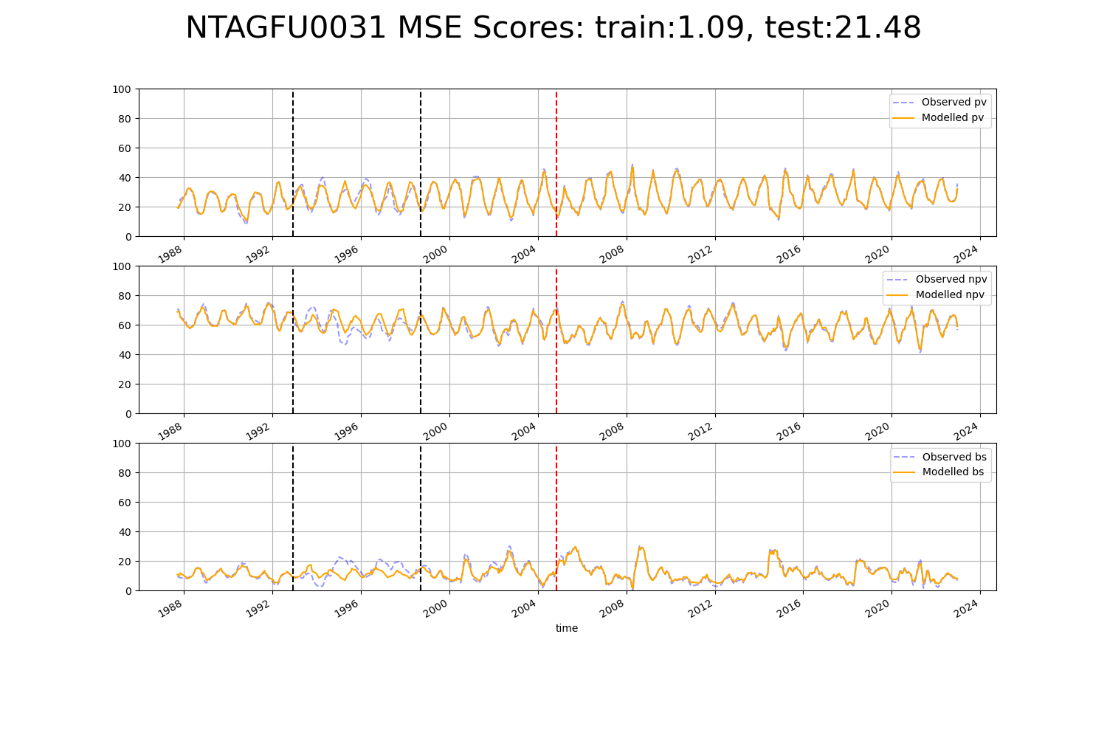

# NTAGFU0040

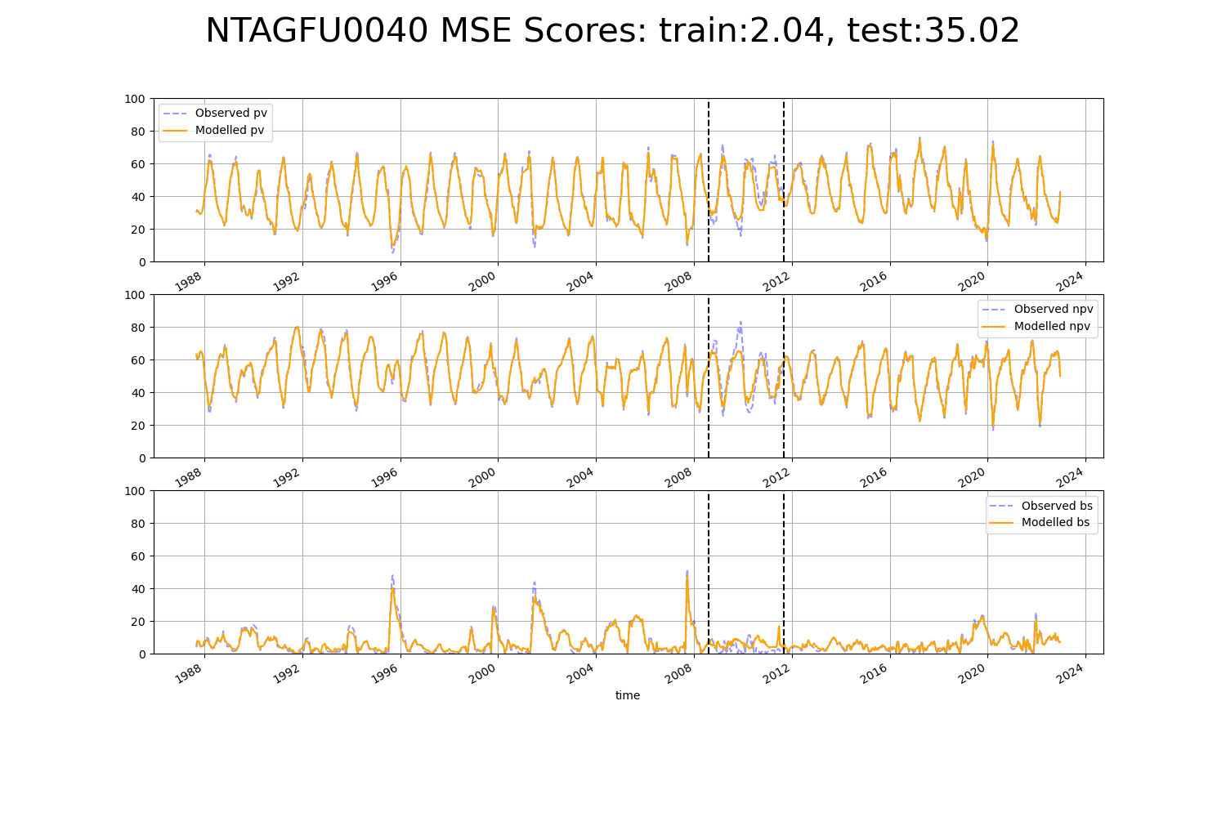

# NTAMGD0005

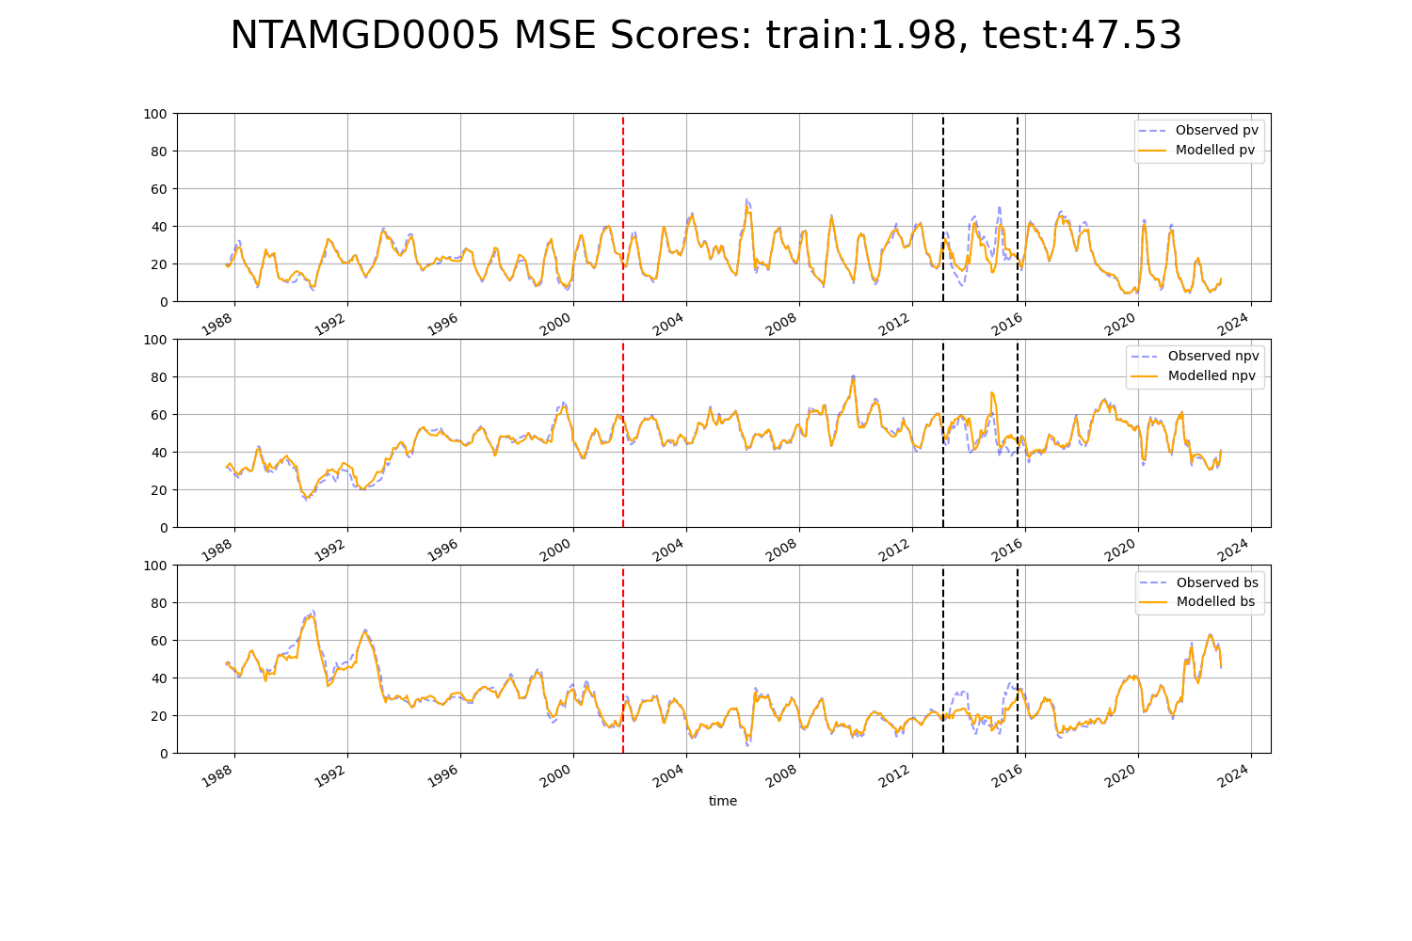

# NTASSD0004

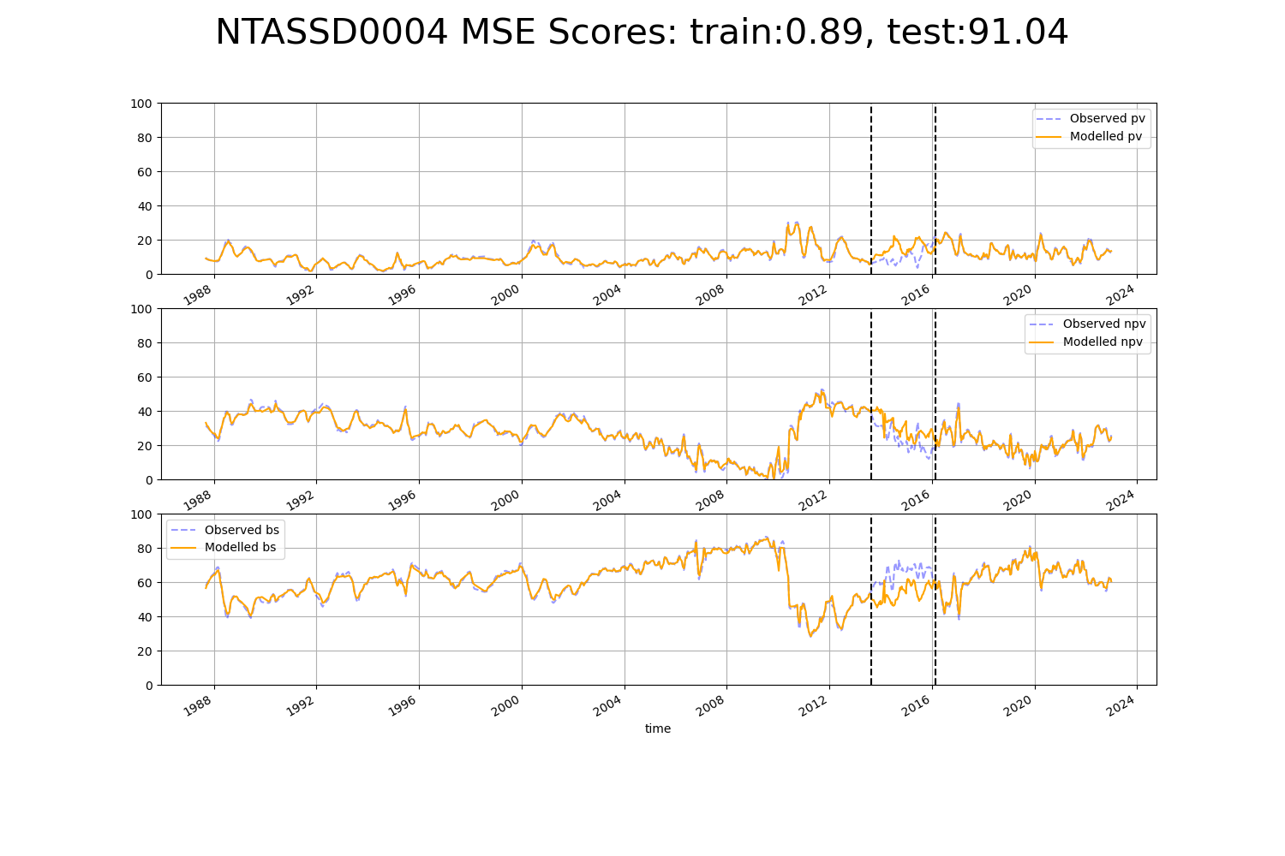

# NTASSD0017

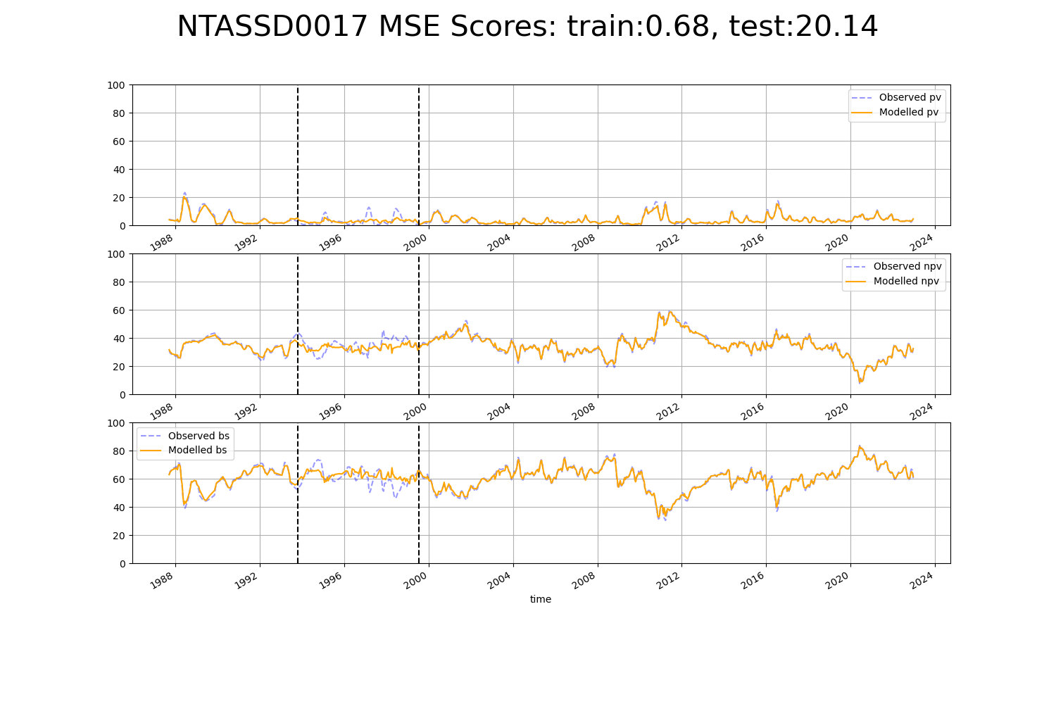

# NTASSD0019

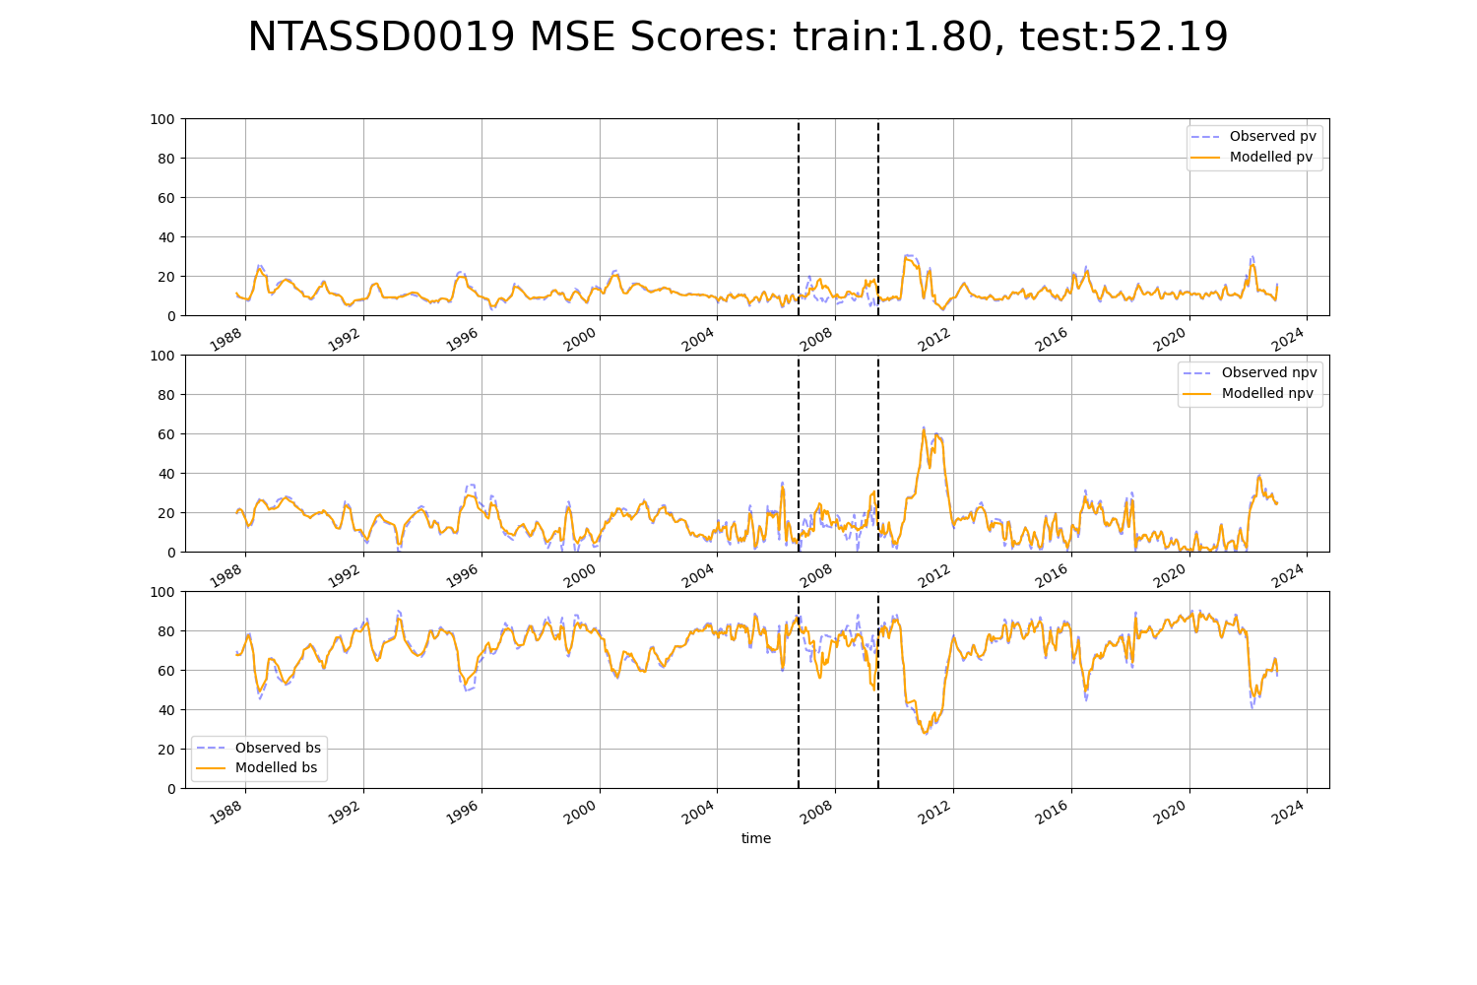

# NTATAN0001

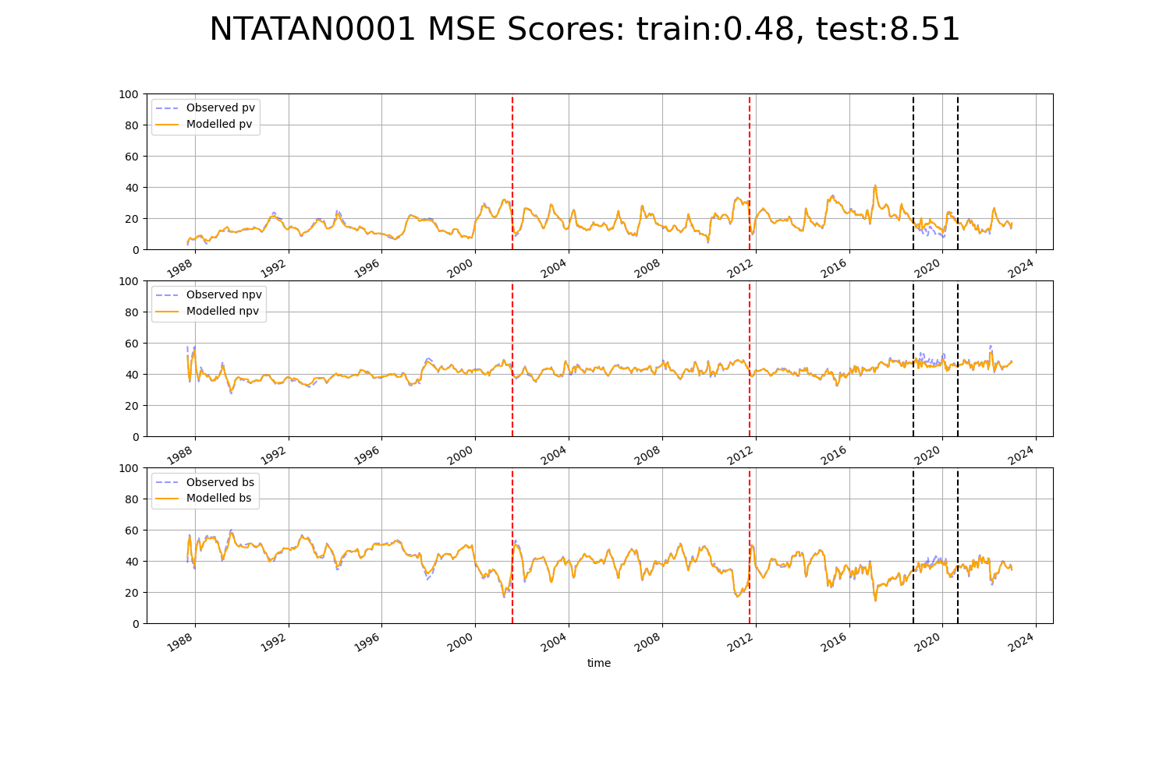

# NTATAN0002

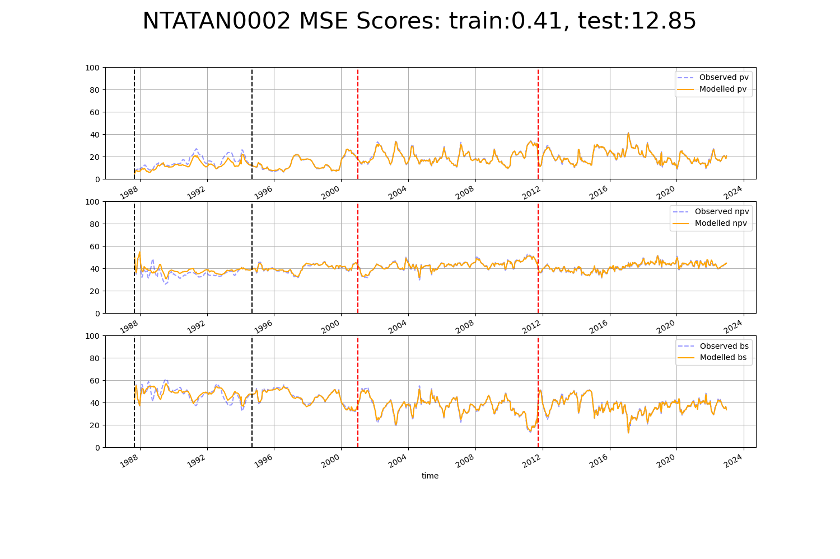

# QDABBN0001

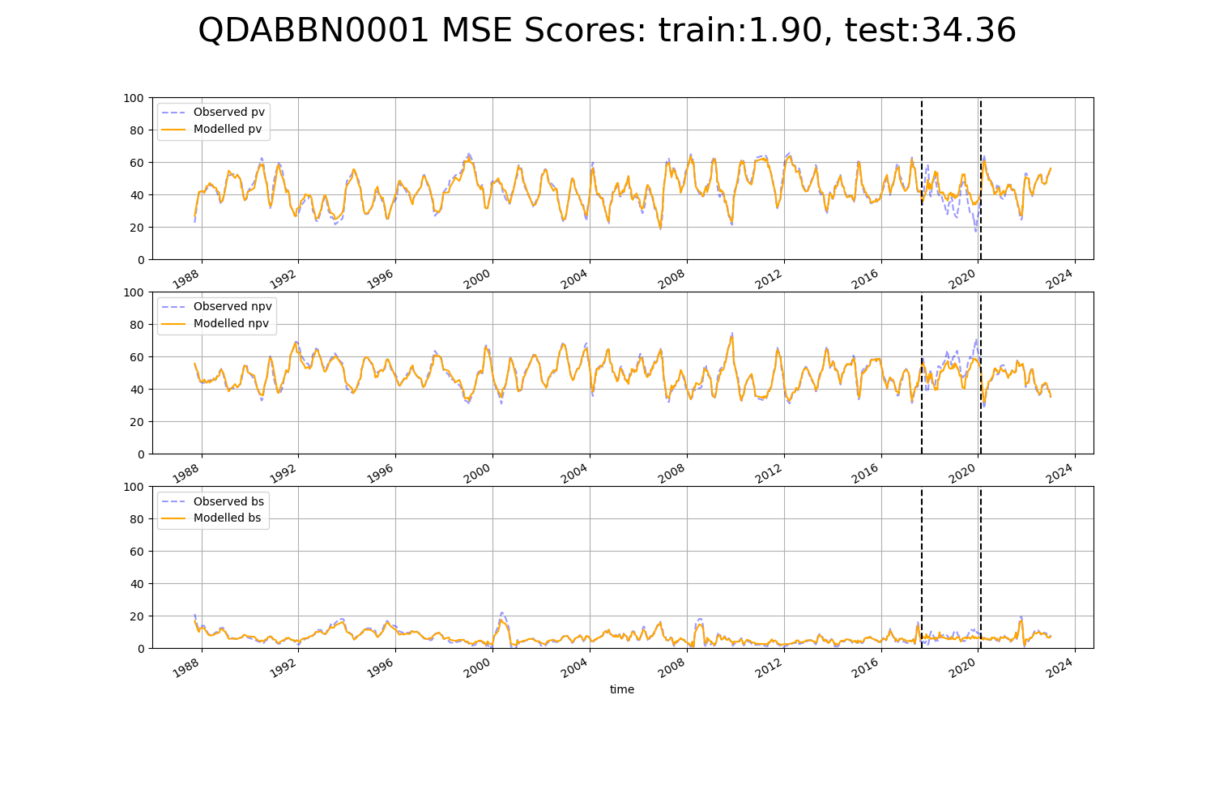

# QDABBS0010

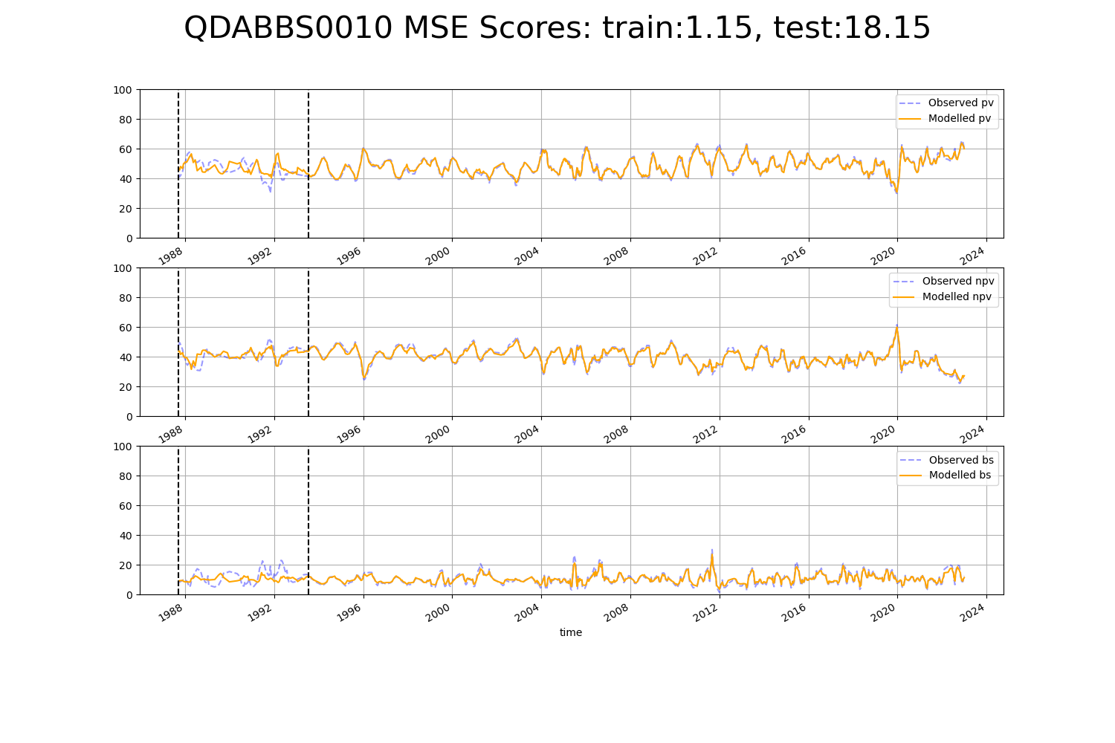

# QDACYP0001

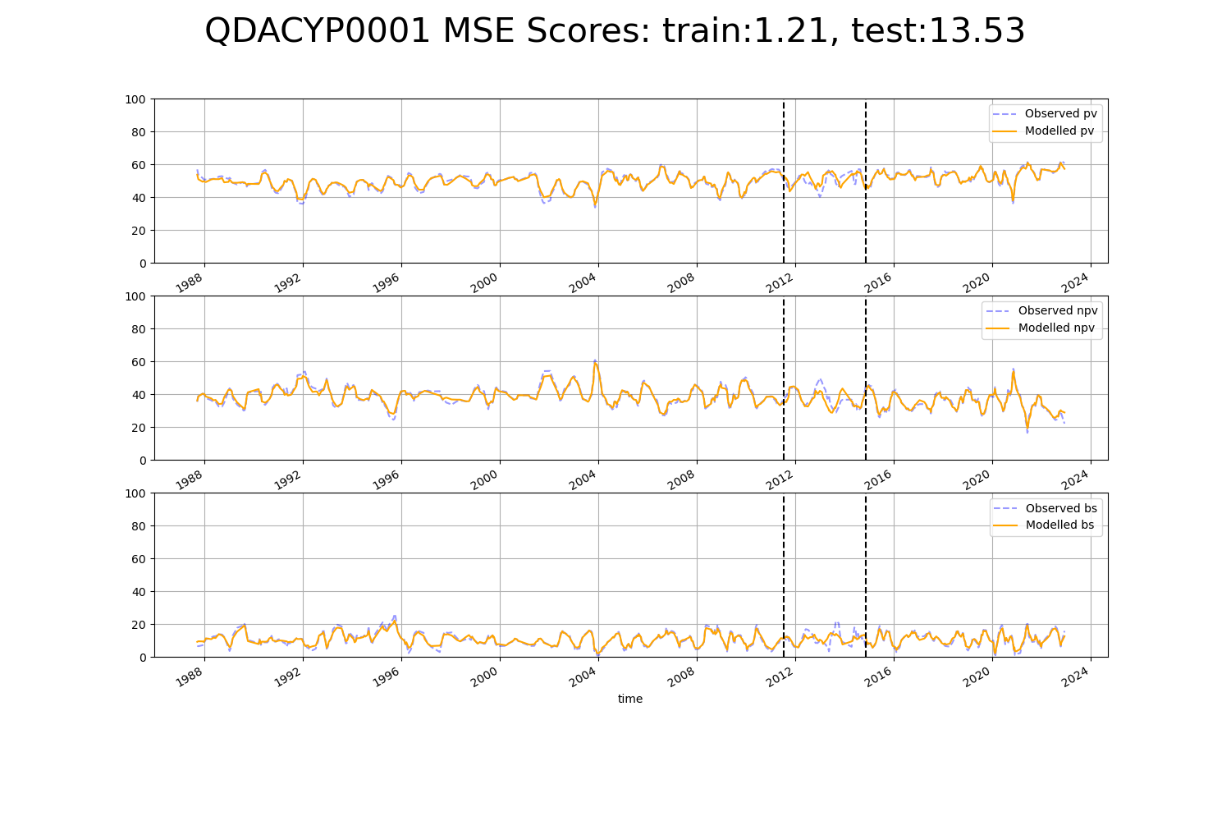

# QDACYP0002

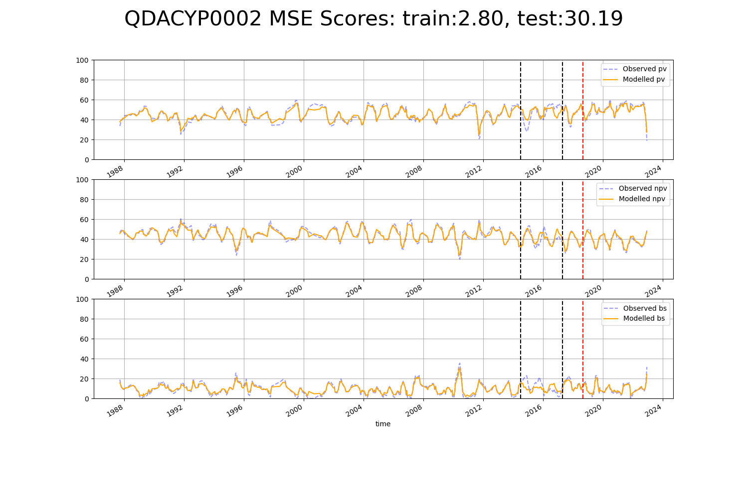

# QDACYP0003

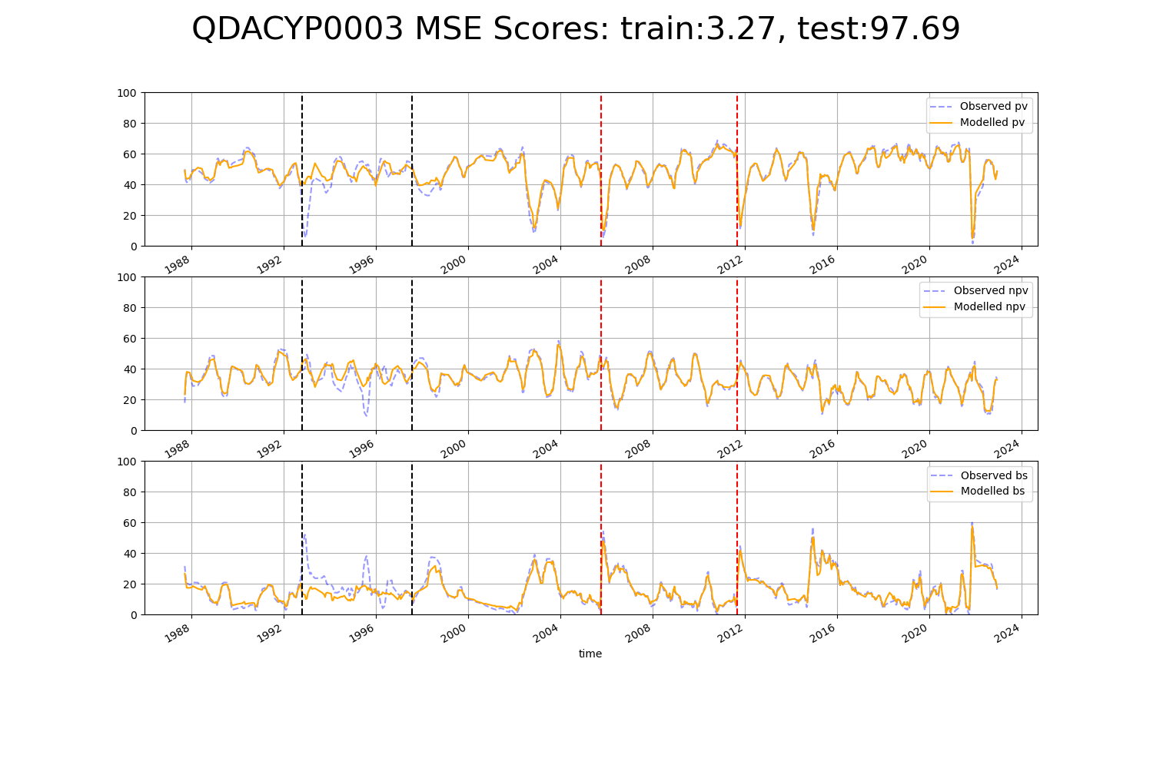

# QDACYP0017

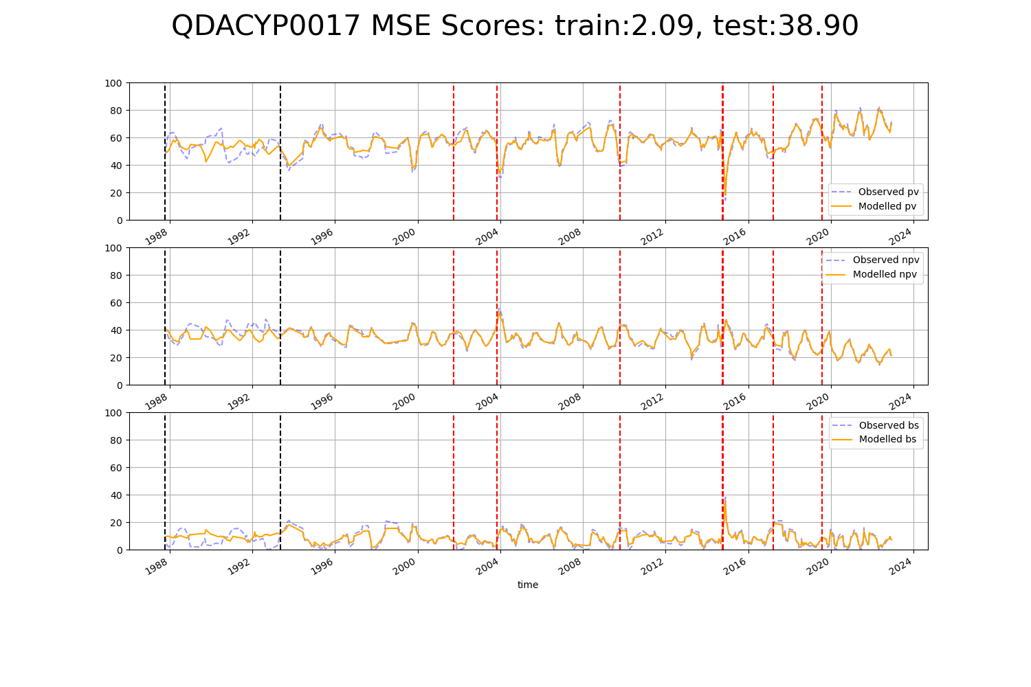

# QDACYP0018

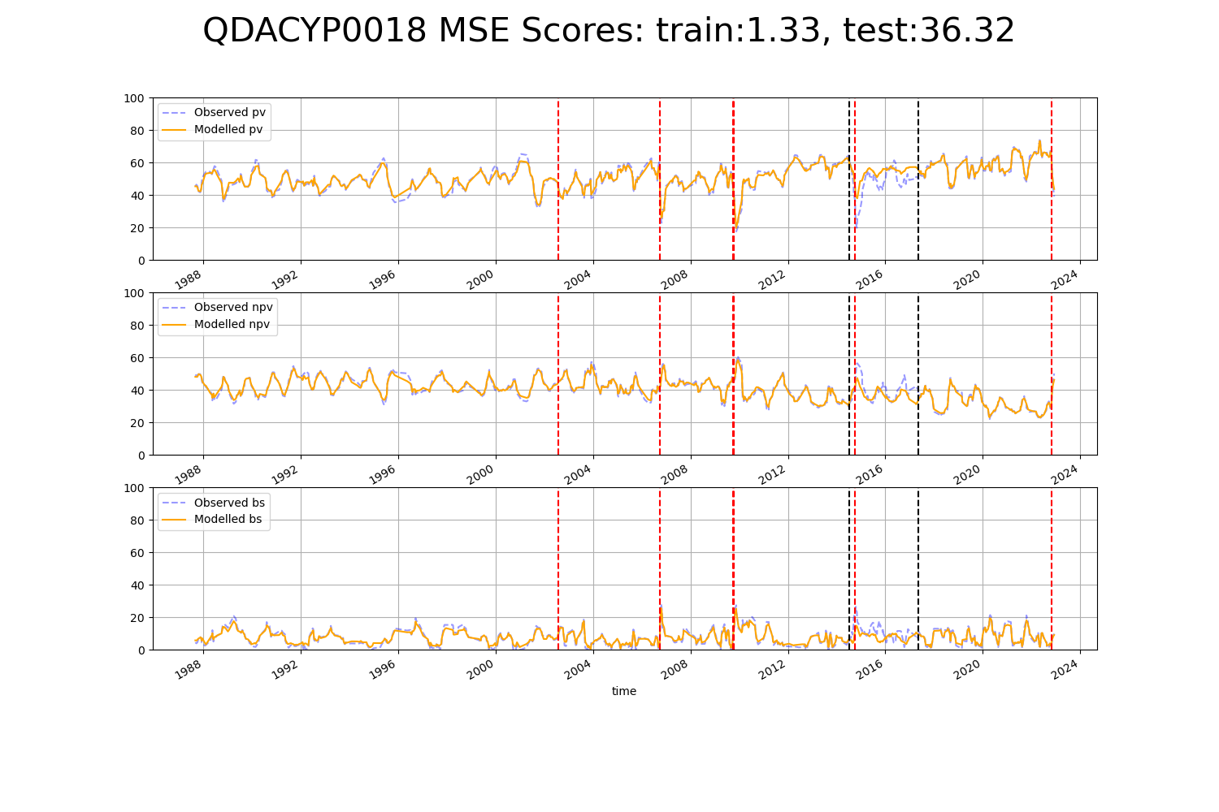

# QDAGUP0001

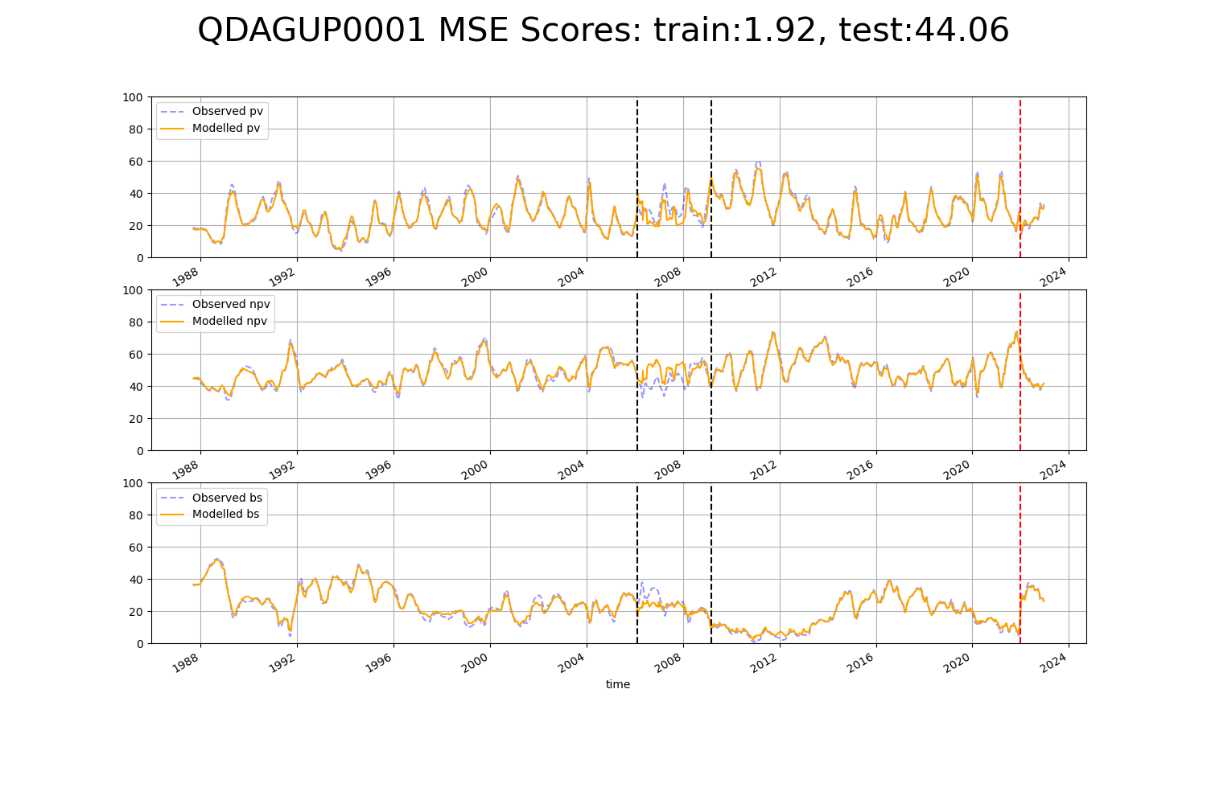

# QDAGUP0010

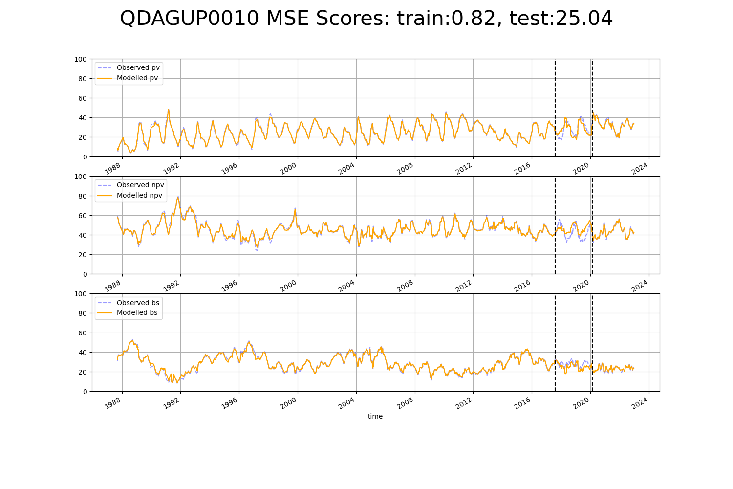

# QDAMGD0010

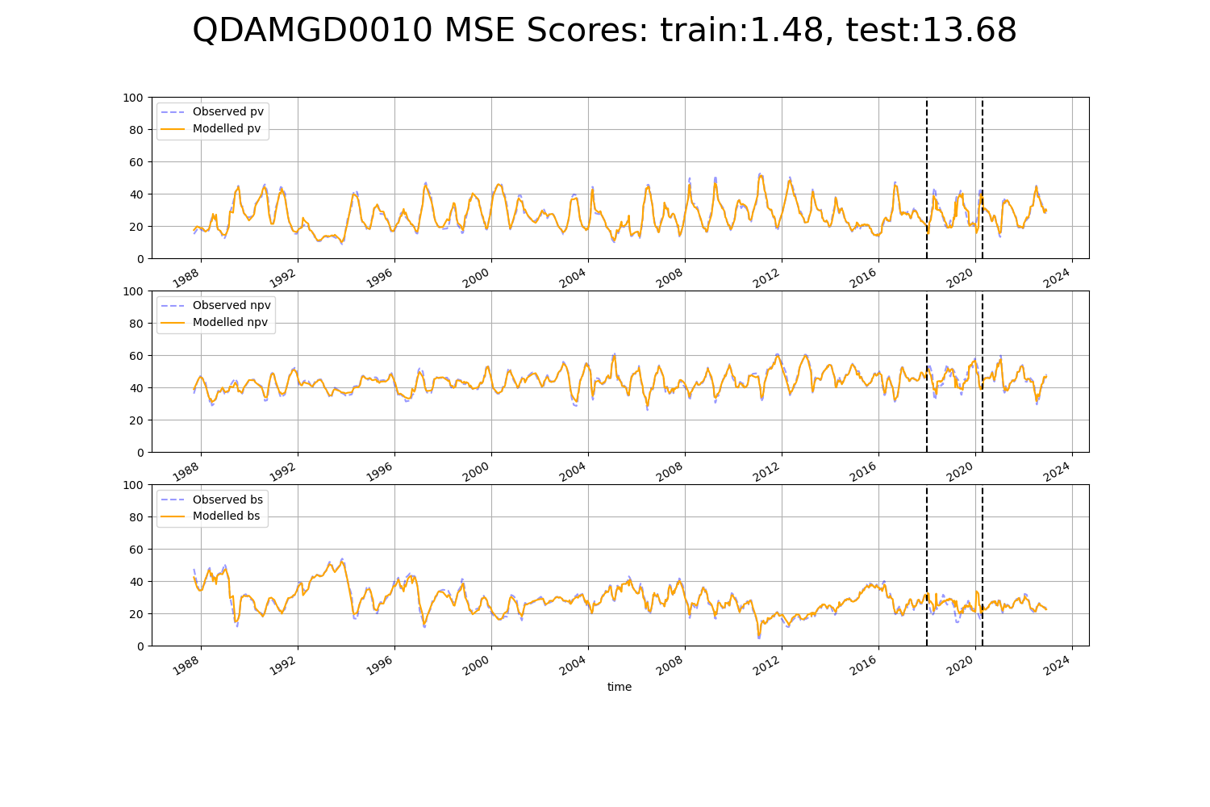

# QDAMGD0012

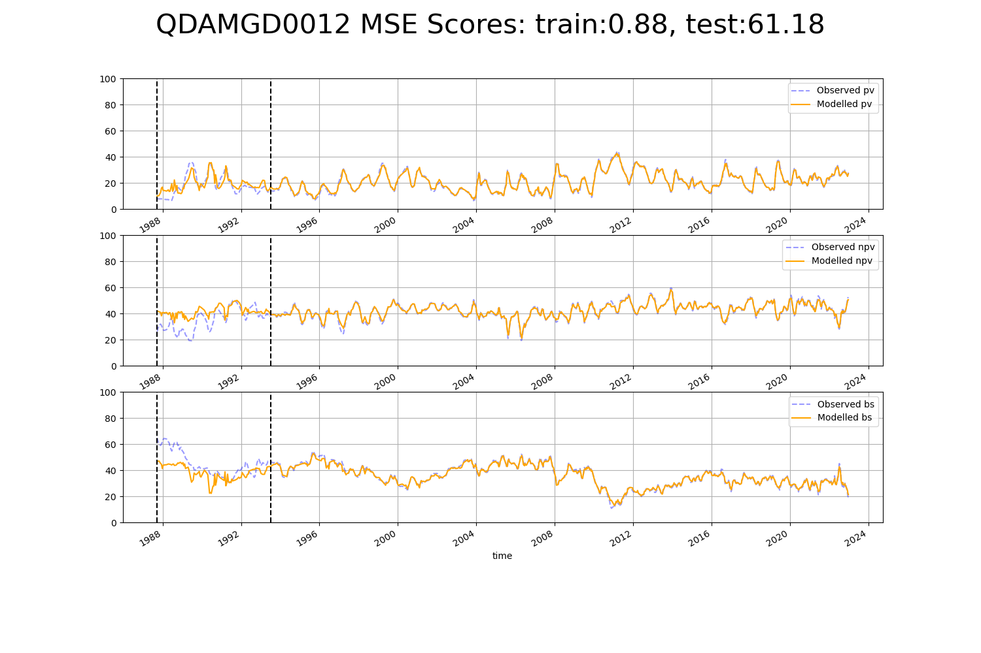

# SAABHC0001

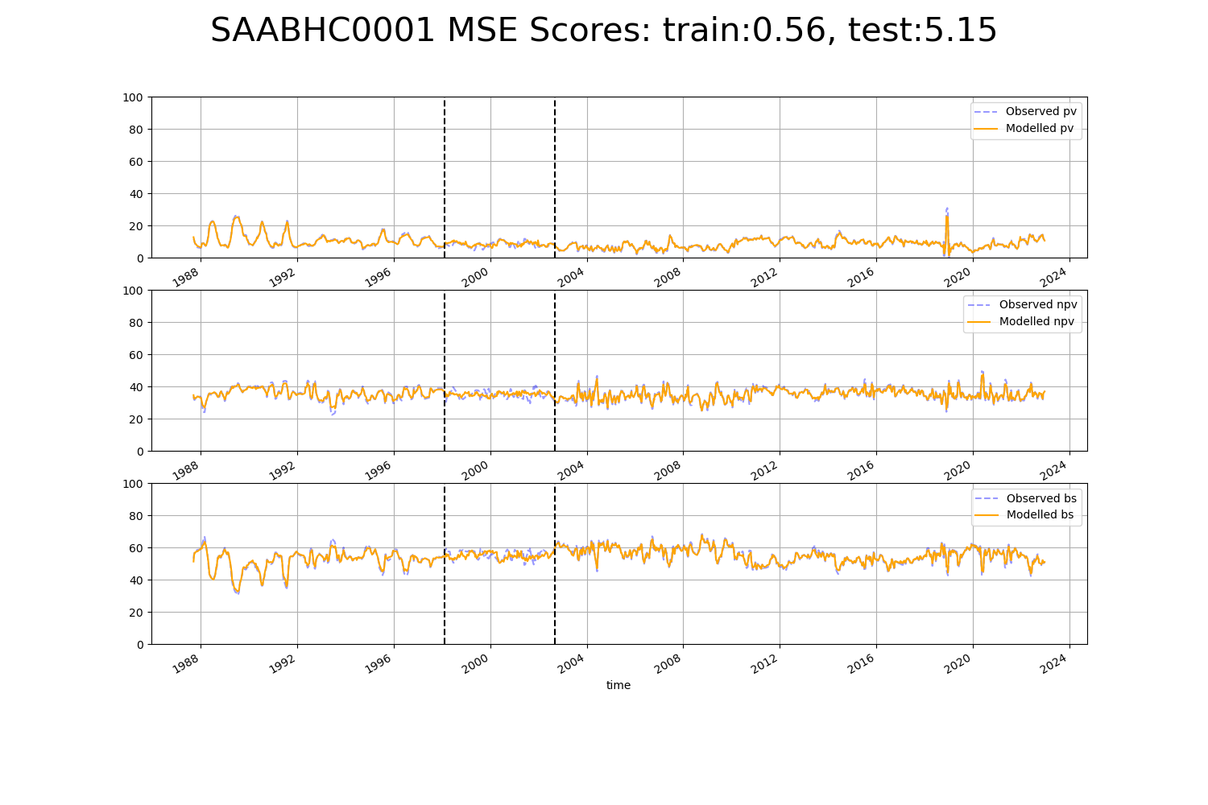

# SAABHC0003

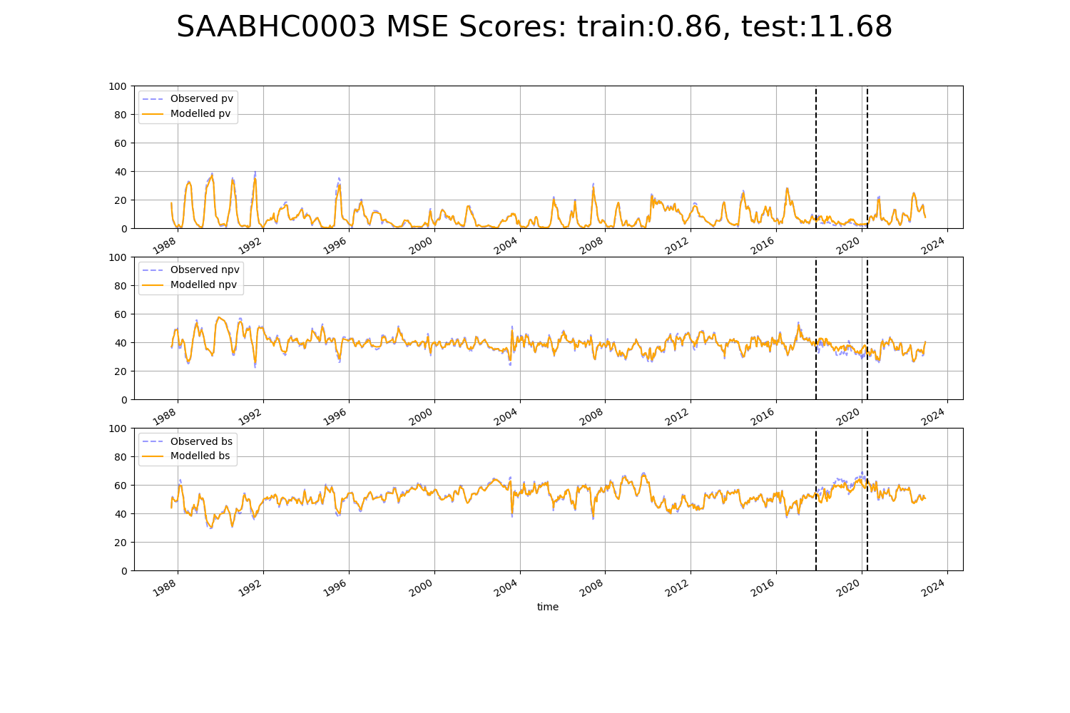

# SAAFLB0005

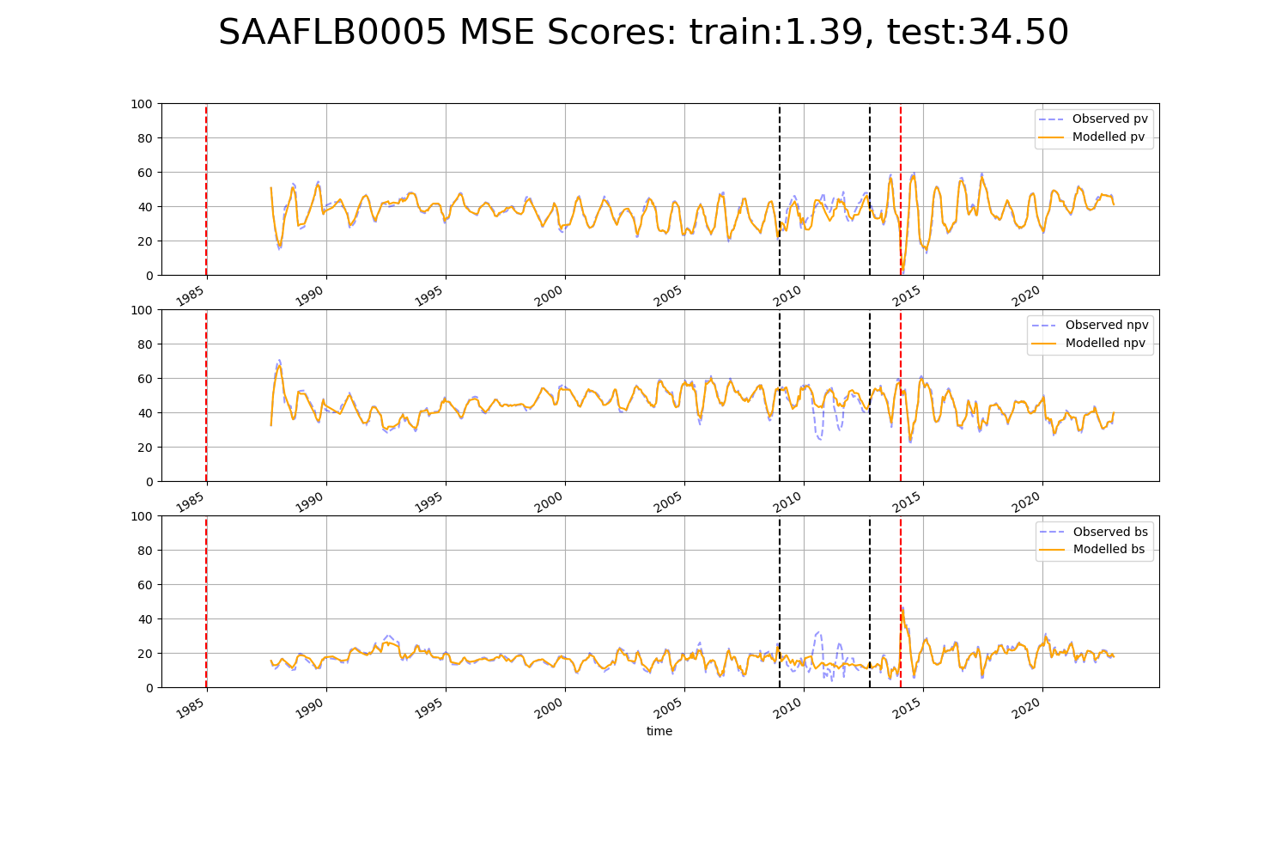

# SAAFLB0006

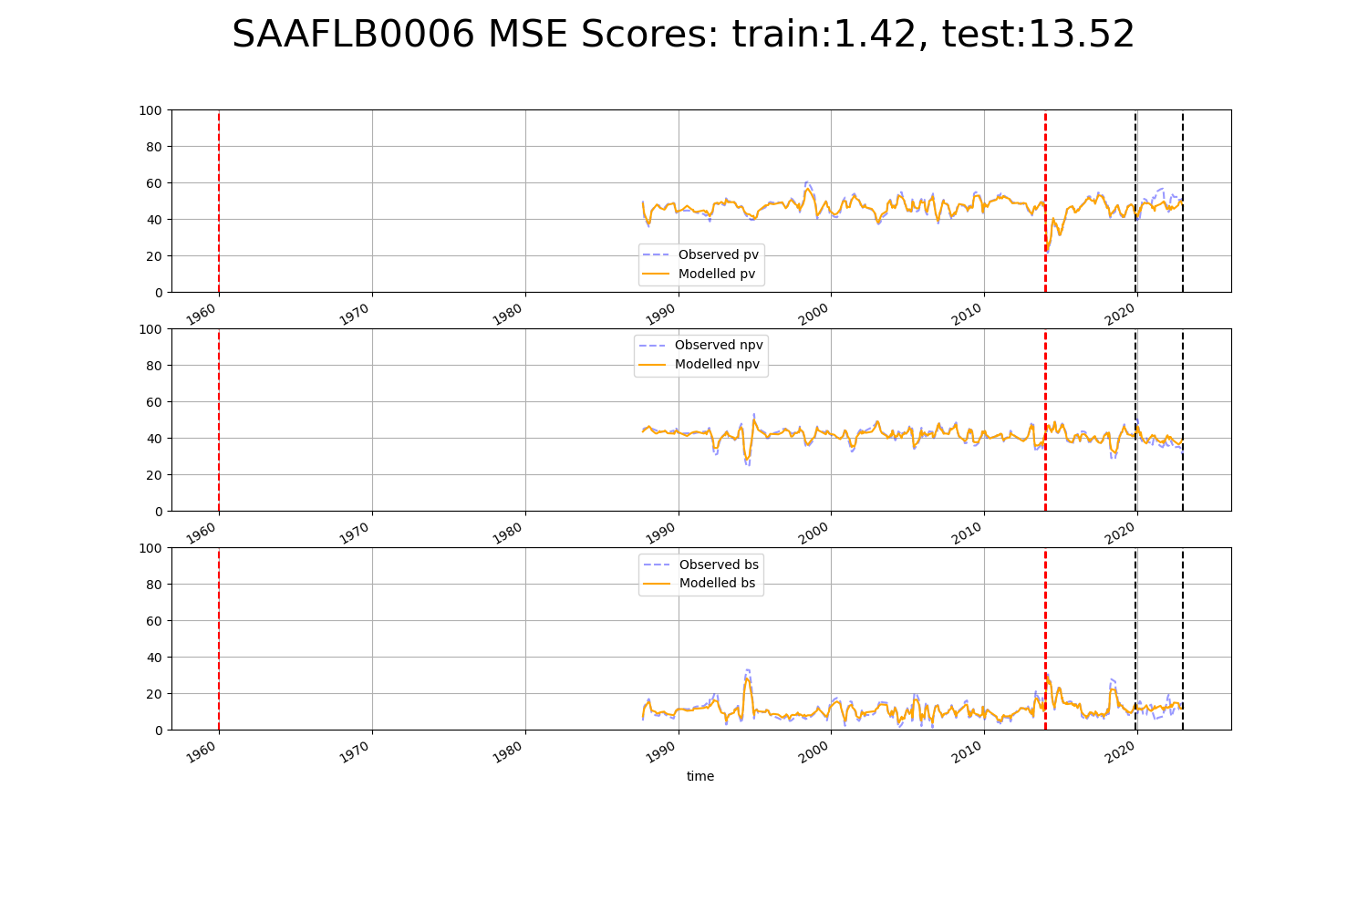

# SAAGAW0003

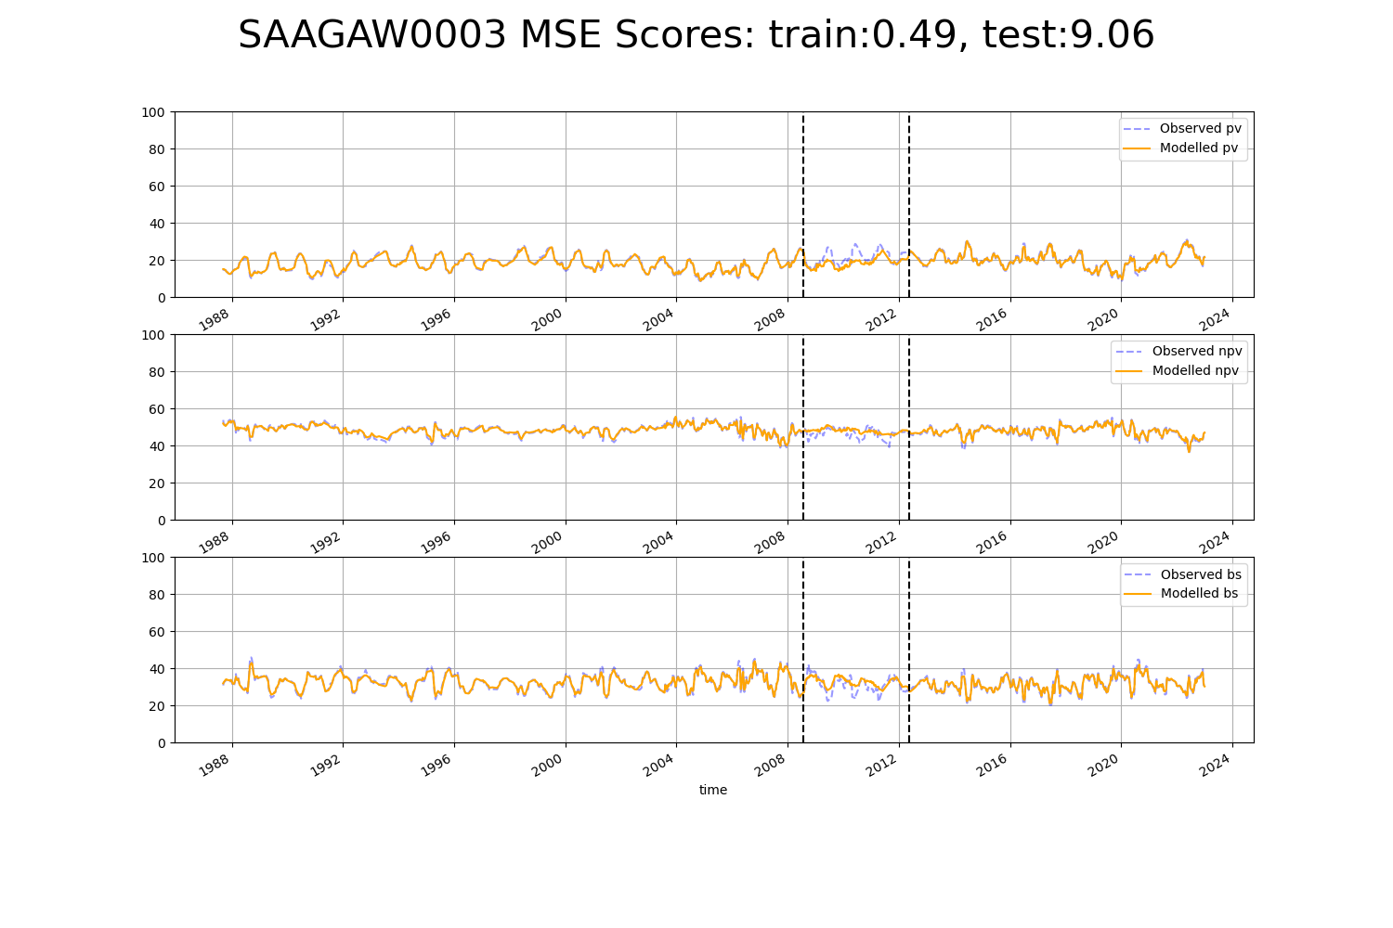

# SAAGAW0005

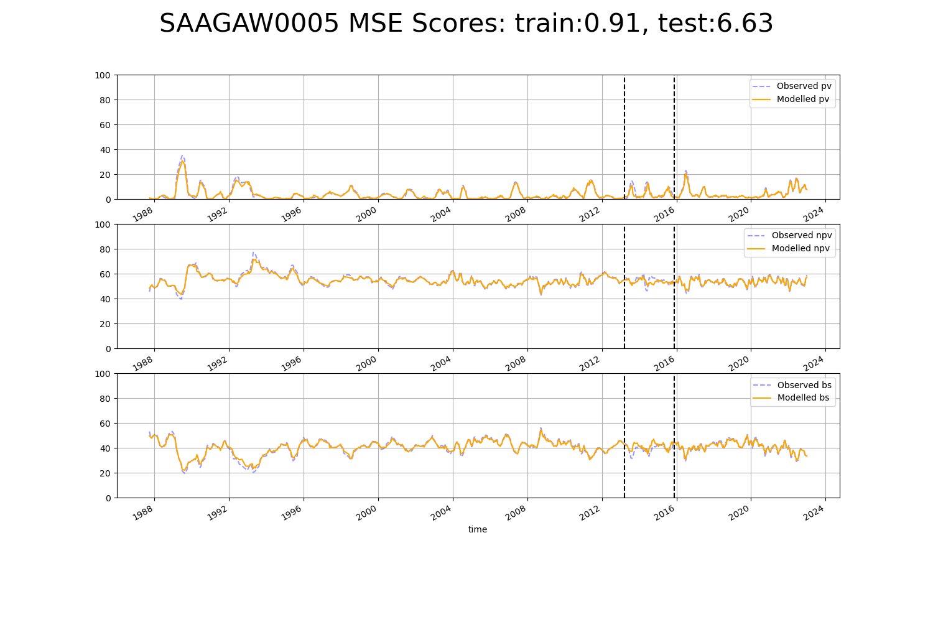

# SAARIV0007

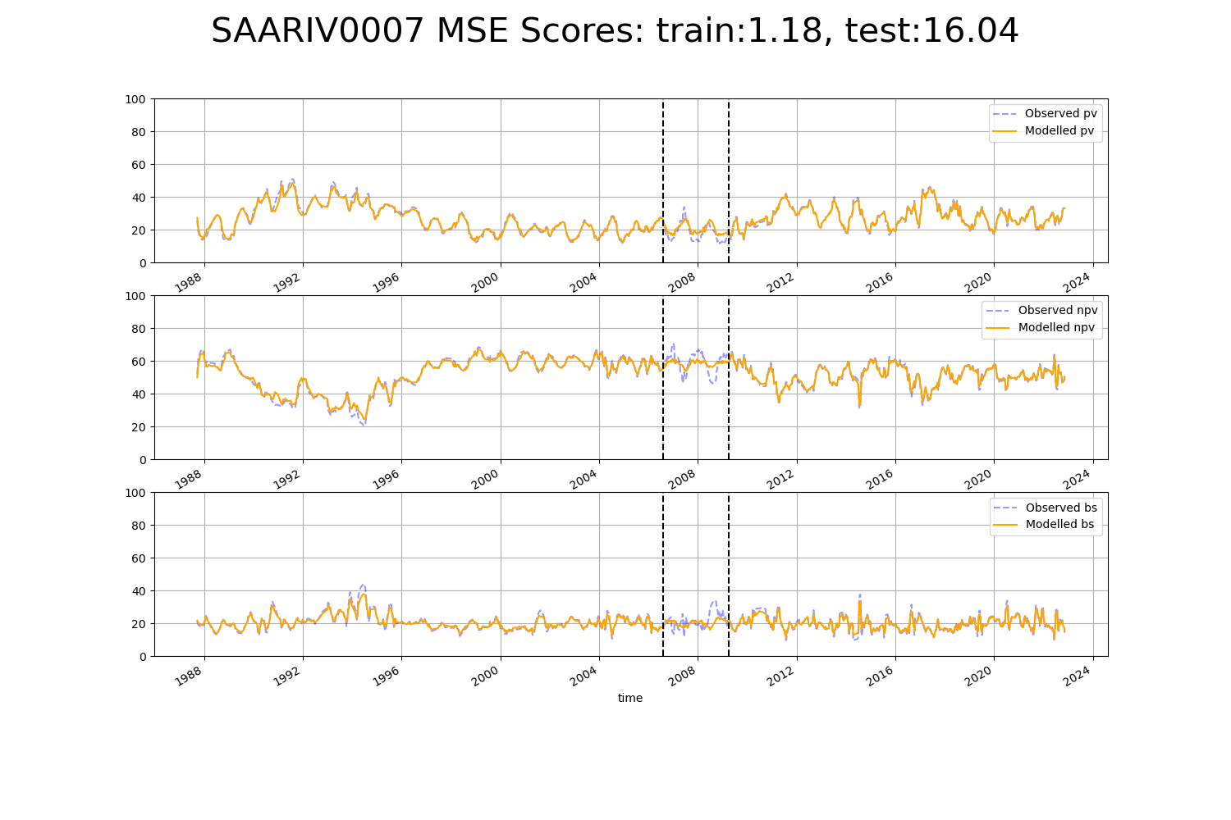

# SAASTP0009

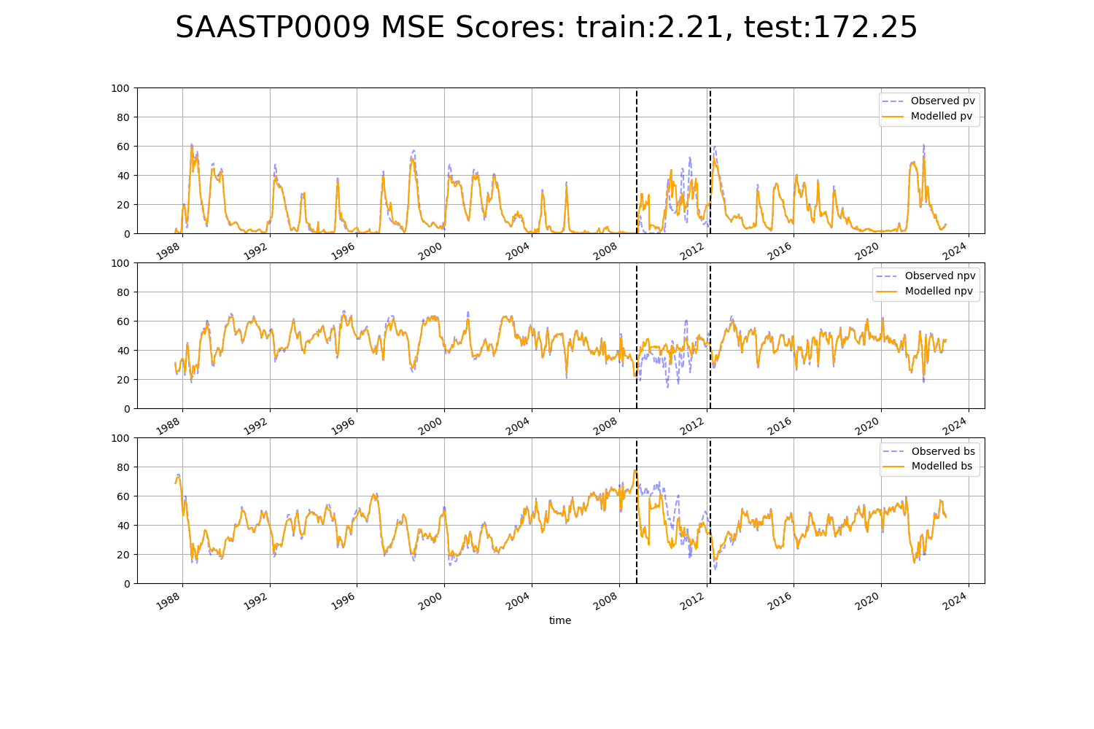

# SASMDD0009

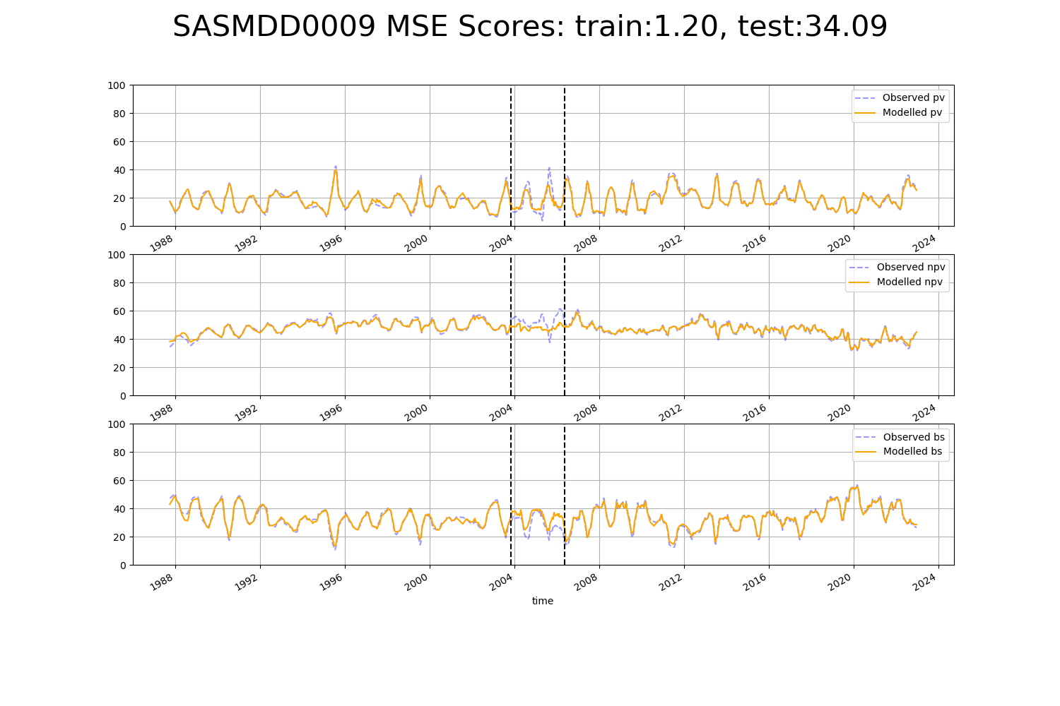

# SASMDD0014

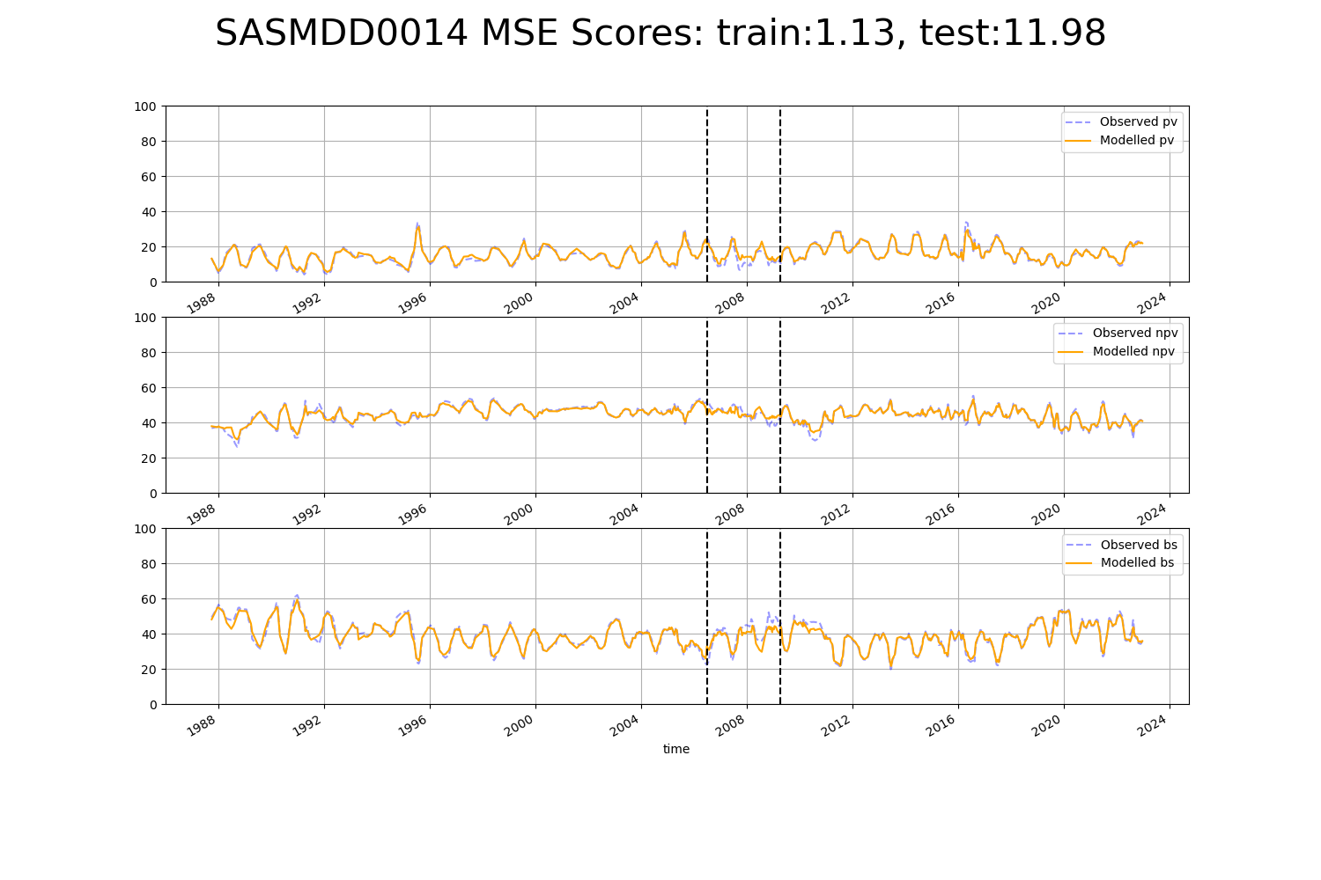

# SATFLB0005

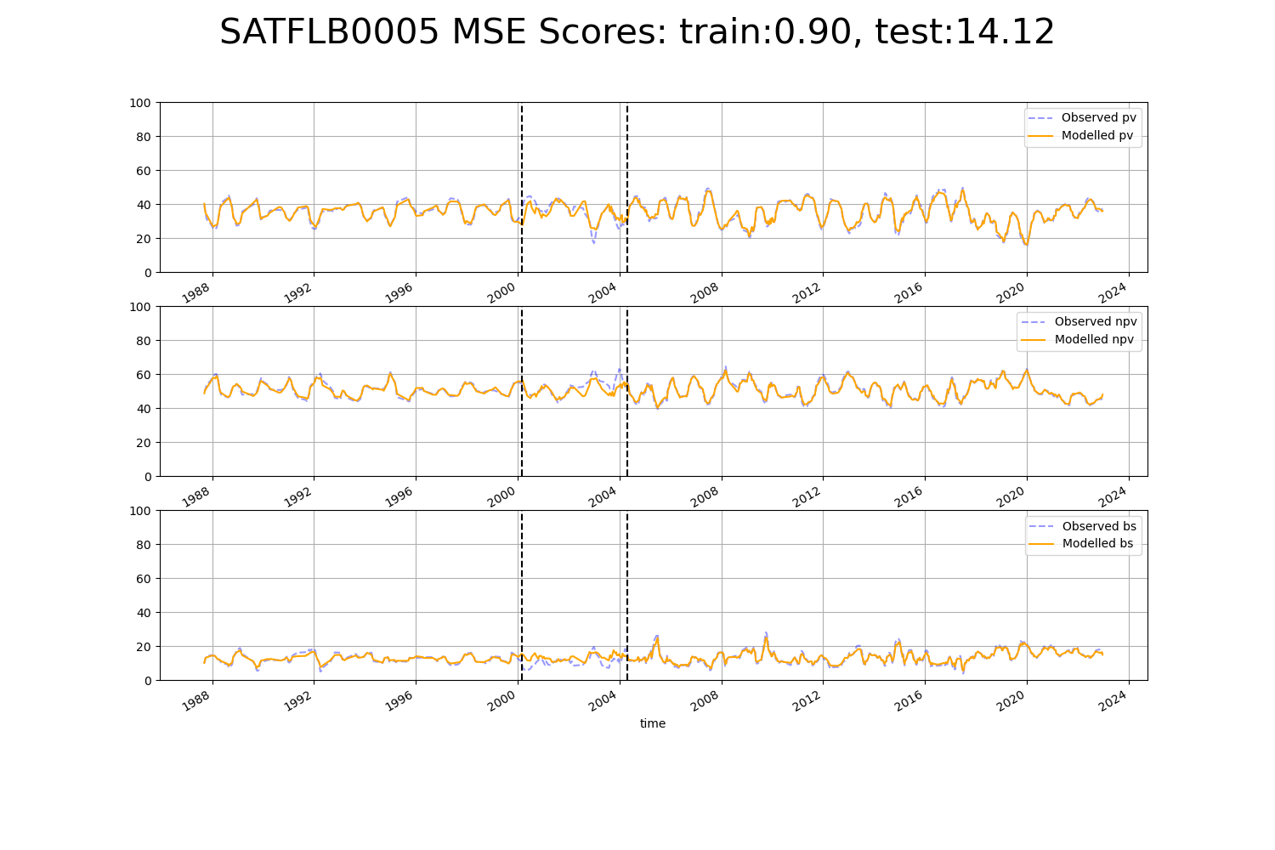

# SATFLB0006

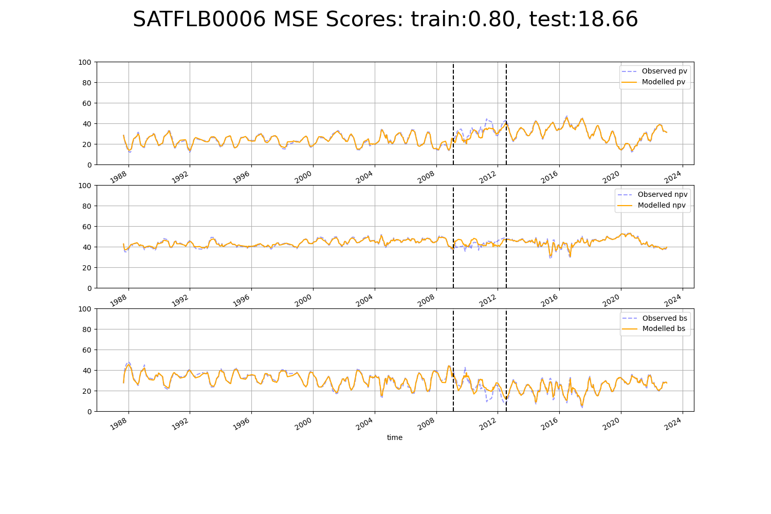

# SATFLB0009

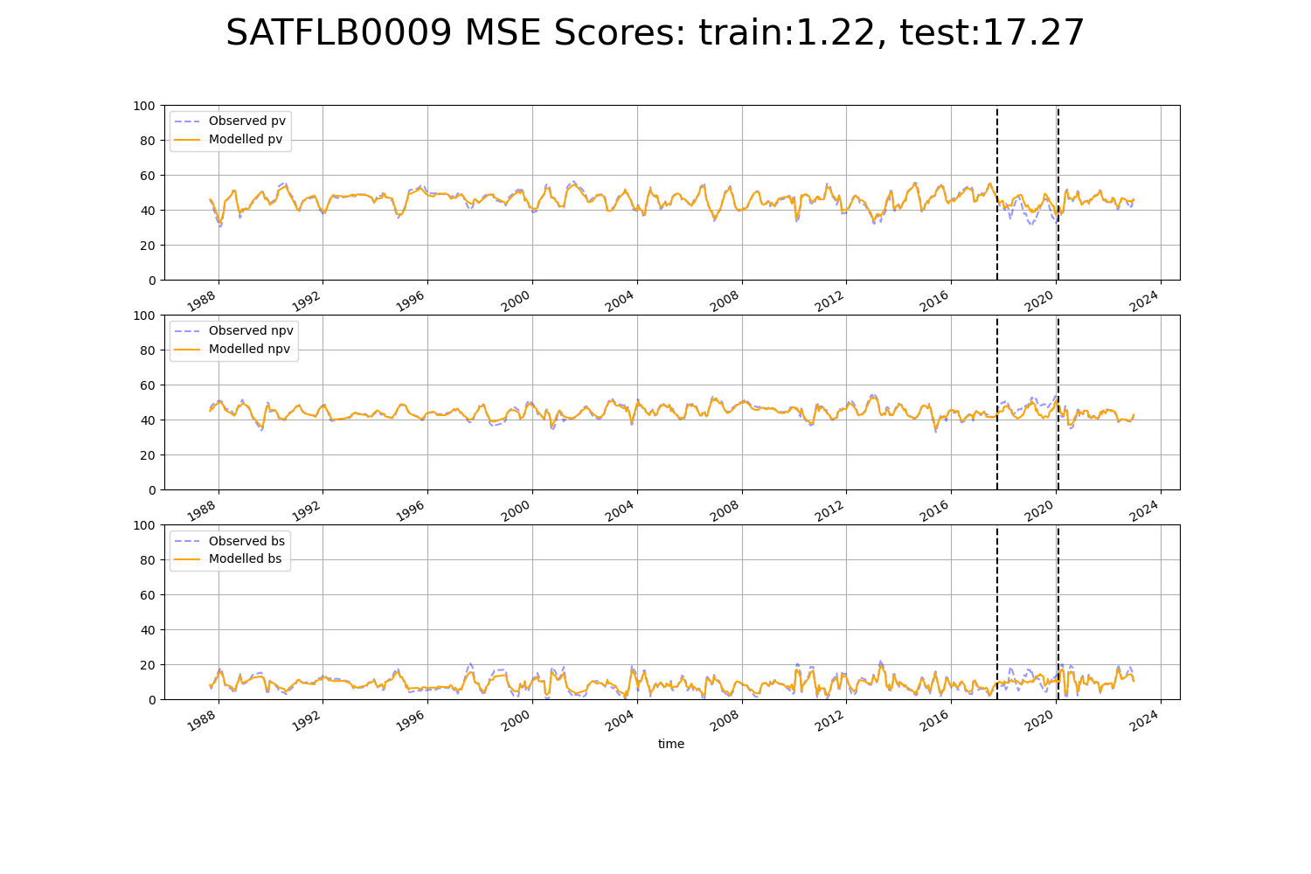

# SATFLB0017

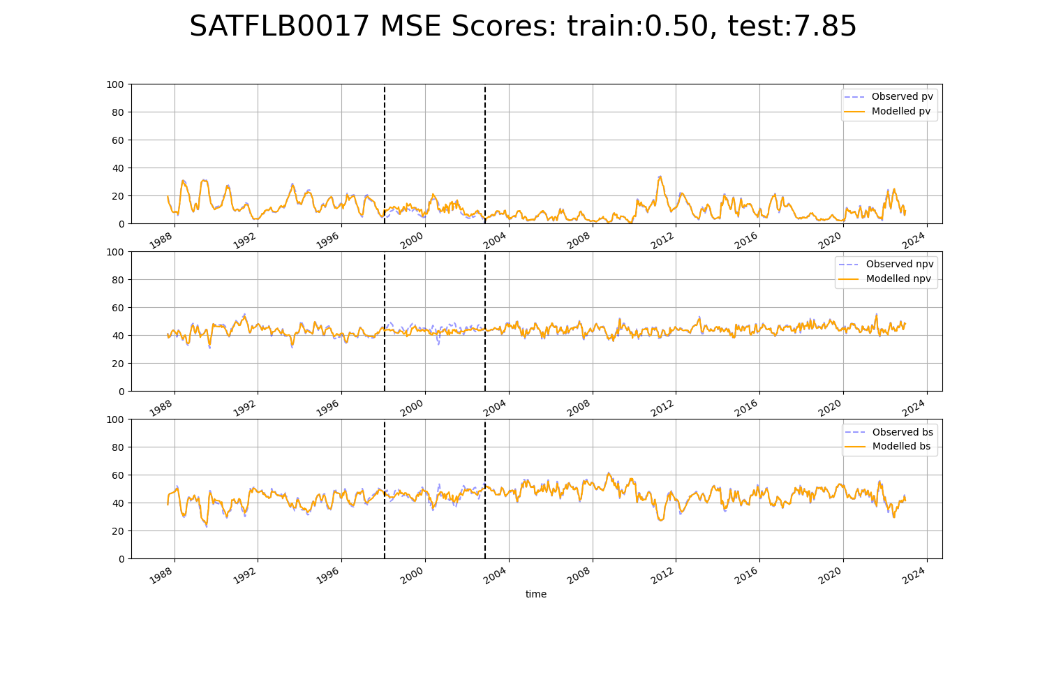

# SATFLB0023

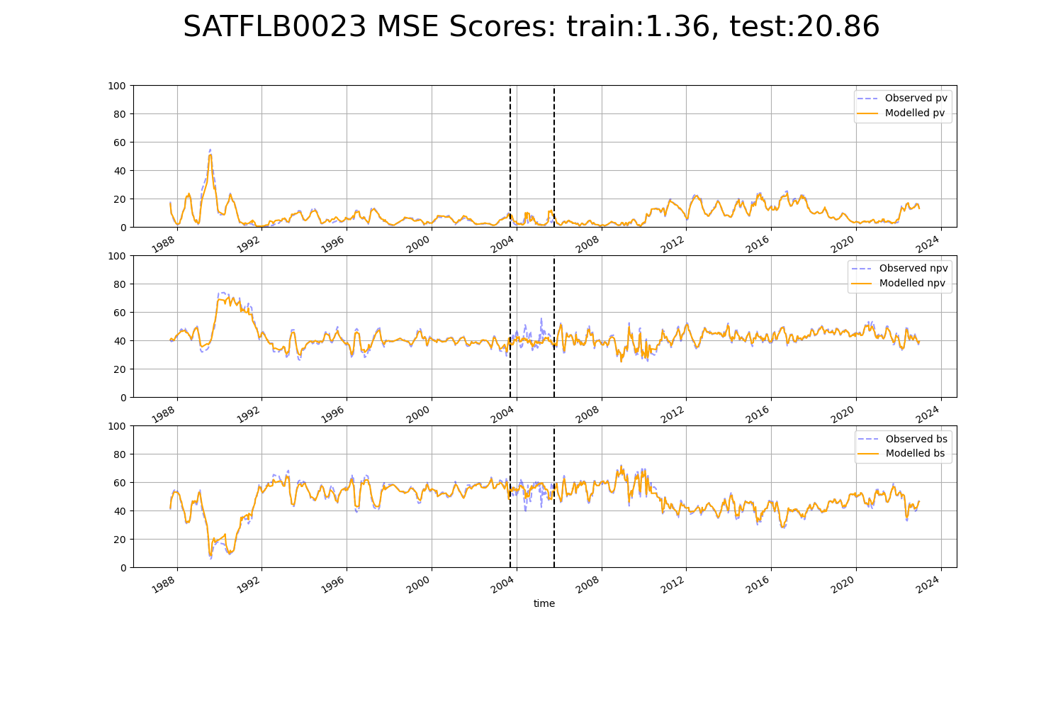

# SATSTP0004

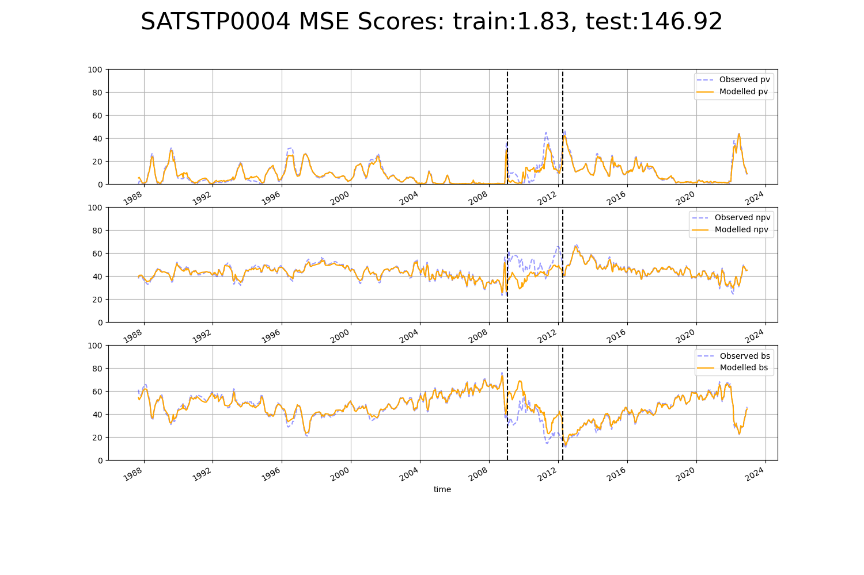

# SATSTP0005

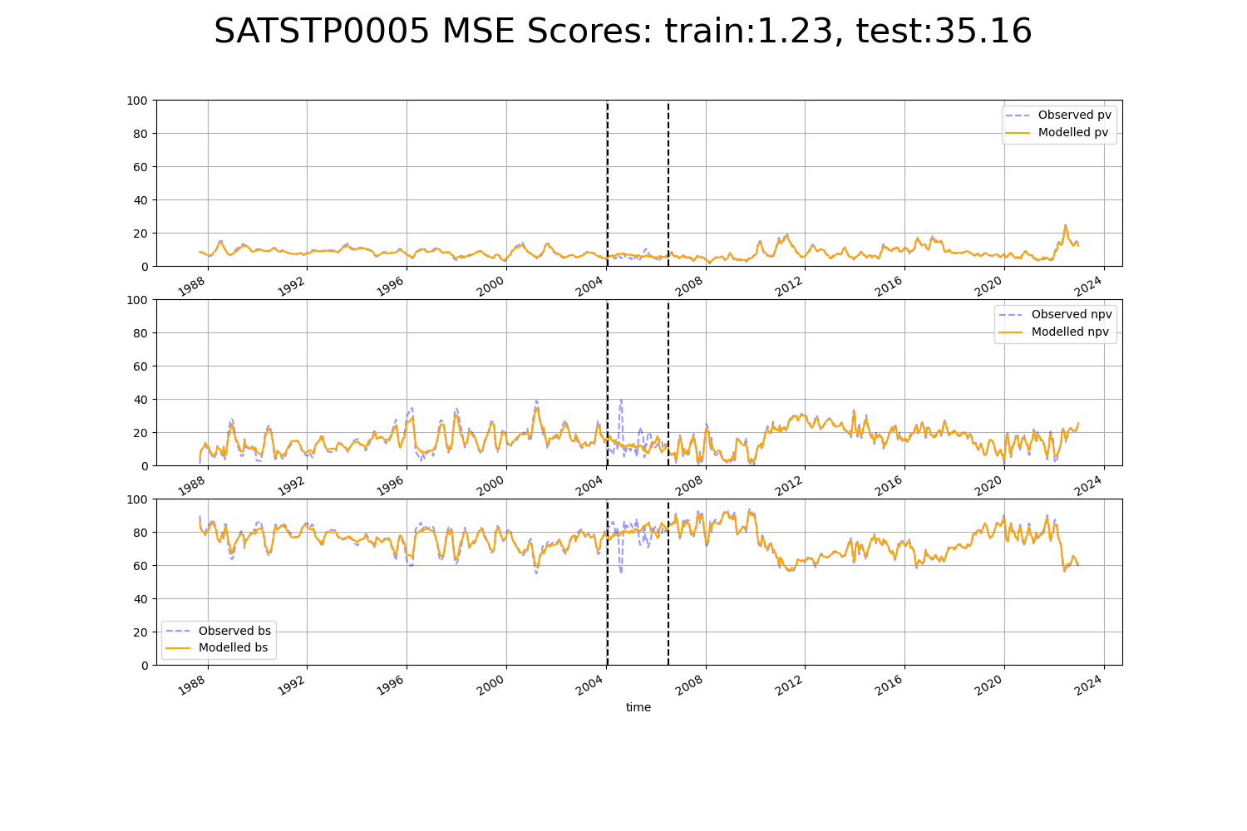

# SATSTP0006

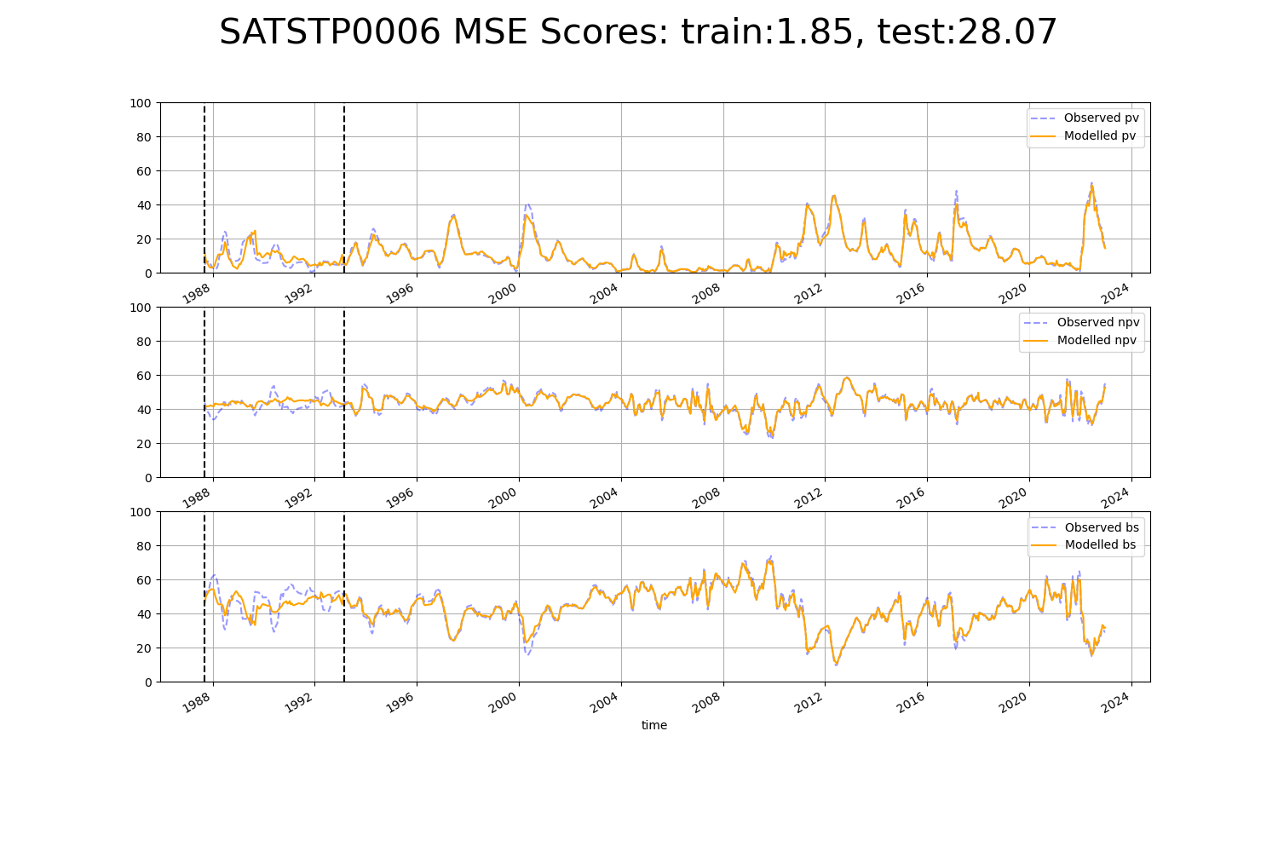

# WAACAR0003

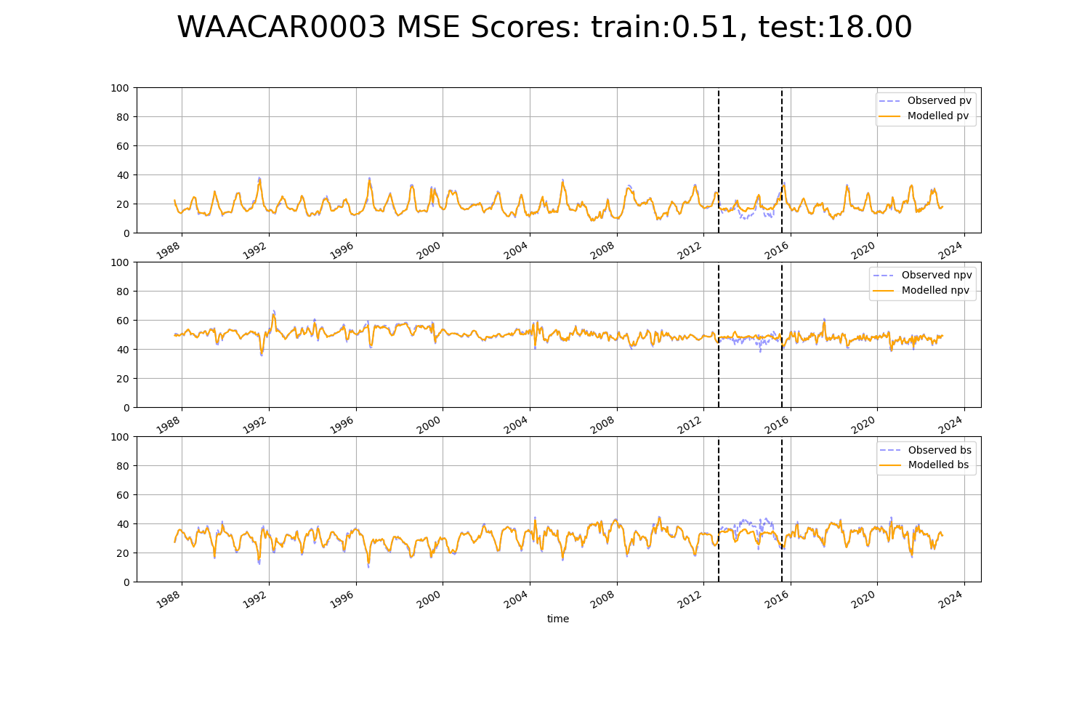

# WAACOO0009

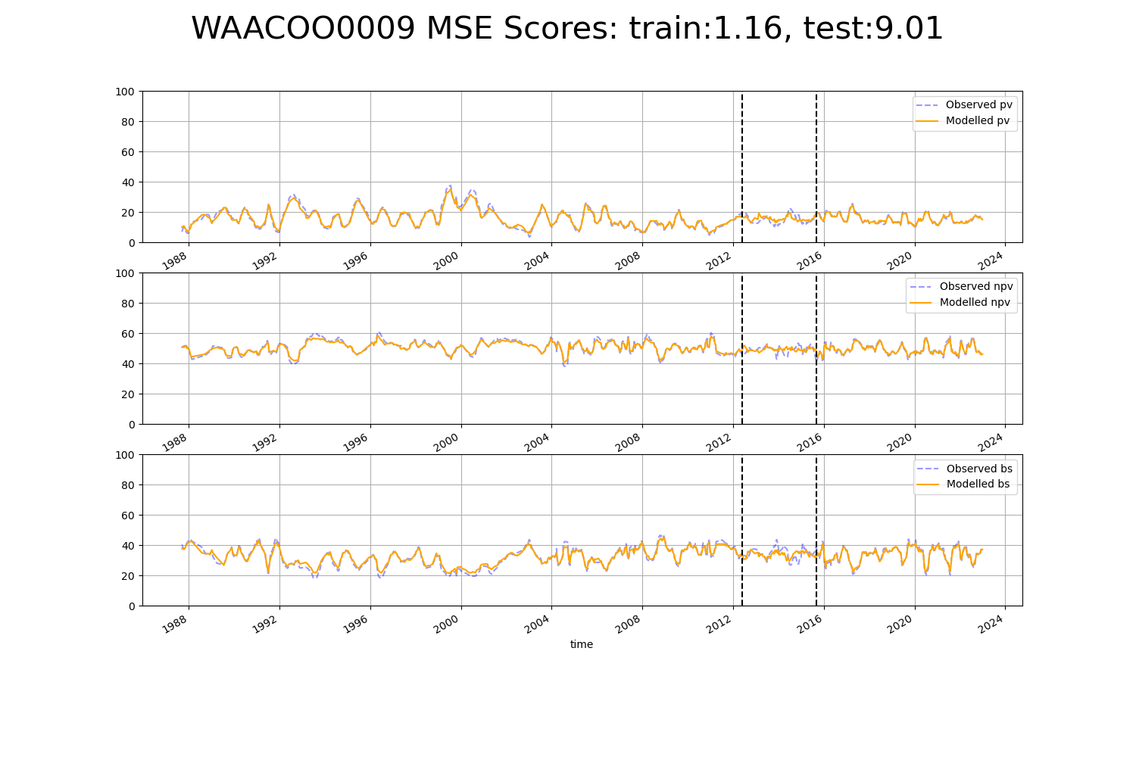

# WAACOO0011

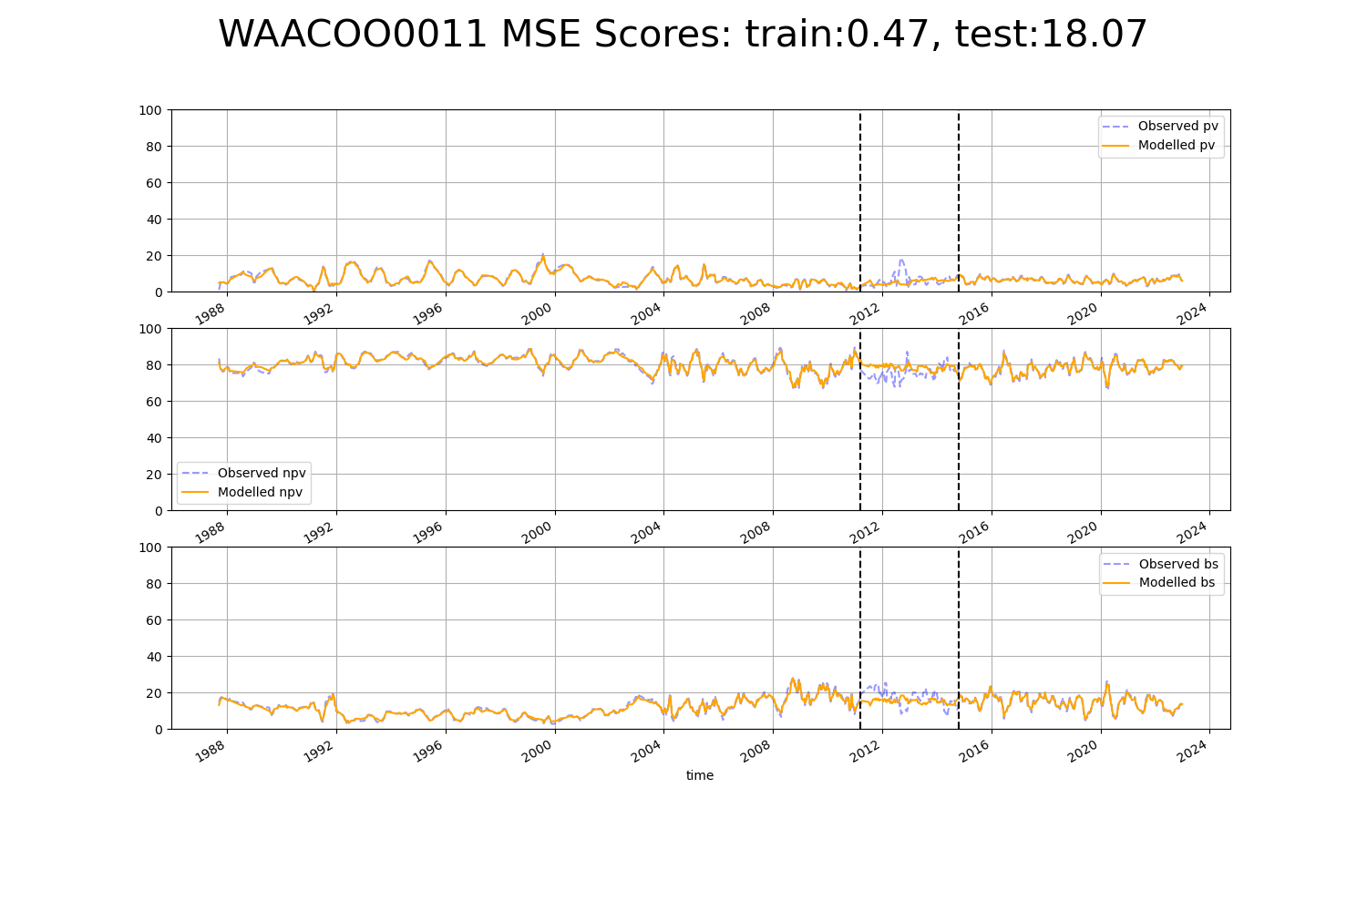

# WAACOO0016

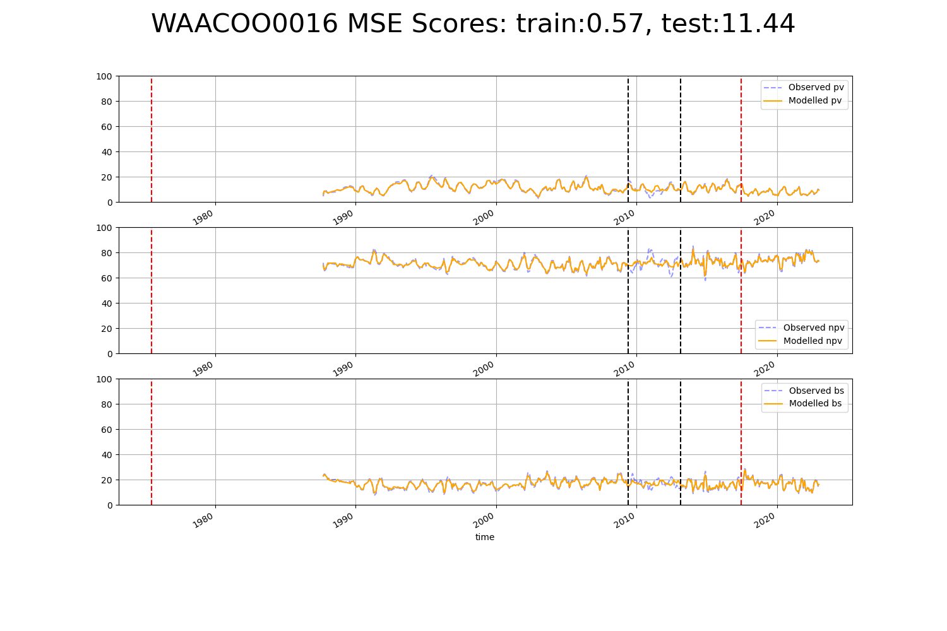

# WAACOO0017

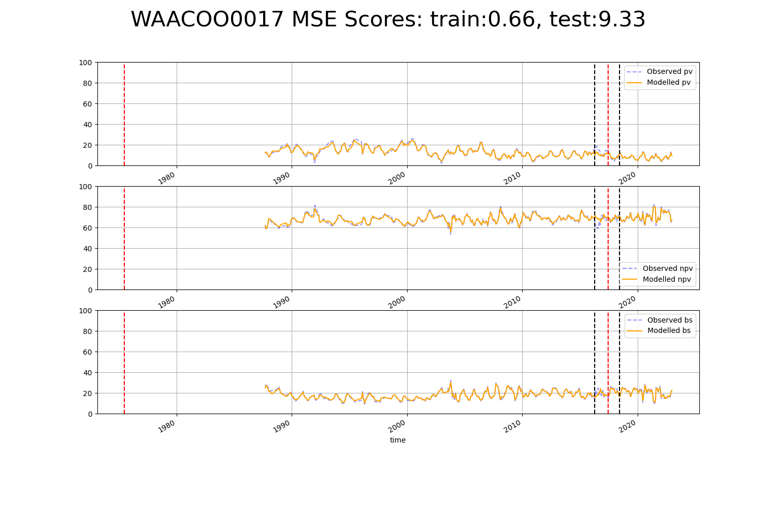

# WAACOO0018

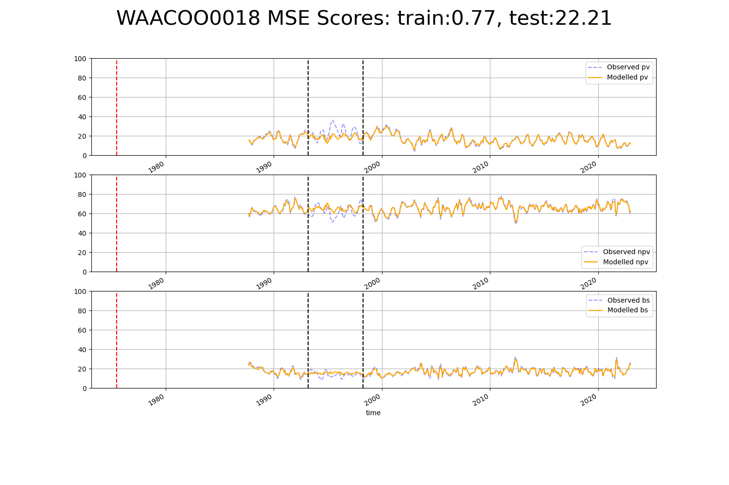

# WAACOO0020

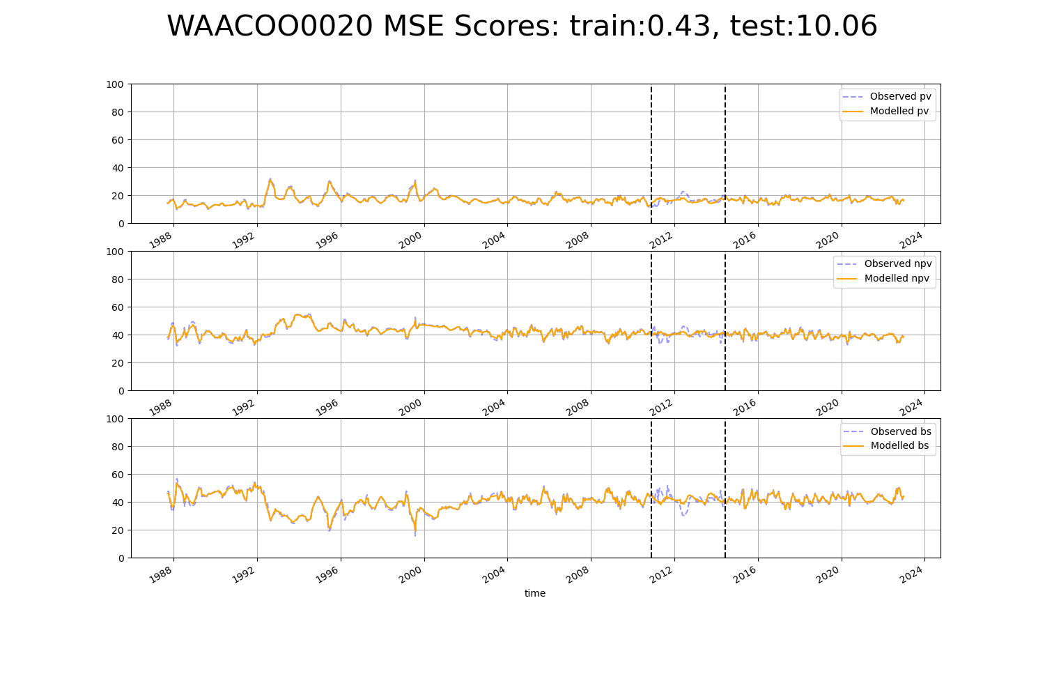

# WAACOO0021

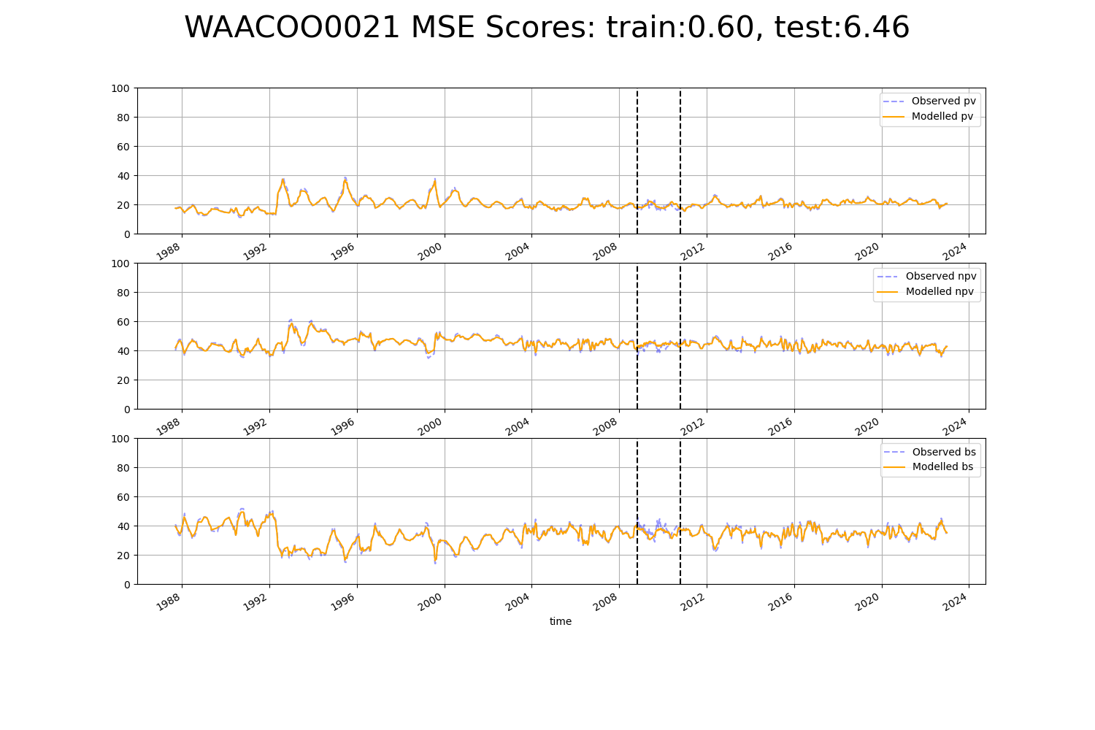

# WAACOO0024

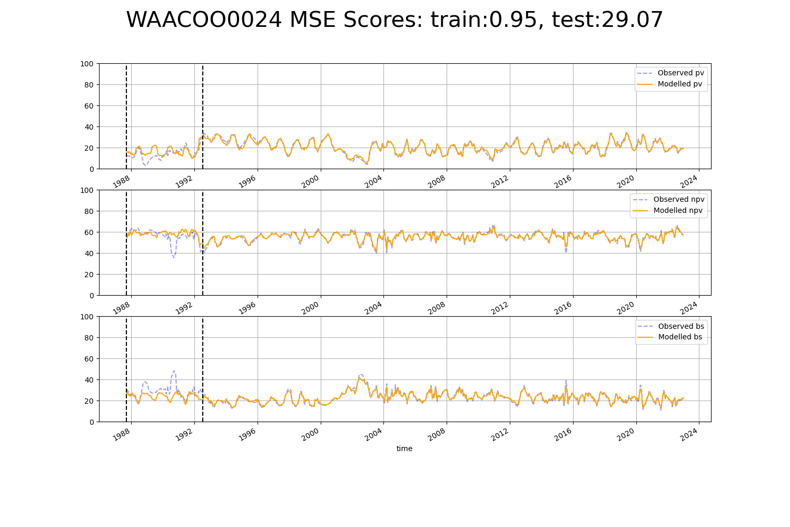

# WAACOO0025

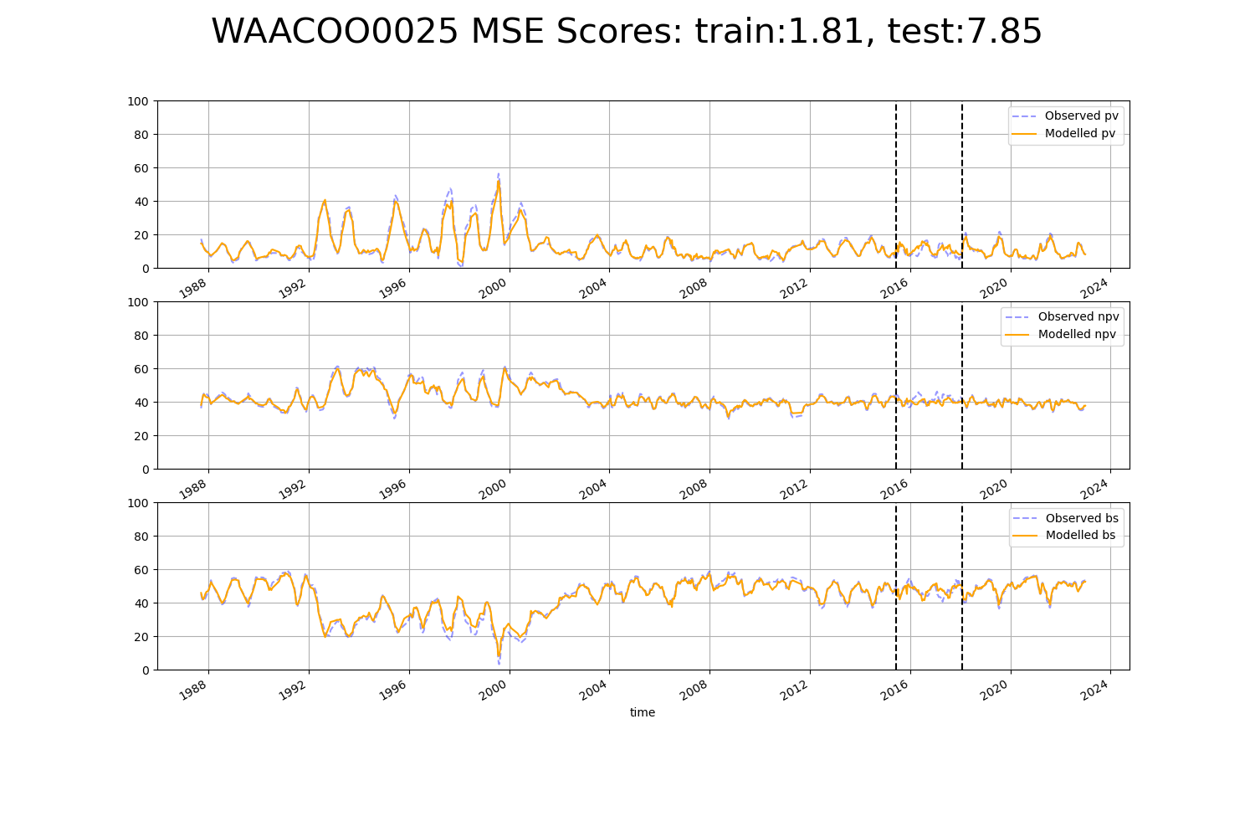

# WAACOO0026

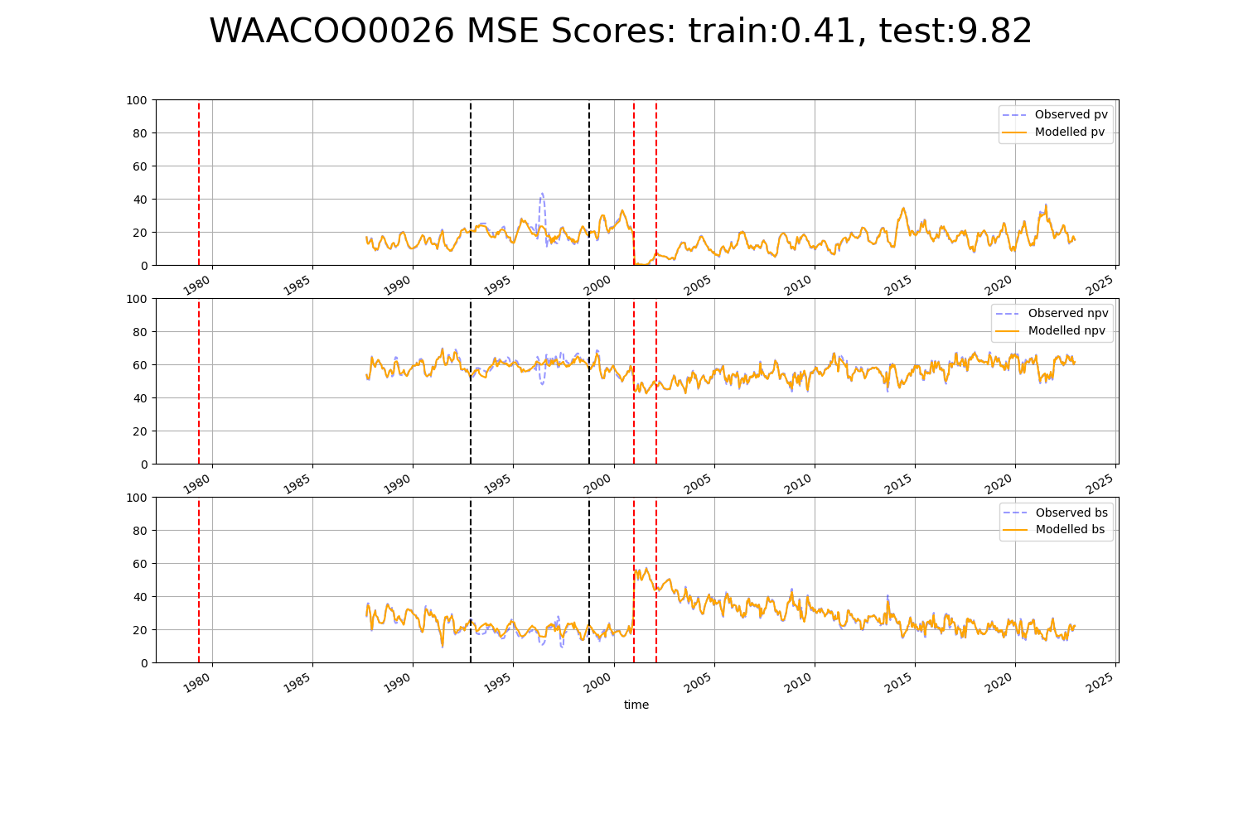

# WAACOO0027

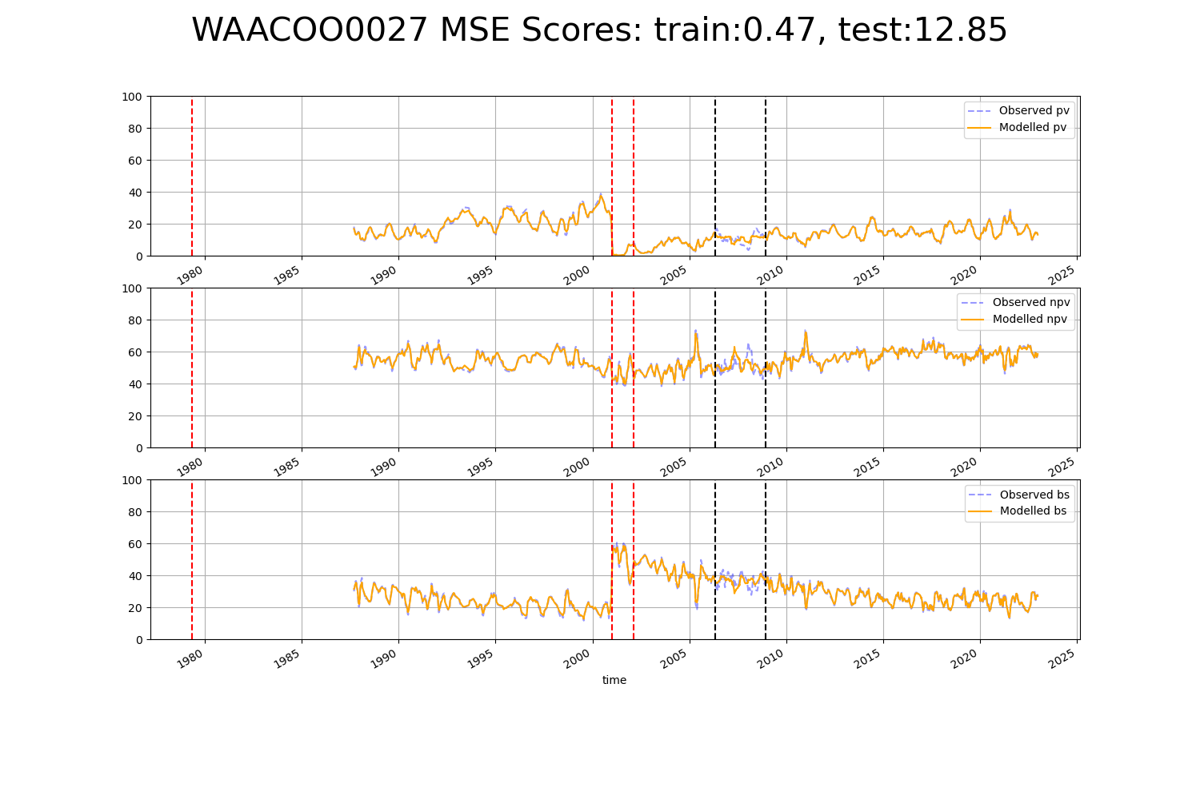

# WAACOO0028

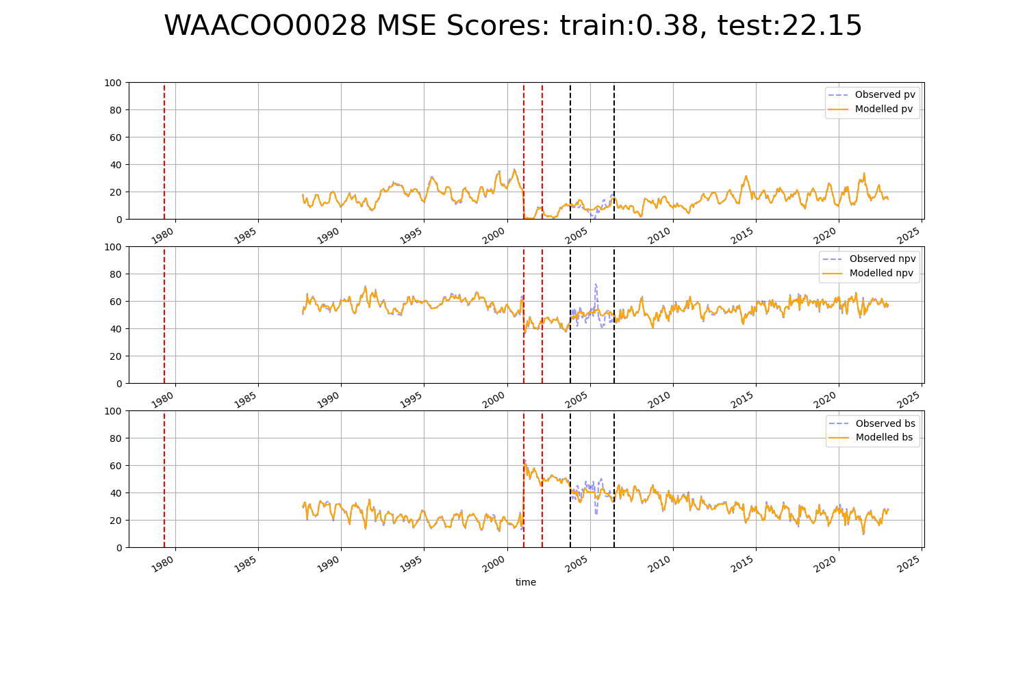

# WAACOO0029

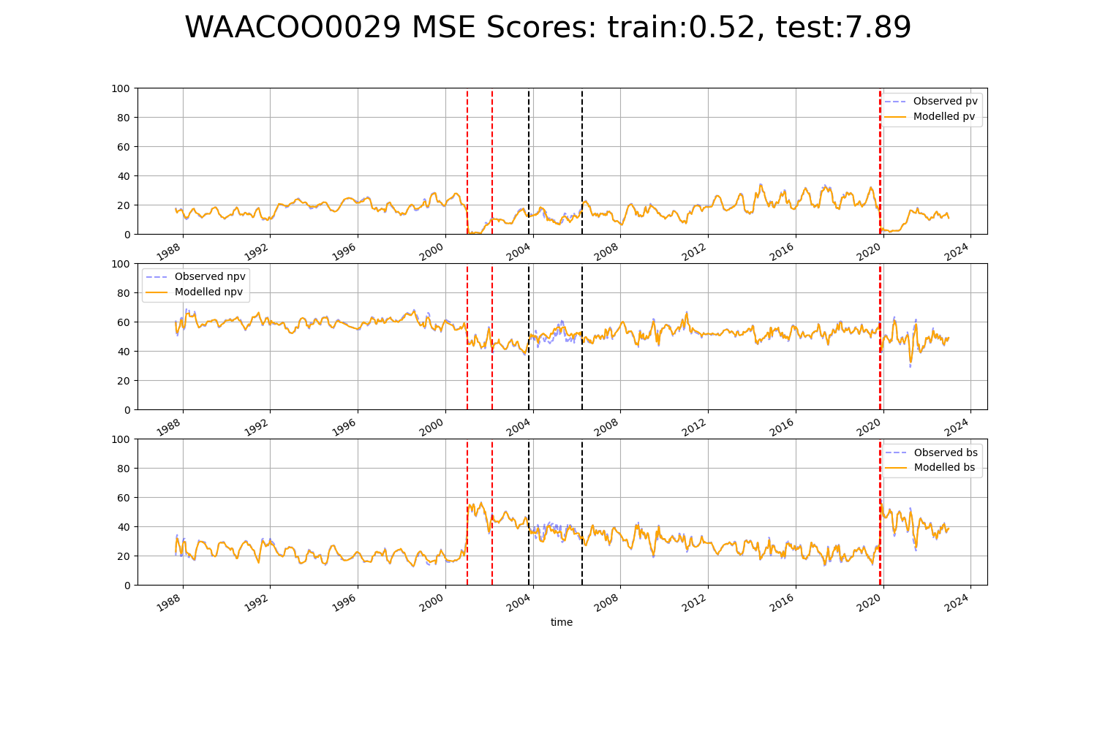

# WAADAL0002

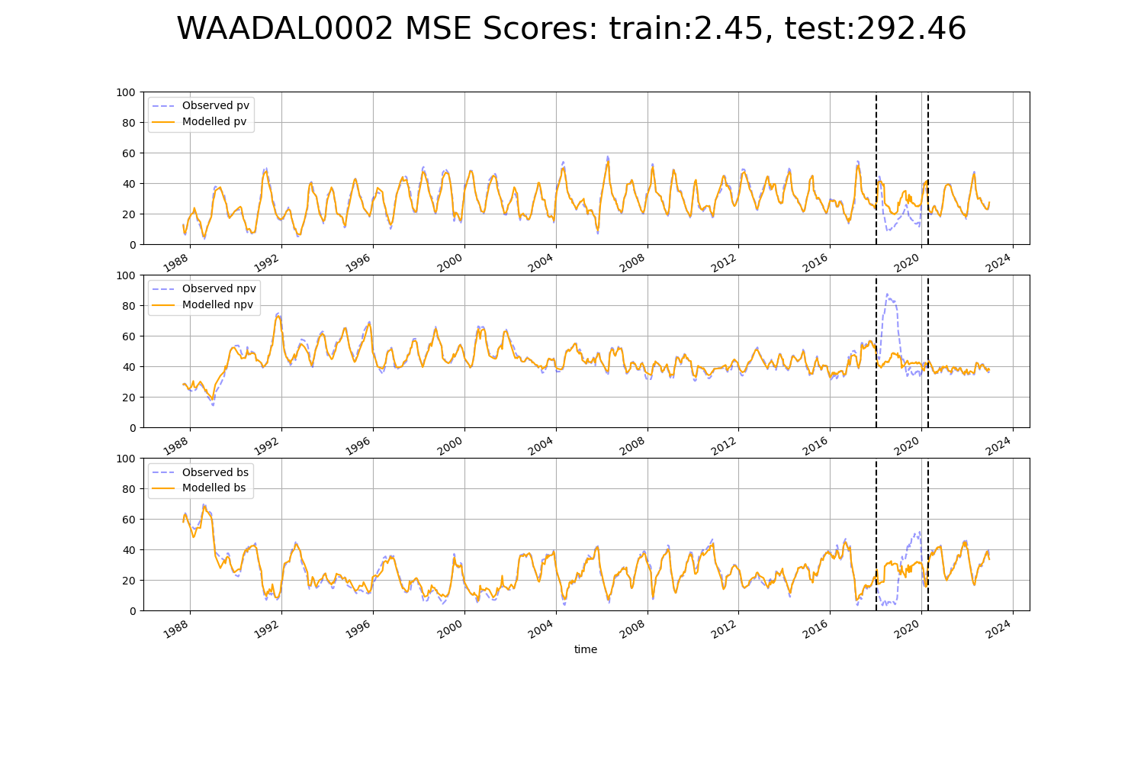

# WAAGVD0001

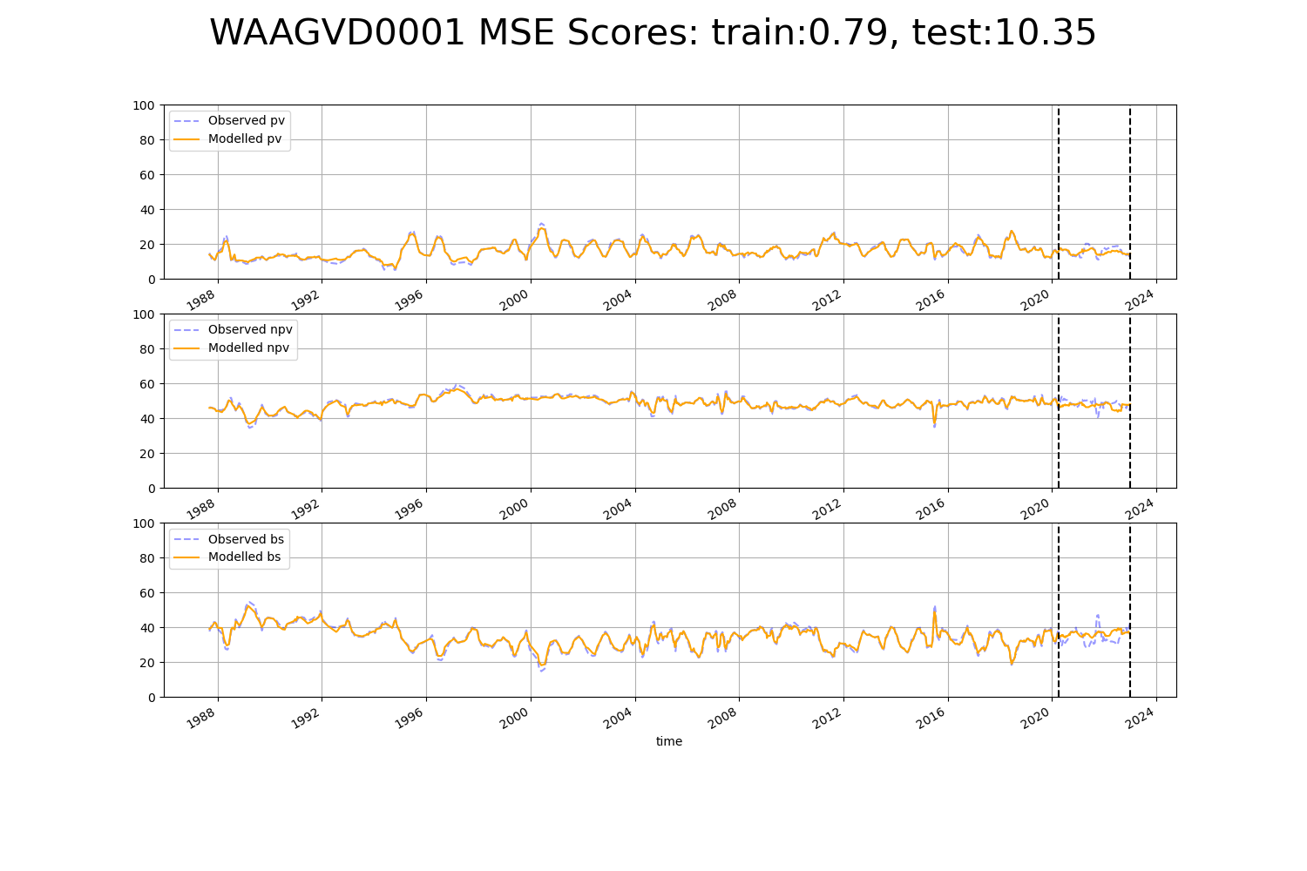

# WAAHAM0001

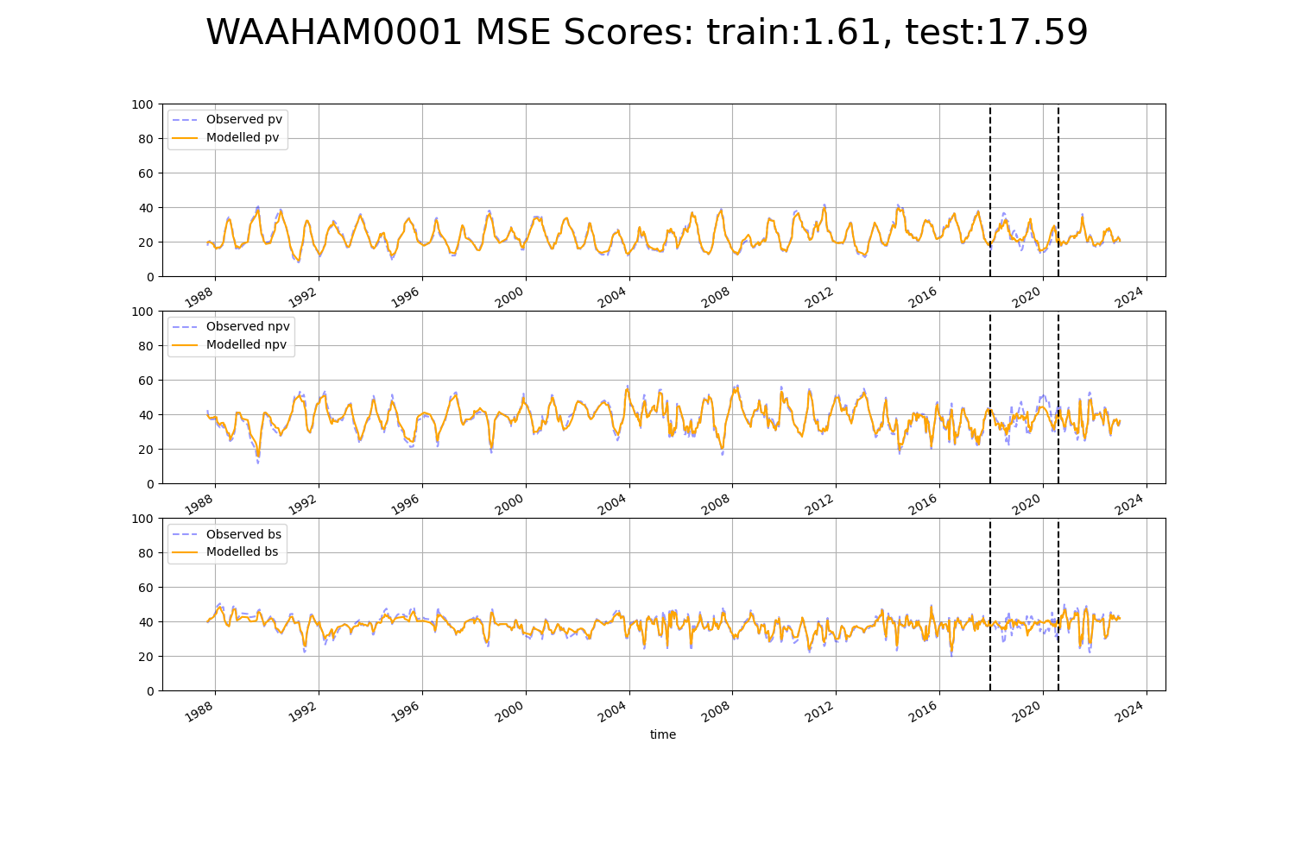

# WAAHAM0002

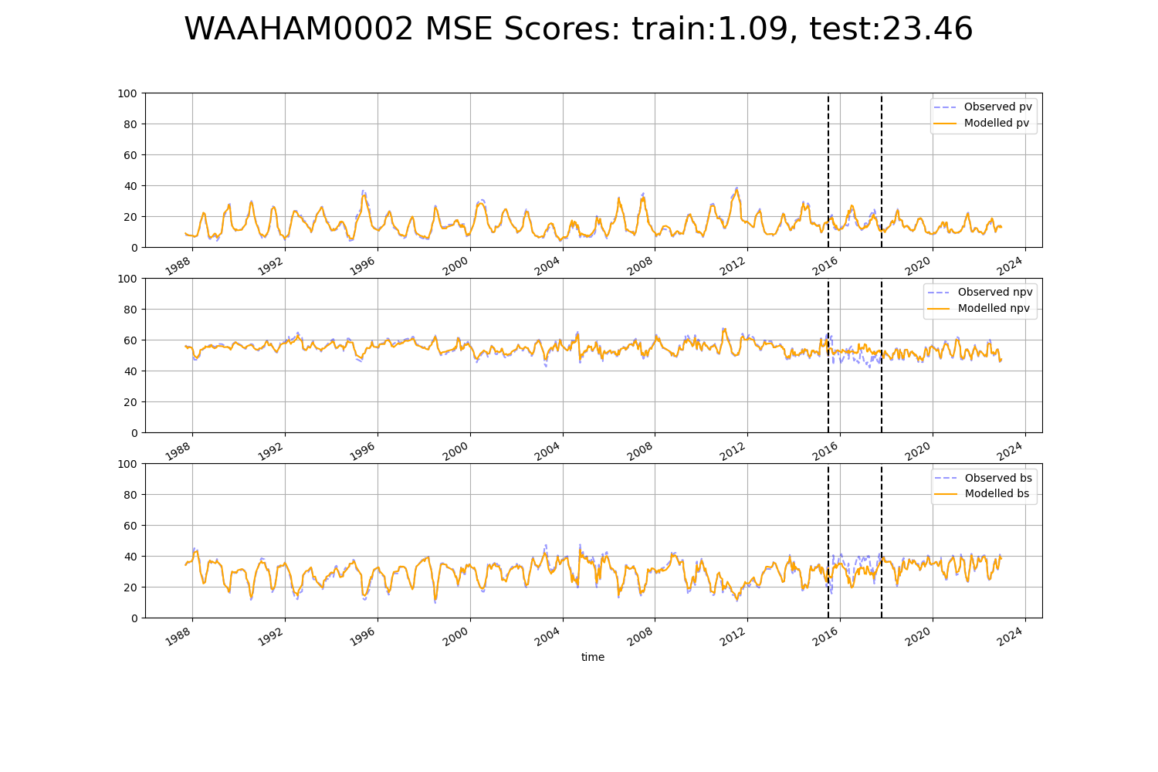

# WAAHAM0005

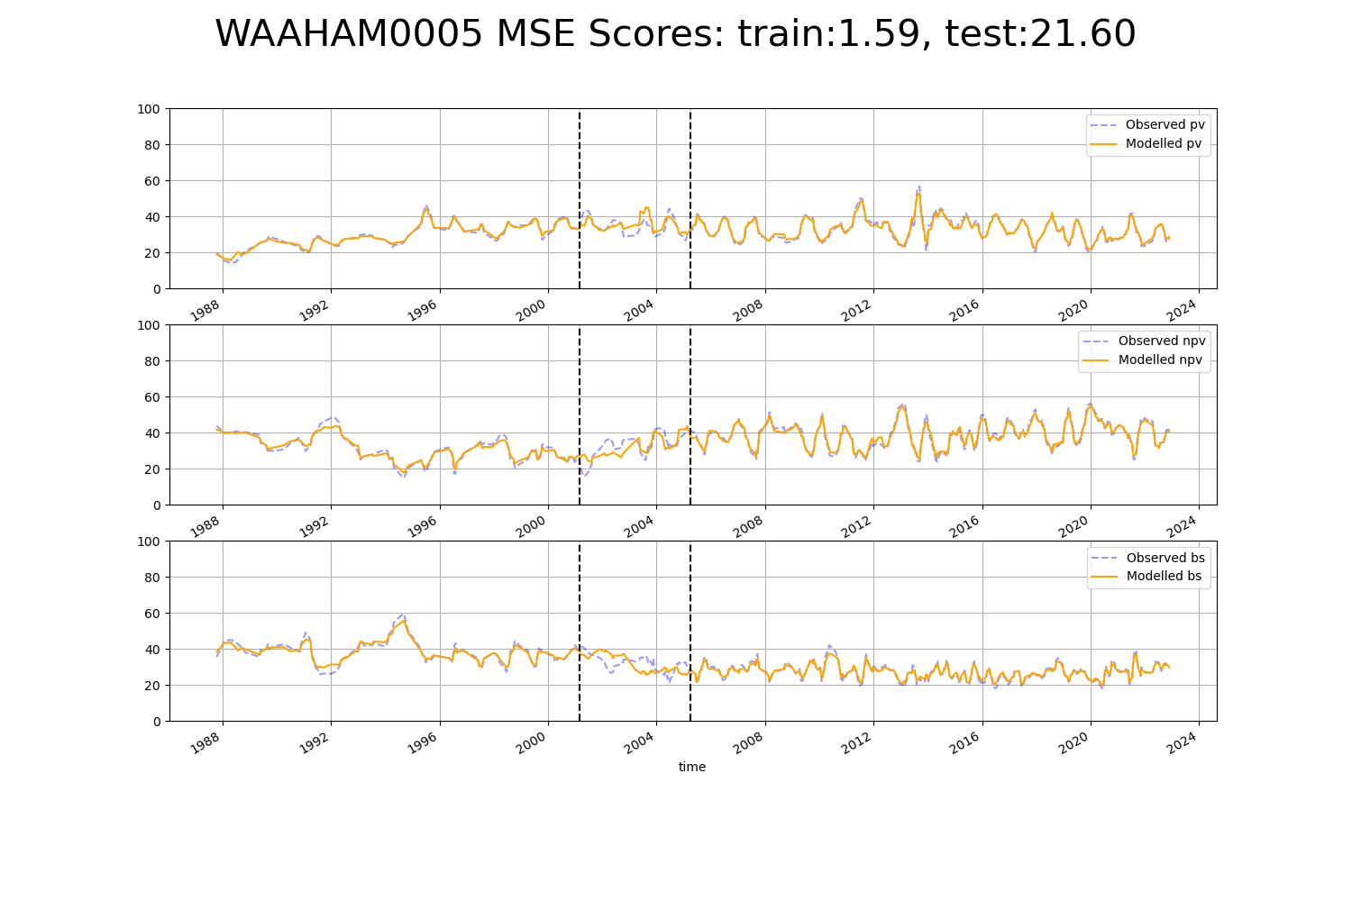

# WAALSD0002

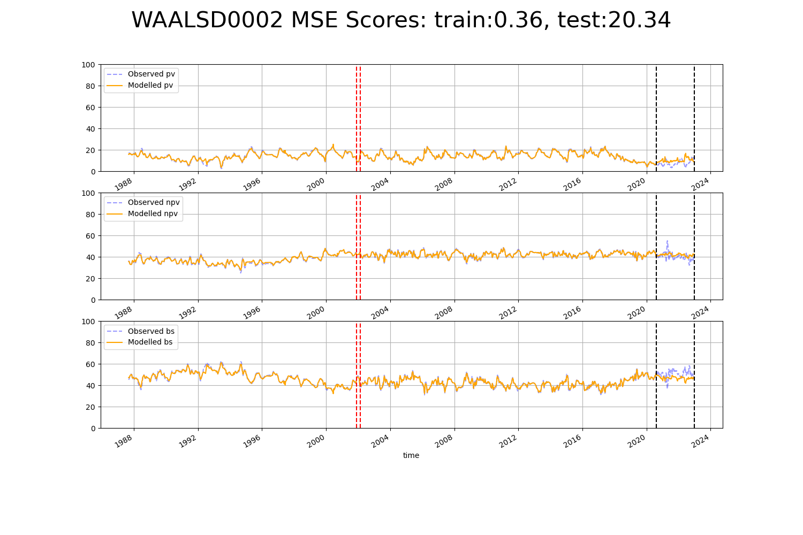

# WAAMAL0001

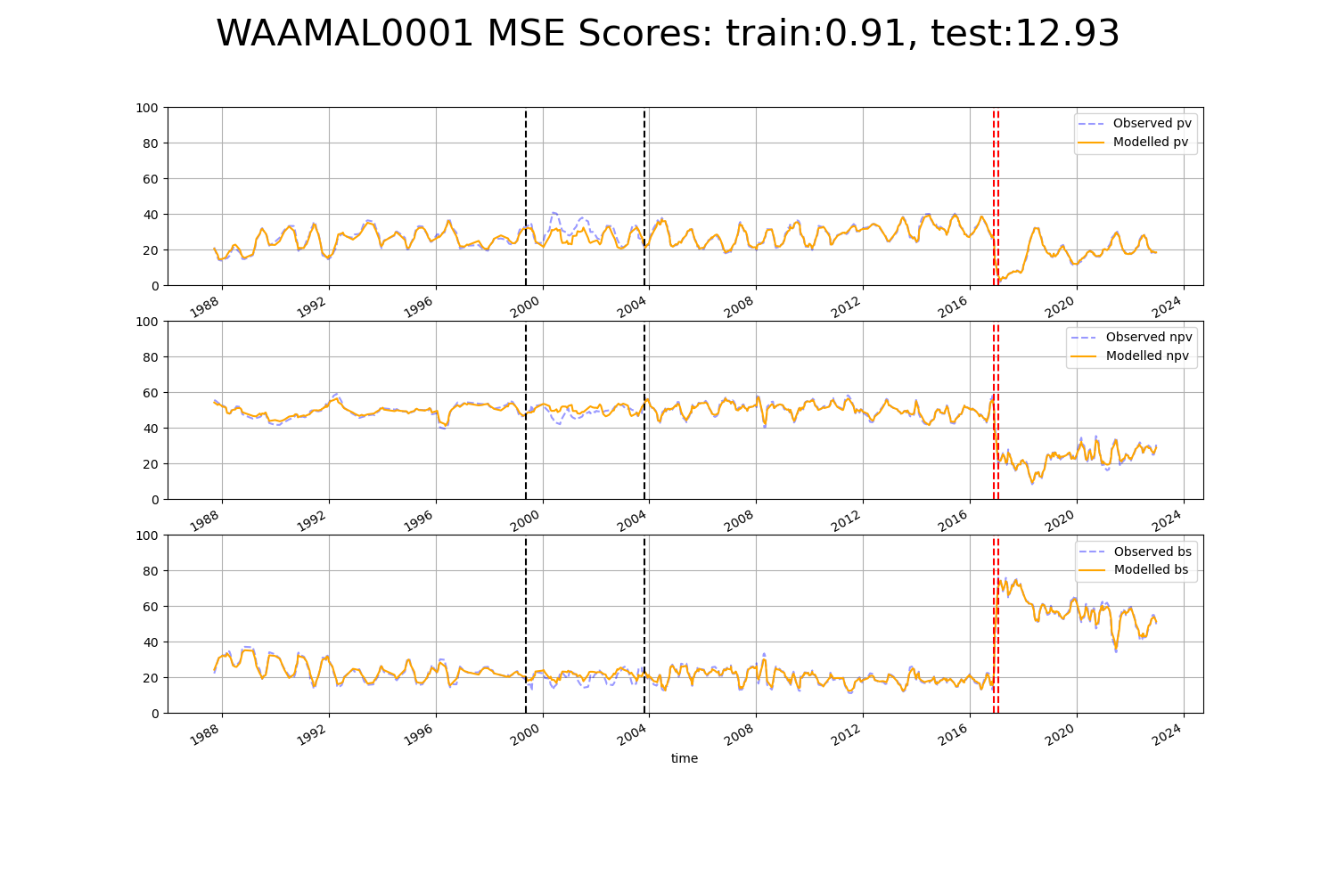

# WAAMUR0006

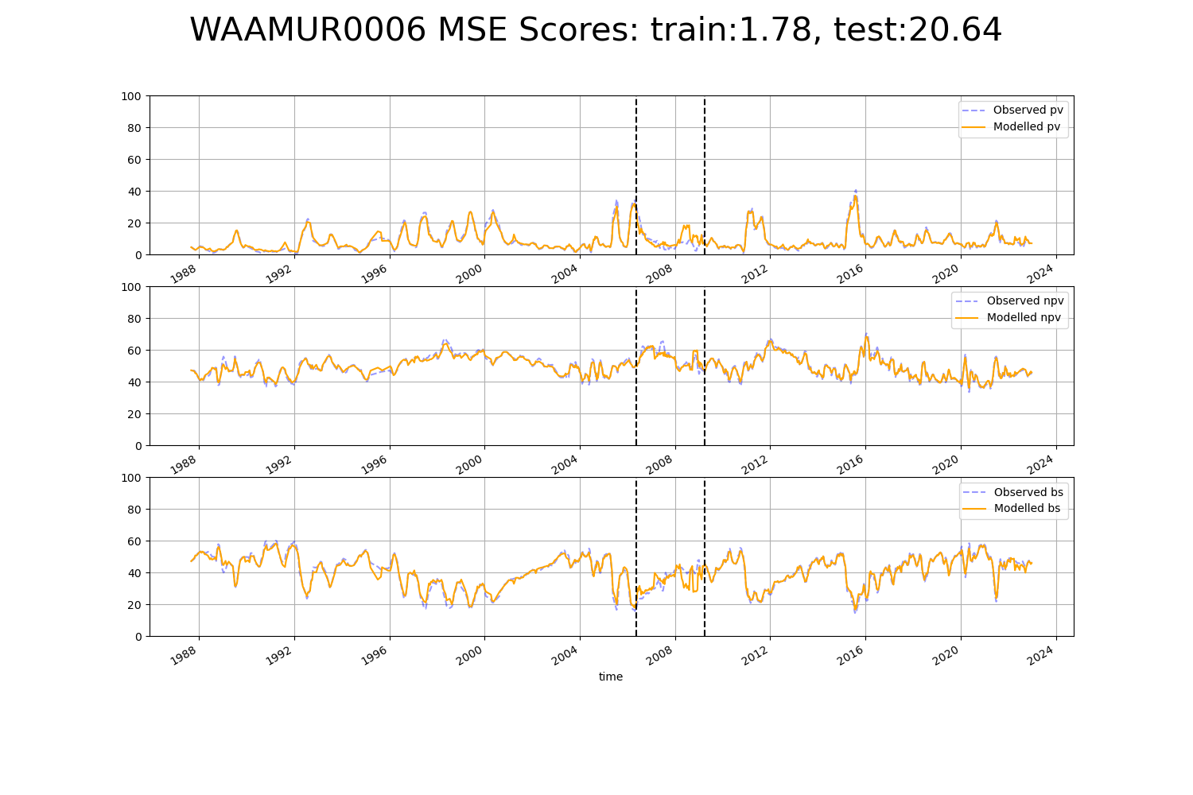

# WAAPIL0005

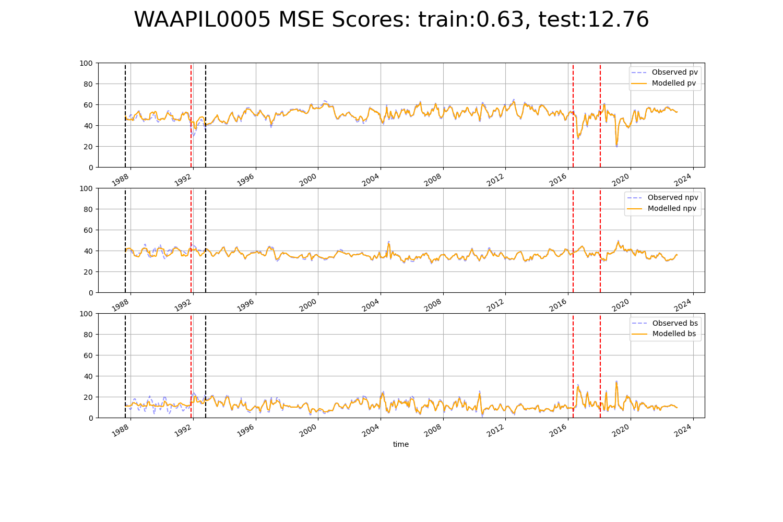

# WAAPIL0010

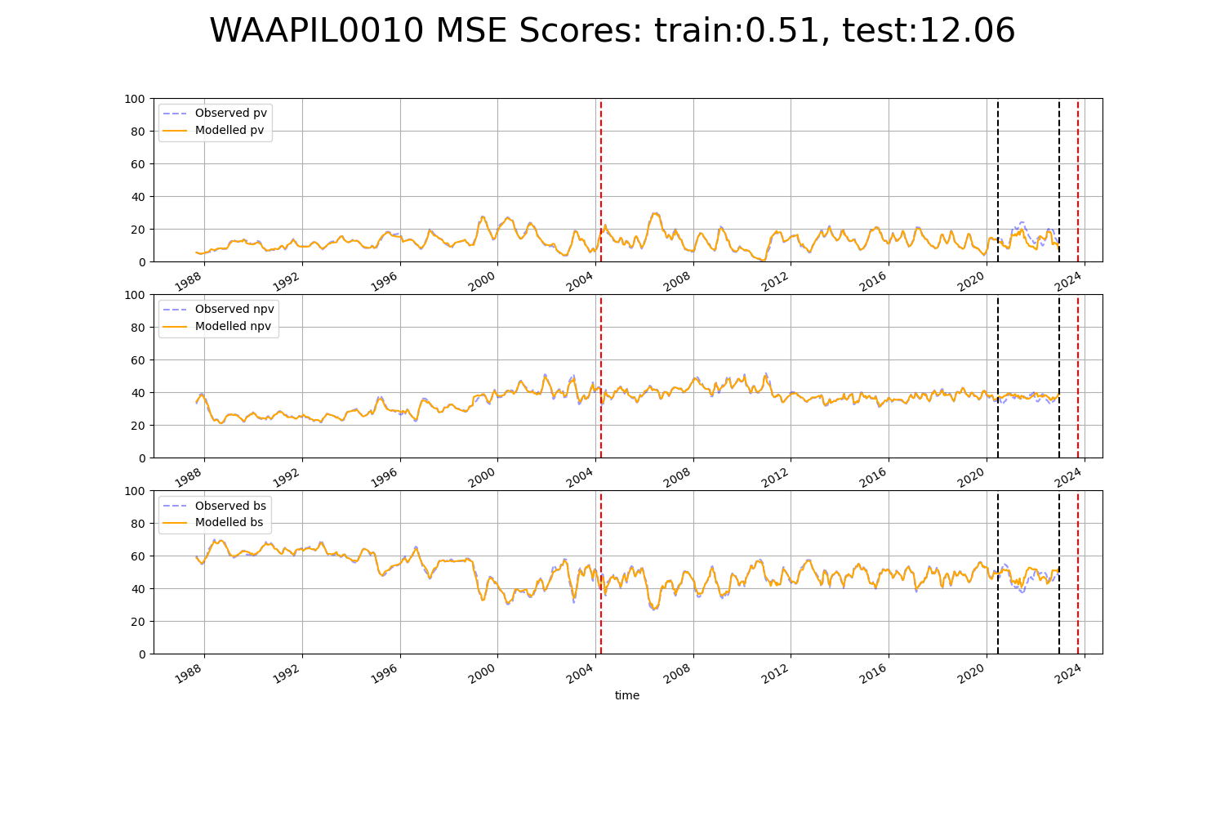

# WAAPIL0011

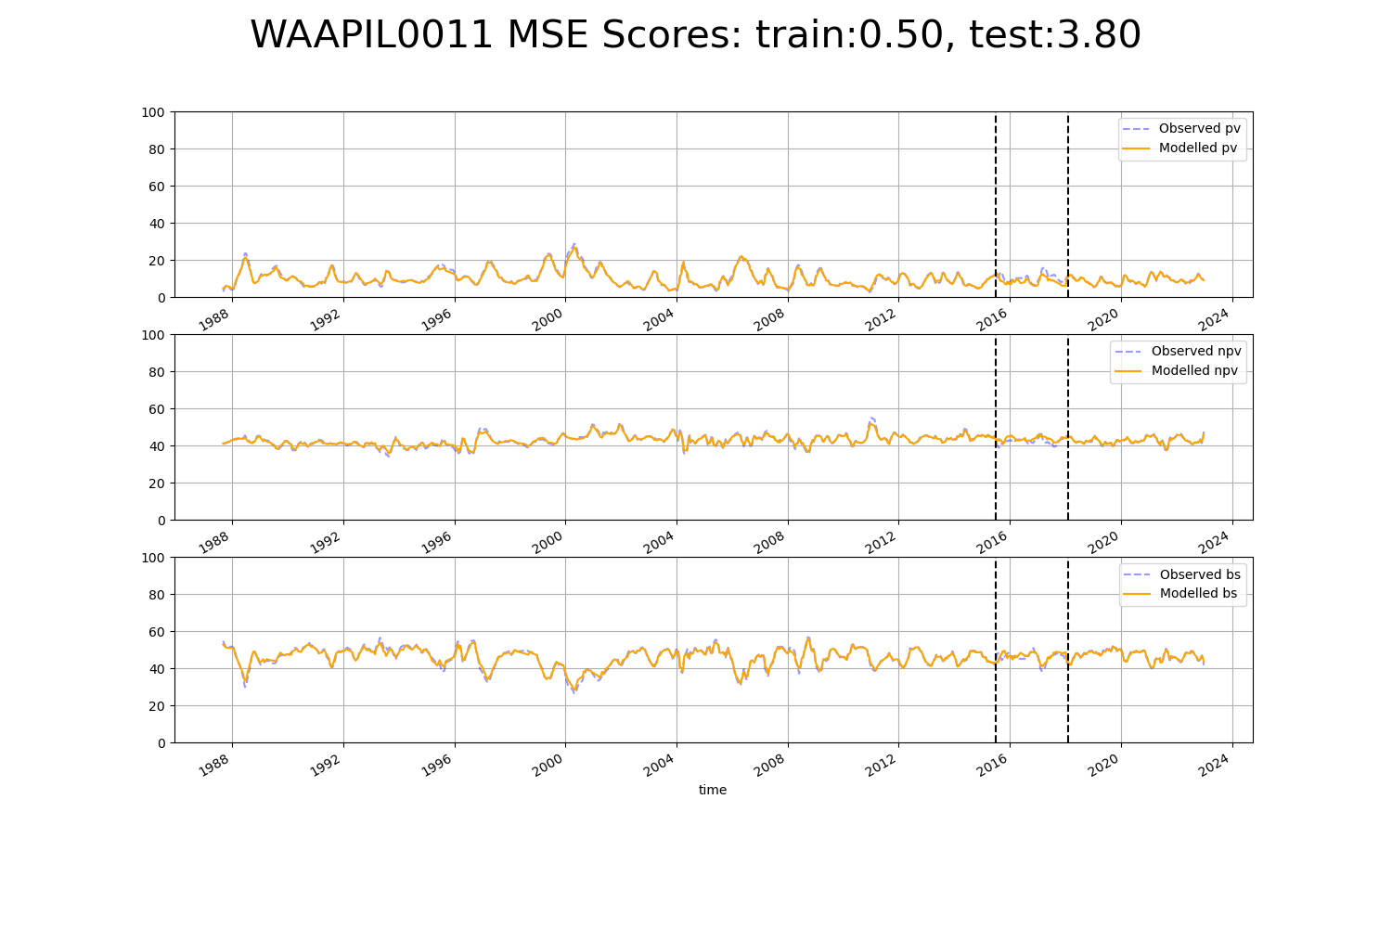

# WAAPIL0021

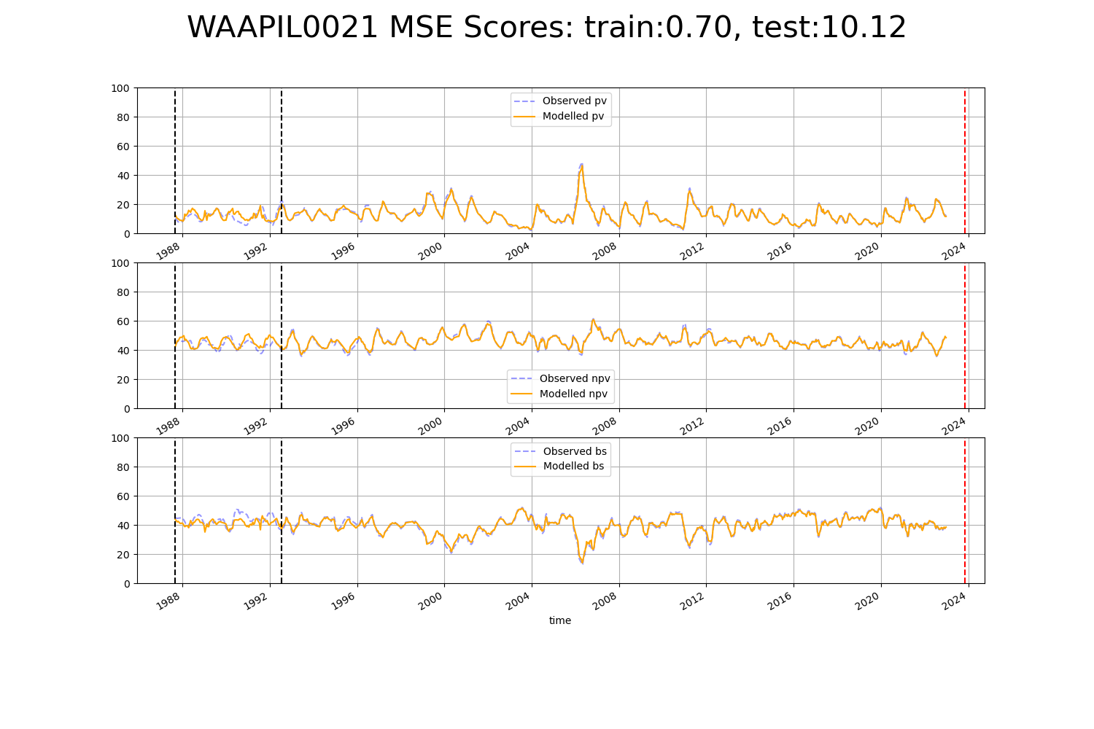

# WAAPIL0024

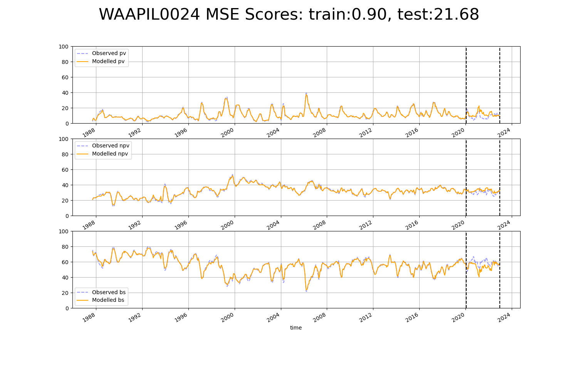

# WAAPIL0028

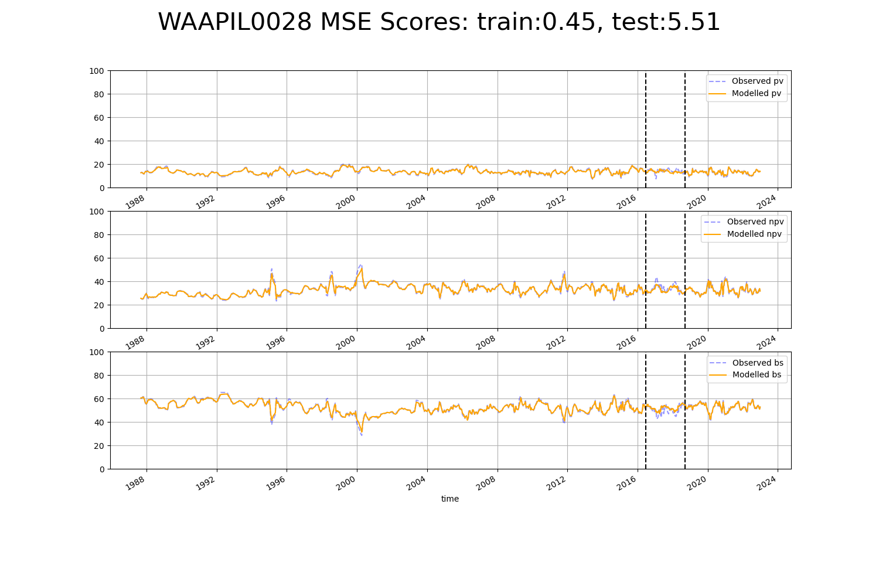

# WAAPIL0032

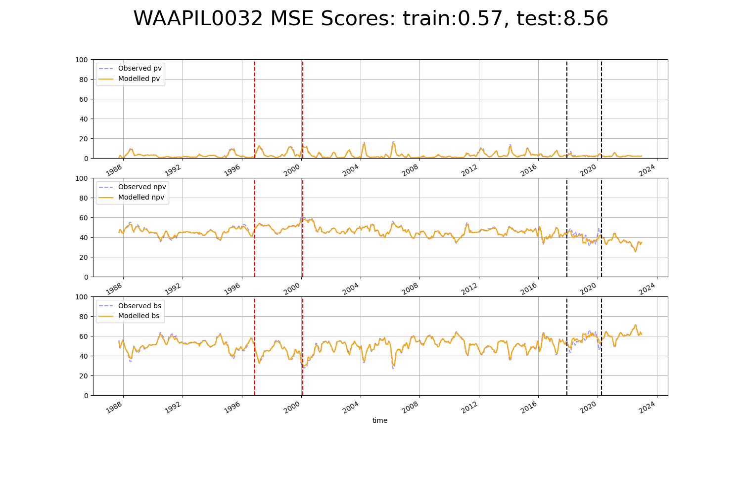

# WAAYAL0002

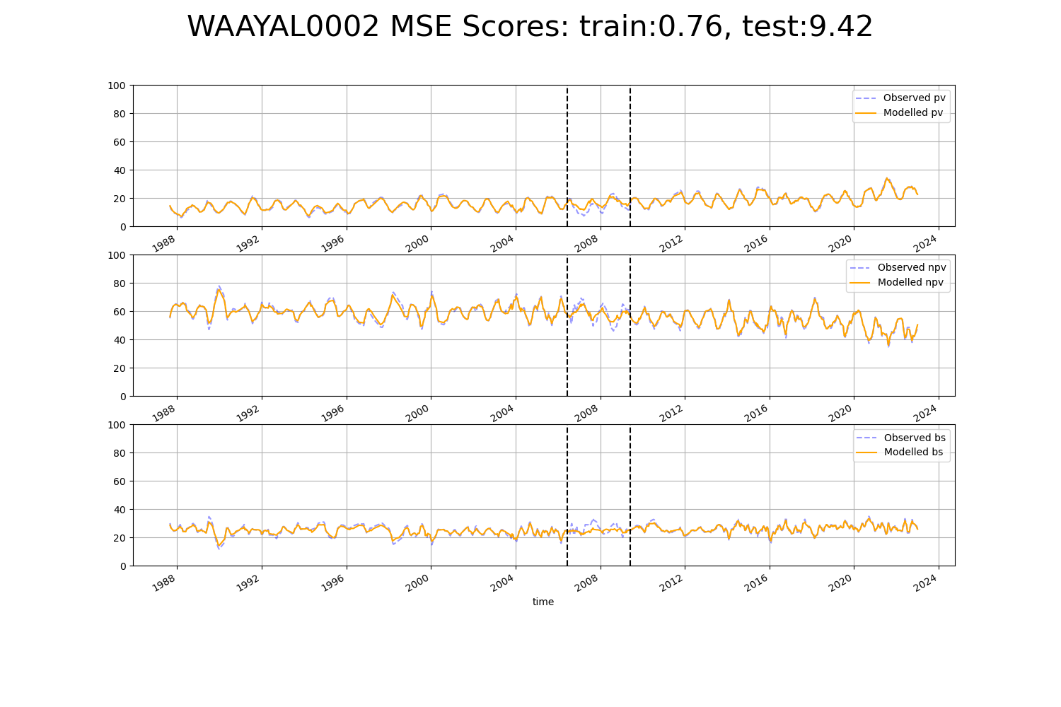

# WAAYAL0005

